When need register the device, need check the amount devices of MDVR with unencryption.

- Use Navicat for MySQL software connect to mysql, then find the dev_status table.
https://www.dropbox.com/sh/a44t2tv3o78jok4/AAA6vG9AeX1yeDamAwcfMiSka?dl=0
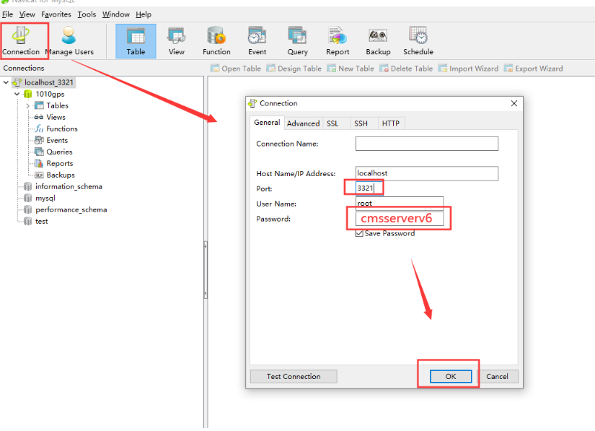
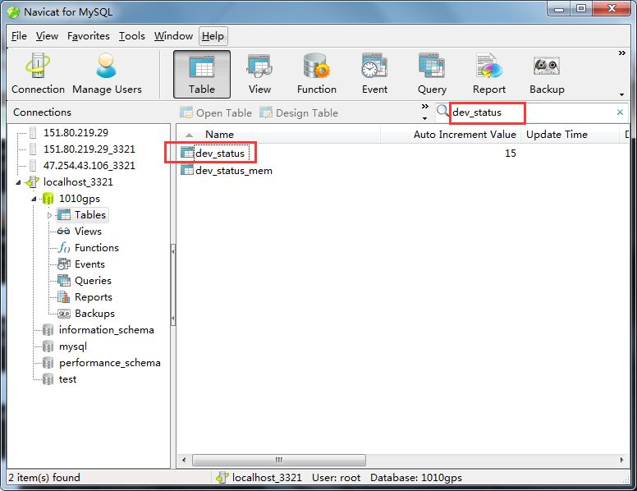
- Use command “select COUNT(*) from dev_status WHERE llReserved1 = 0” and check the device with unencryption.
