How to play each channels’ real-stream cyclically

There are the steps about how to set the configuration of playing each channels’ real-stream cyclically.
First, add a group and set the cycle time for example AA, 20 sec.
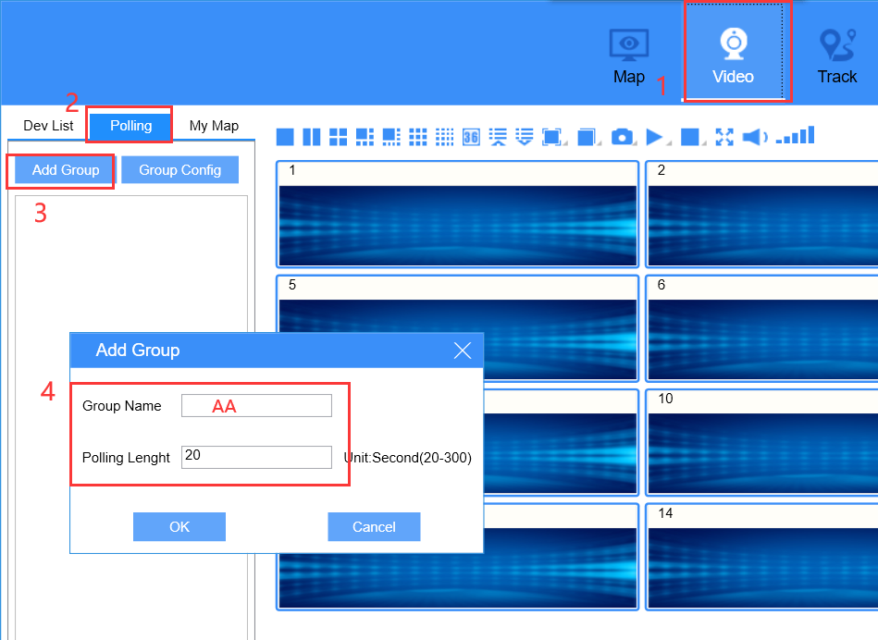

Next, Move the channels you want to the Monitor Group.

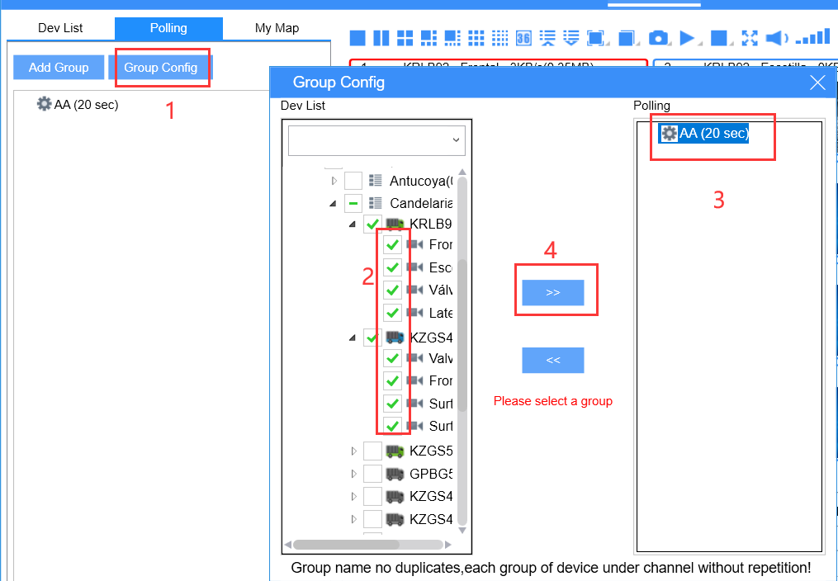
Then click the option “ Start Polling ”.
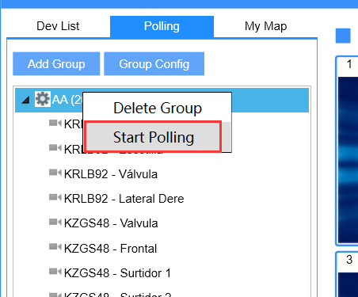

Finally, you will see each channel of the group playing Cyclically.

Note: It is recommended that using a big monitor screen to achieve this function.
