How to import the original videos to HDD and playback by monitor
Sometimes, we need use 7 inch monitor screen to playback the video that get from other devices. If the videos are not beyond the date time.
- Copy the original video and move it to the HDD disk. The date time can be distinguished from the original file name, H20200415 means 15/4/2020. If the HDD didn’t have the date file, you need add one manually. Otherwise, the video can not be read by MDVR, cause MDVR query the videos by the name and date.
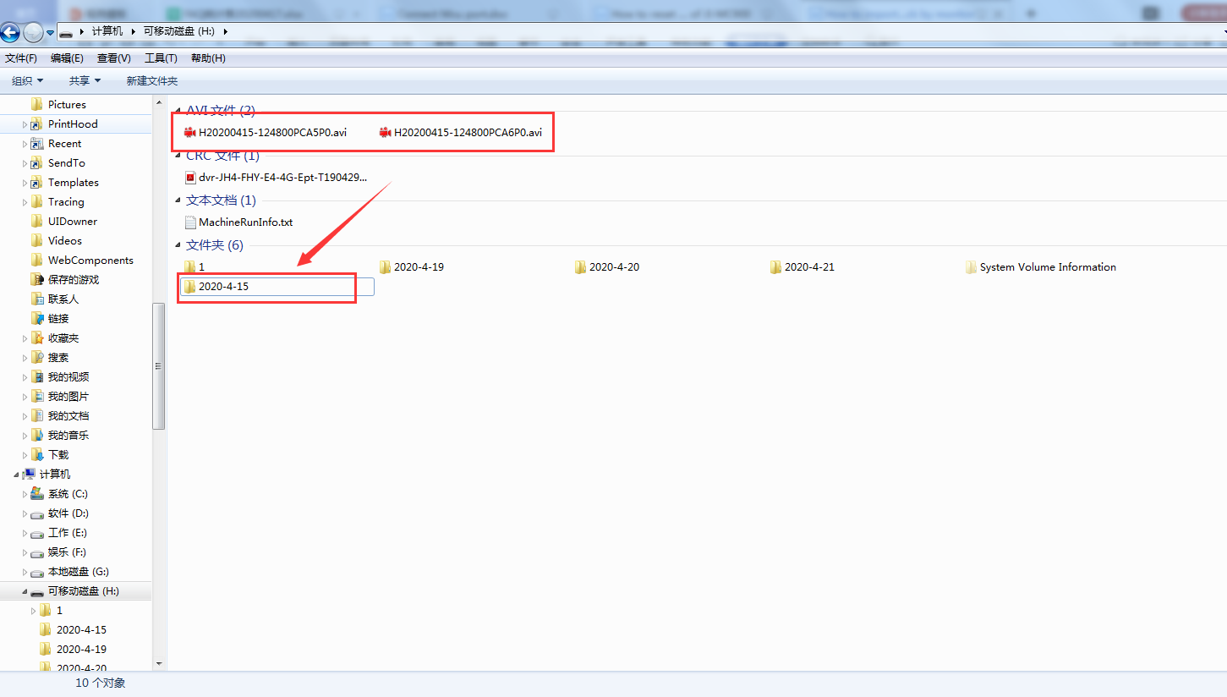
- Move the original videos to the file of 2020-4-15 and then save it. Then insert the HDD to the MDVR and you can see the record search page, if the date is right, and the video if original and format is right, if can be found, at the following page, I use video of 15/4/2020.
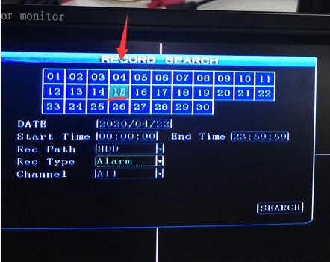
- And the final step is to playback the videos, you can search and select and press the button of the remote controller.
