How to solve high CPU issue due to Storage Server
There is a phenomenon that Storage Server consume too high CPU.
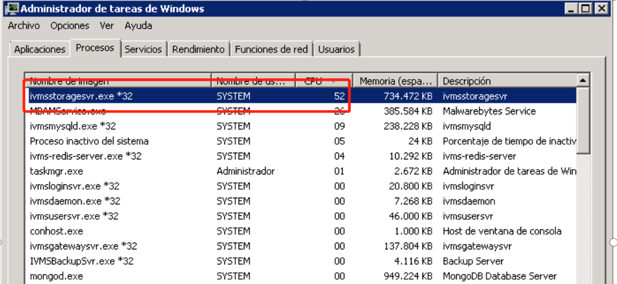
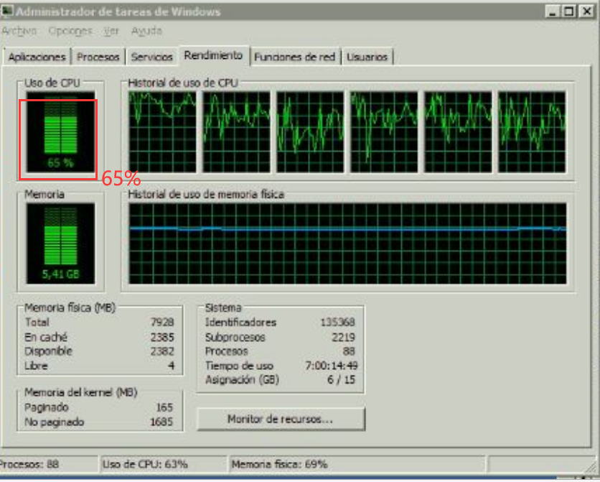

High CPU issue will cause the follow issues:
- Server respond slowly even no respond.
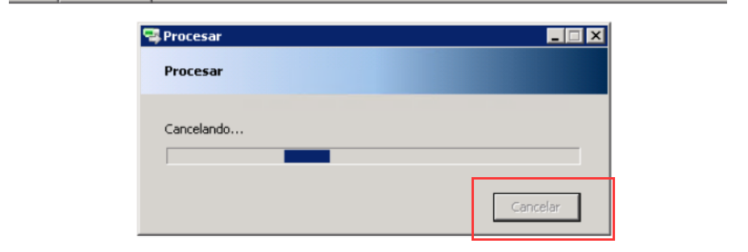
- Preview video real-stream failed as below.
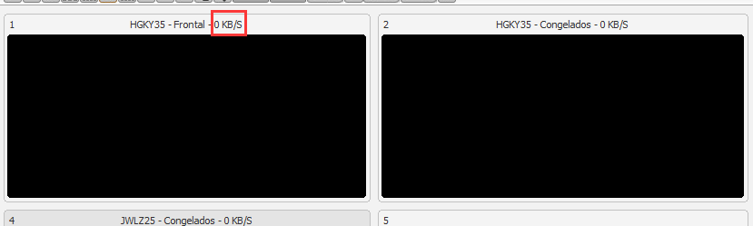
- IVMS Client login failed.
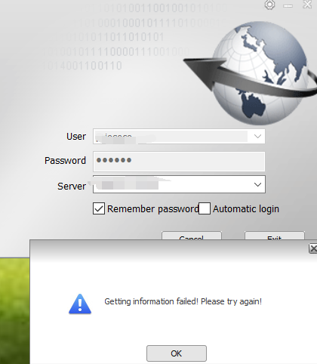

The reason why high CPU of Storage Server is that the ftp did not end correctly after finishing download task, which causing a loop.

So kindly download the Lib files and put them to the path: IVMS Server>bin64.

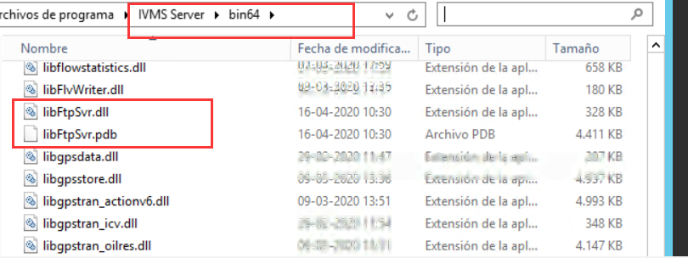

After that. The storage server no longer consumes too many resources even if there are many download tasks.
