How to remove the Video Loss alarm

When we use the MDVR, and do not connect all the camera, it will send Video Loss alarm all the time, this will make us can not distinguish the real video loss alarm, then when the channel which connected camera can not show the video, we can not know it at the first time.
1. If your device is near with you, then you can change it at MDVR side, you can choose the channel which you do not connect camera to close it. After change this, the channel which do not connect camera will not send alarm to platform.
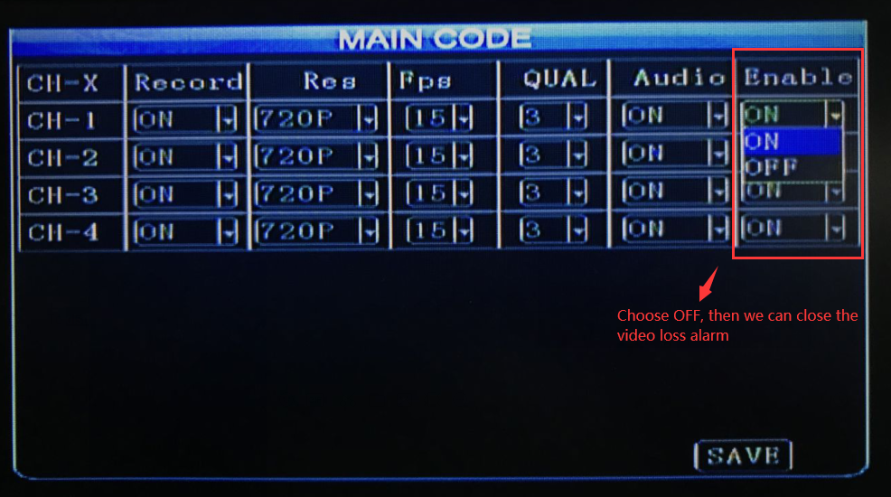
2. If your device is far from your side, then we can change it via IVMS Client, use your account login the IVMS Client, and choose the device which you want to close, then right click the device and choose the Parameter Config option, click main stream option, then you will see the Enable option, choose OFF will close the video loss alarm for the channel which do not connect camera.
