How to supply power to IP camera separately
There are some issues of IP camera as below.
- MDVR can not search IP camera successfully.
- Preview video but no image and recording failed.
- The MDVR voltage of network port is unstable and the recording is lost.
- Noise from recording video files.

These issues can be checked by supplying power separately.

Here is the steps how to supply power to IP camera separately

- Divide network cables into three parts: ACC, GND and for camera.
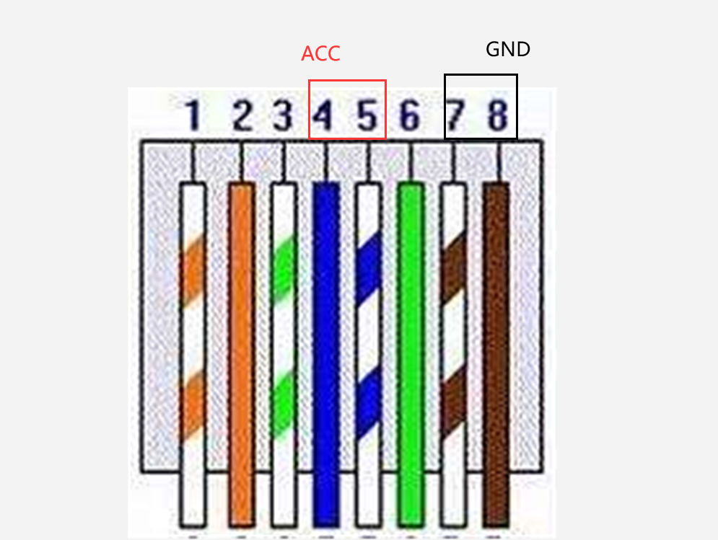

- Solder a power terminal as below, 7th 8th for GND, 4th 5th for ACC. I think this cable could be available at the local shops if you want it directly.
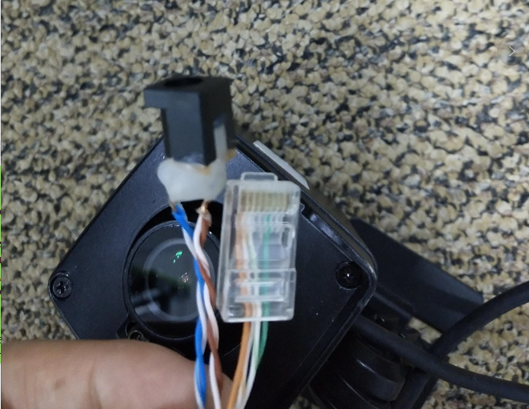
- Therefore, the camera could get the voltage not from MDVR but from other side separately.
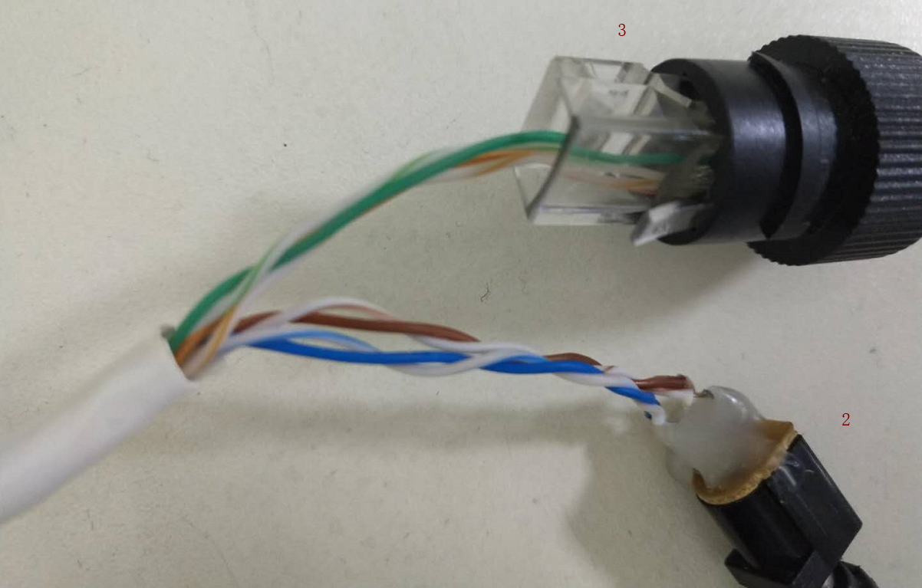

- After all steps. You could check whether the above issues still exist.
