Use Cluster to WIFI download

First, you need to make sure your main server mysql can remote access, you can follow this link to open it.
https://www.icarvisions.com/faq/ivmsserver-mysql-enable-remote-access-340.html

1、The main Server.

Log in the user of admin and add a new download site. (The download site is unique).
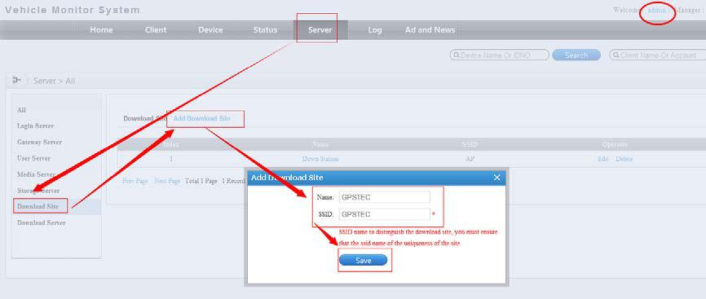

Add WIFI download Server. (Set your IP correct).
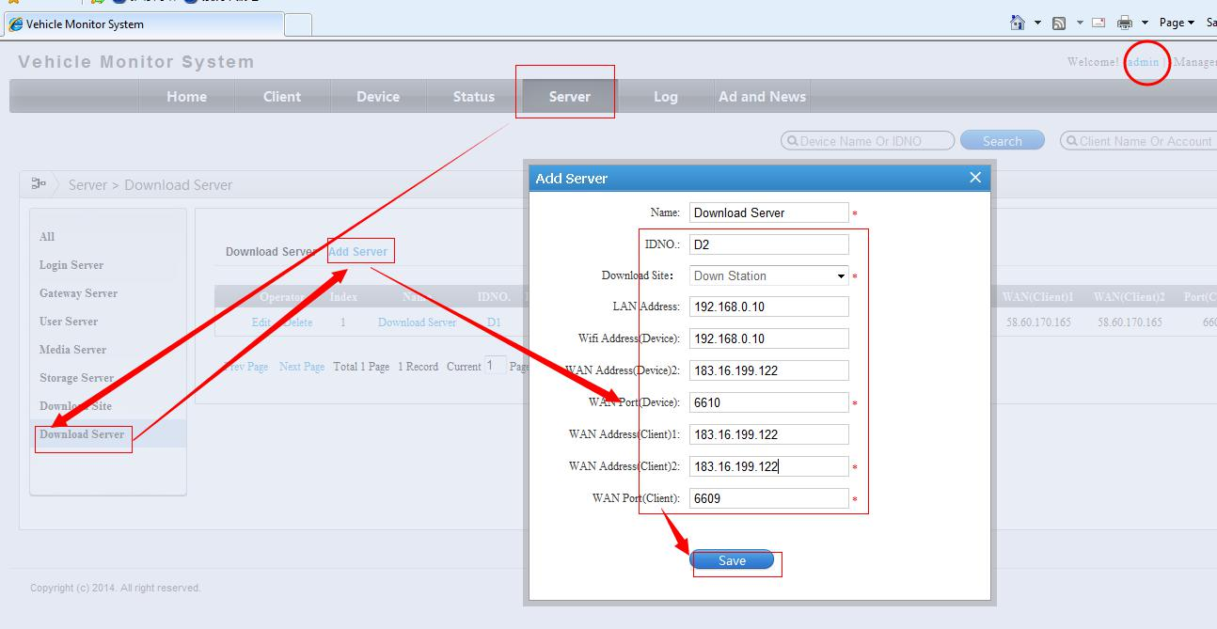

If your server did map port (6601-6612) and the new WIFI download server in the same LAN, you need to map the 6610&6609 ports to the IP of WIFI download server. If the main server and WIFI download server in different
network, you need to set “LAN Address, WIFI Address(Device), Address(Device)2” according to WIFI download server.
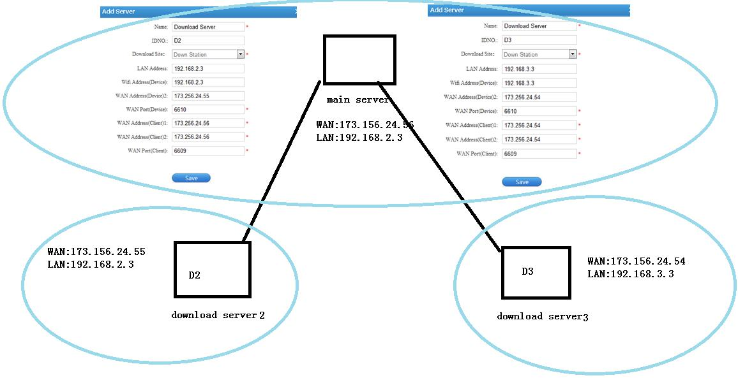

Stop the WIFI server on the main server.
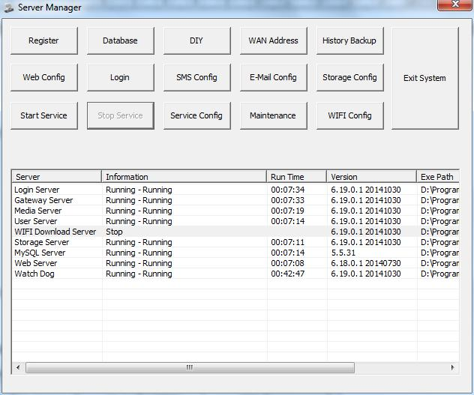

If you main server need to be used to a download server you can keep the main download server running.

2. New WIFI download server

Stop other services. As the picture shows:
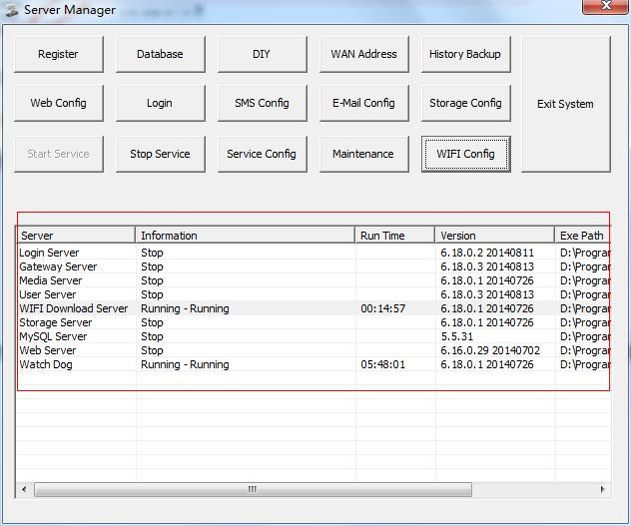

Set download server：

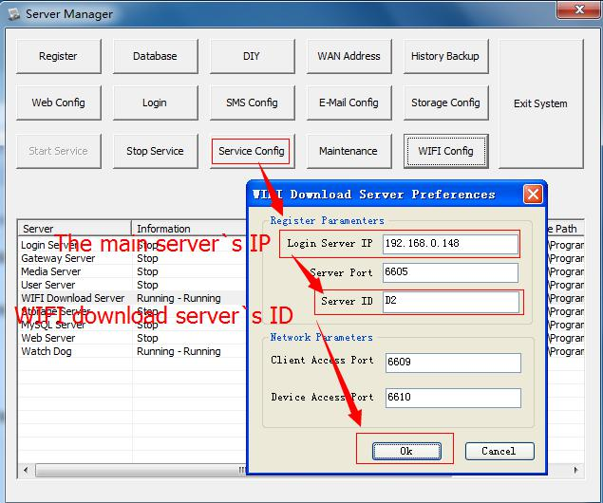

If your WIFI download server in the LAN, you need to do a map port (6609, 6610). If the download server and main server in different network, you need set the WAN IP at “Login Server IP”.

3、Set WIFI download plan on the main server. Log in the second level user. (admin is the first level, your 24102014 is the second level.)
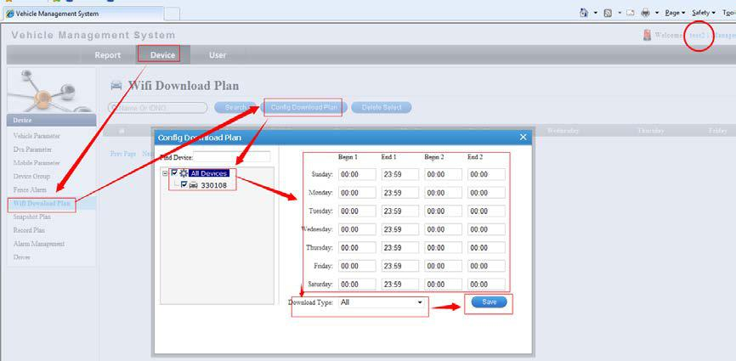

4、Set successful
