How to disassemble the JI3 and check the 4G module
- There is one screw at this place, use the tool with the screwdriver in the accessory box to make this screw loose.
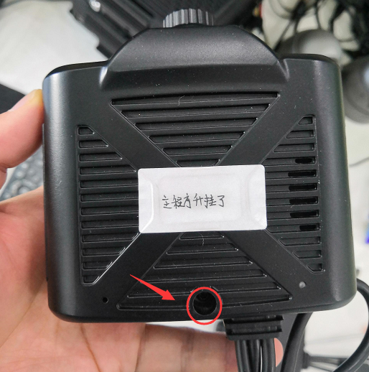
- Focus to the bottom side of the dashcam, and use screwdriver to disassemble these 4 screw.
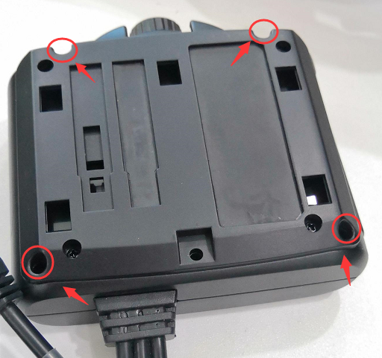
- Follow the direction, push the cover, and you will disassemble the cover of the dashcam.

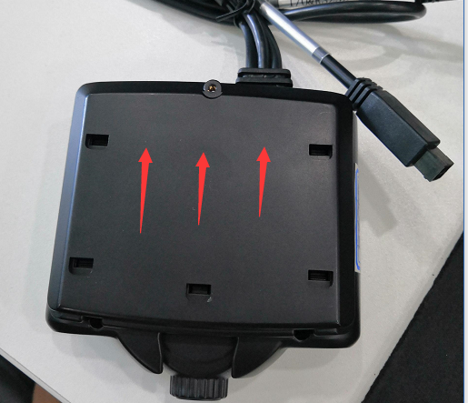
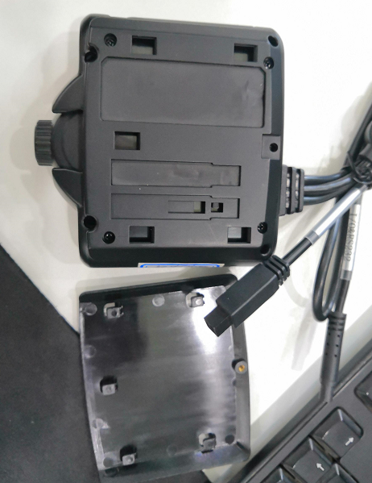
- Focus on this side, press the cable and take the top cover up. Then you can see the main board. And you can see the 4G module.
