This entry in web.xml cause the watchdog to reset Tomcat every now and then.
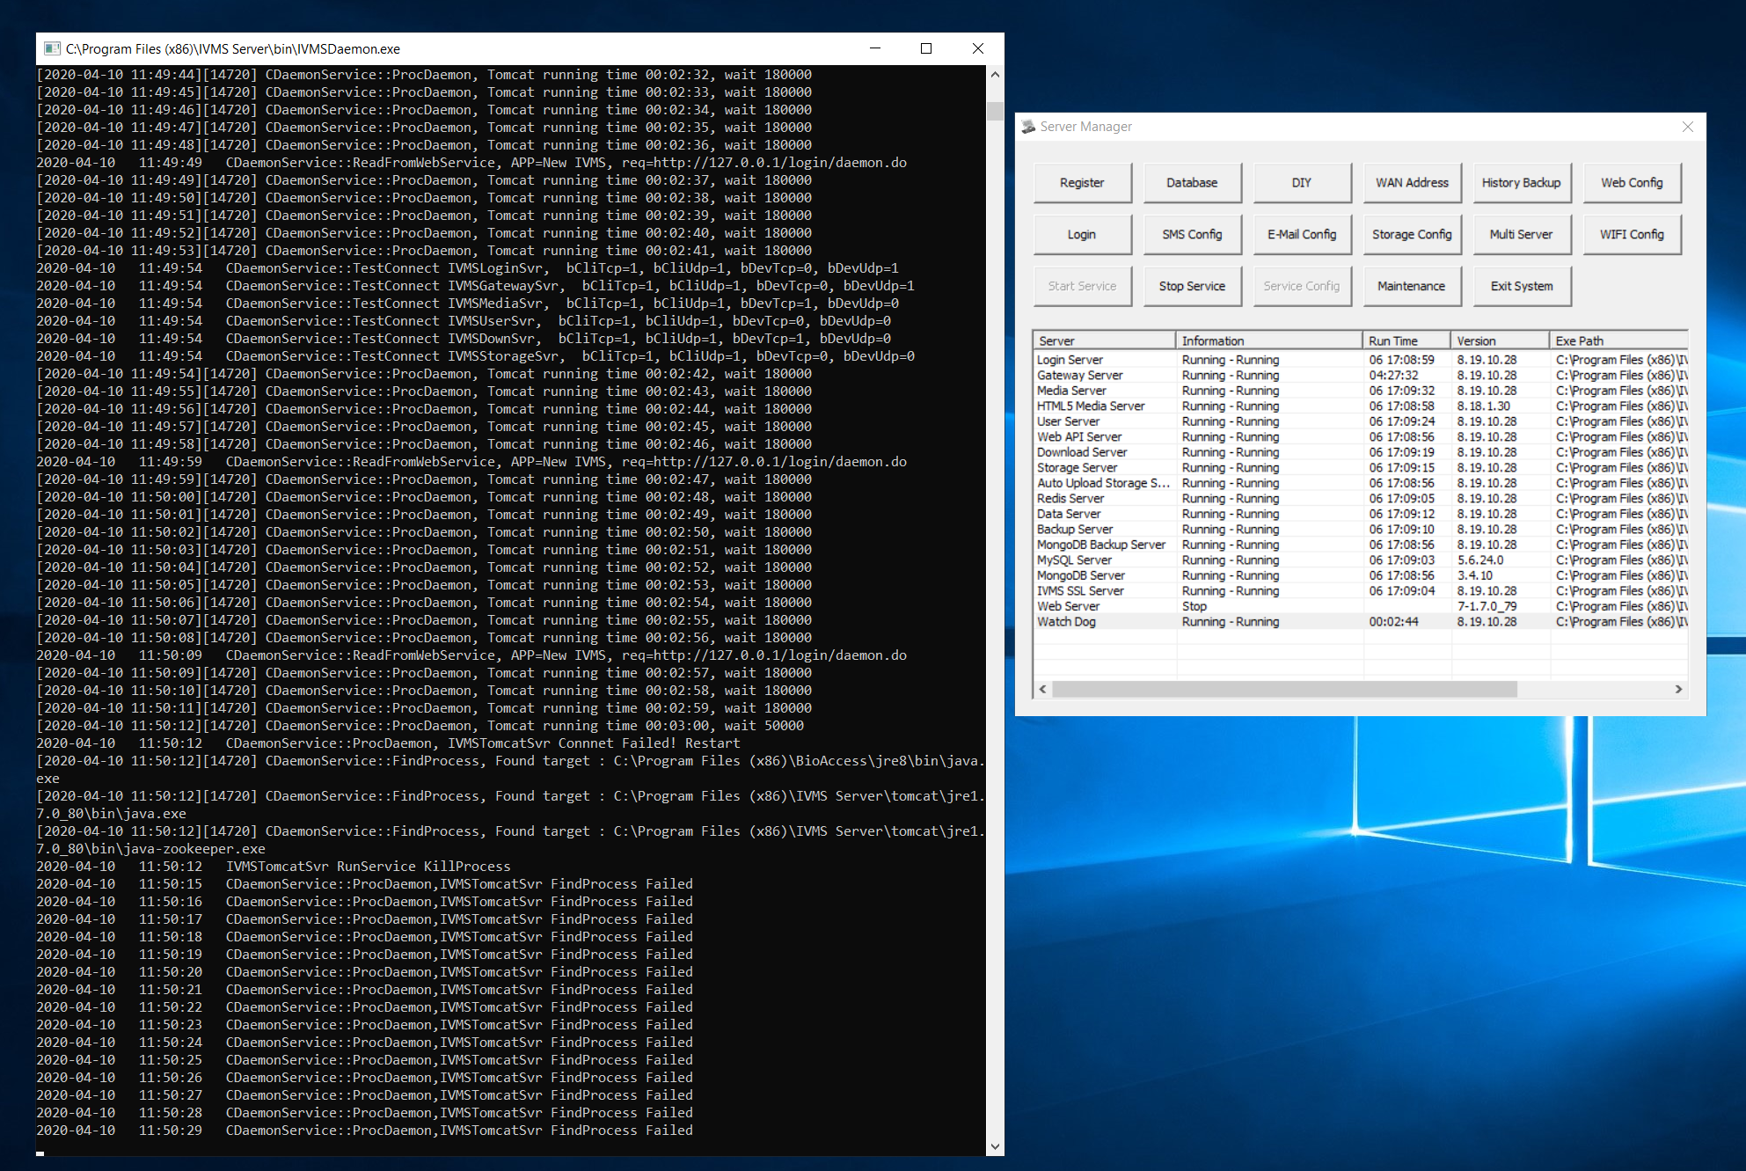
<security-constraint>
<web-resource-collection>
<web-resource-name>SSL</web-resource-name>
<url-pattern>/*</url-pattern>
</web-resource-collection>
<user-data-constraint>
<transport-guarantee>CONFIDENTIAL</transport-guarantee>
</user-data-constraint>
</security-constraint>

Because watchdog cannot be turned off on the production Server.
Here is the way to solve the issue.

- Please follow the path as : IVMS Server/IVMSDaemon.ini/
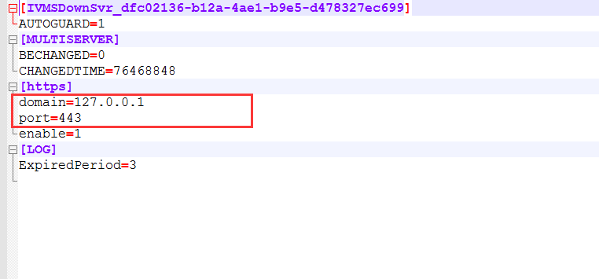
- Fill your correct domain name and SSL port as below.
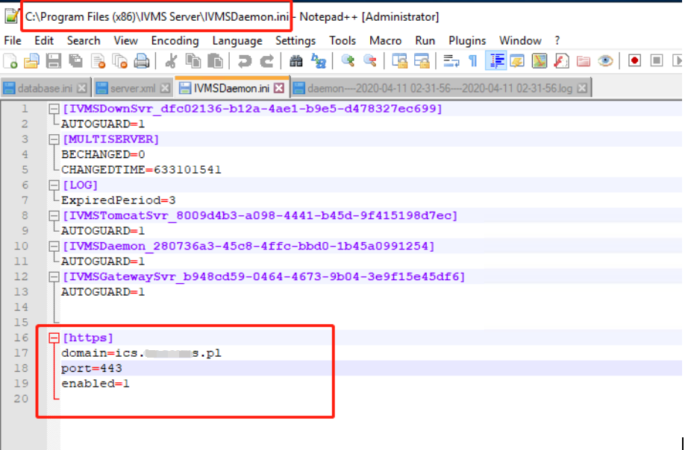
- Then restart the IVMSServer. After that, your Tomcat will work normally.

