How to add channel name to the realtime video
- Choose GENERAL and enter into the next page.
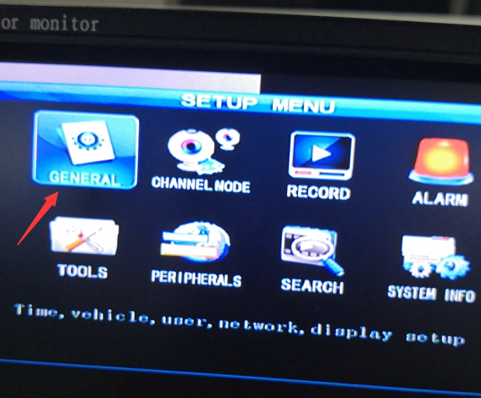
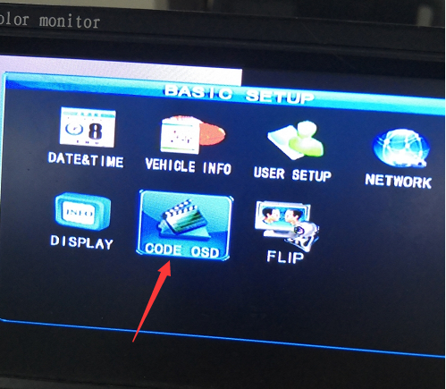

- Change the Channel Name, such as if your CH-1 is using camera for the front of the vehicle, you can set Front.
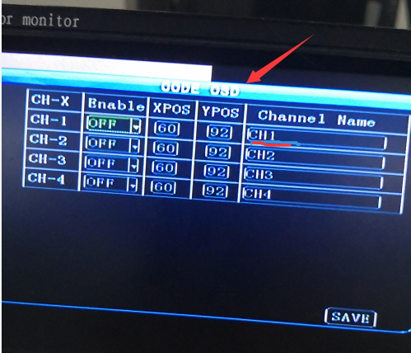
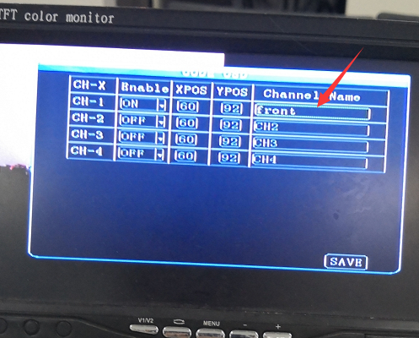
- After finish, save the settings, and login the account and check the realtime video. And you can see the channel name has been added.
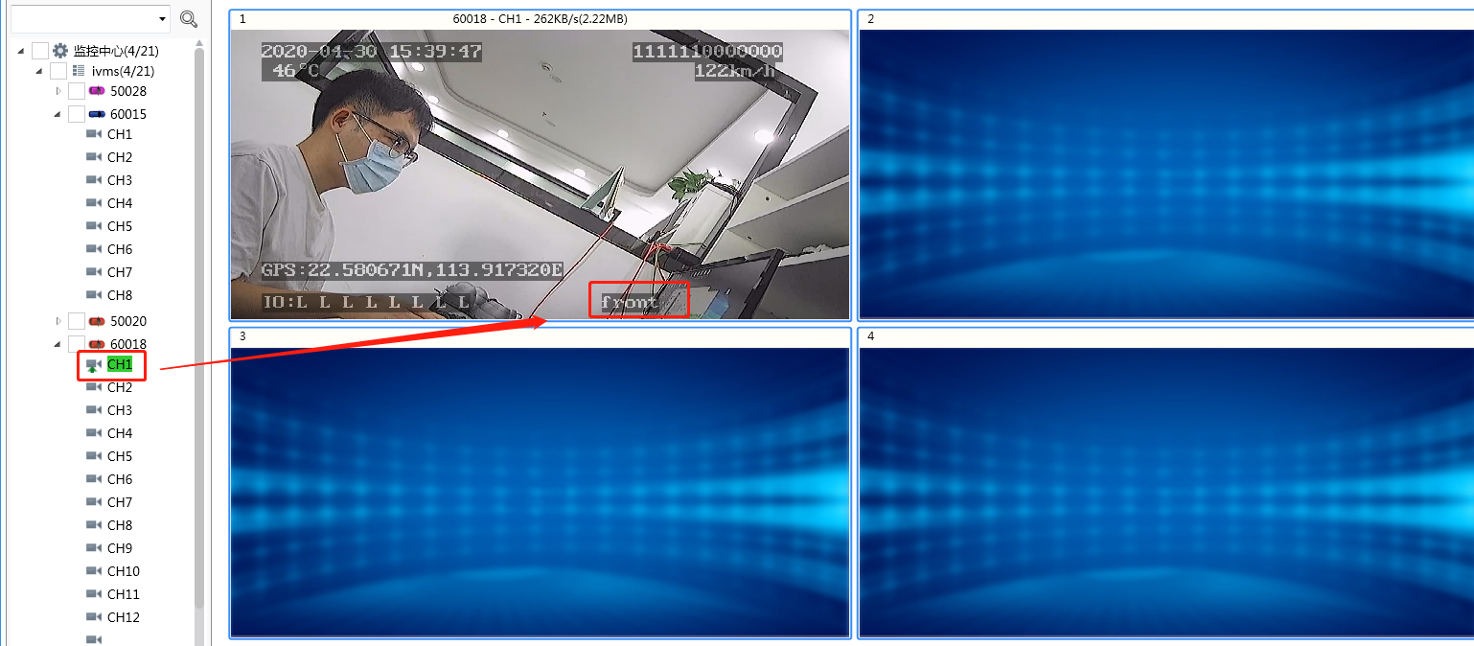
Note: If you need know how to make device online by 3G/4G or wifi, you can refer to the following FAQ.
Online by 3G/4G: https://www.icarvisions.com/faq/how-to-use-3g-4g-online-for-mobile-dvr-227.html
Online by WiFi:
https://www.icarvisions.com/faq/how-to-get-mobile-dvr-wifi-online-241.html

