How to solve the System Error of ivmssvrwizard.exe

There is a System Error of ivmssvrwizard.exe when you install the IVMS Server.
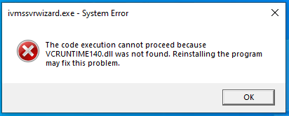

Because IVMS Server Program needs some Operating System dependent Lib files to run.
It is recommended to install these Lib files if your OS missing them.


After that, you will solve the error and continue installation program as below.
