How to get the real-tream of flv format by SDK
A. Preparations of Development

1 . Install and run the latest IVMS Server and make sure the Media Server running.
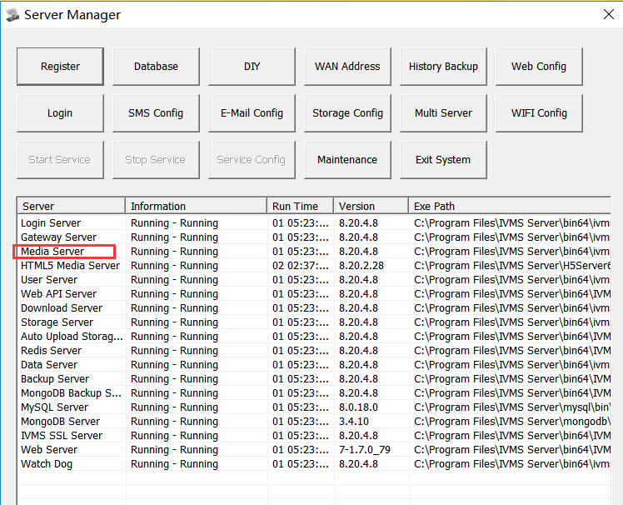

2 . How get the IP address and port of Media Server.
Kindly type the search command as below.
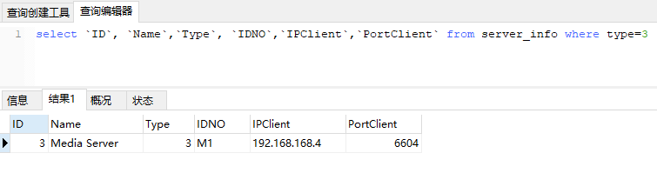
So the IP address and ports of Media Server as above is192.168.168.4 6604.

3 . Configuration of Media Server.
[HTTPService]
WebRootDir=Web
HttpLoginRequired=1
VideoCacheDir=C:\\gIVMSH5Cache
KeepDay=5
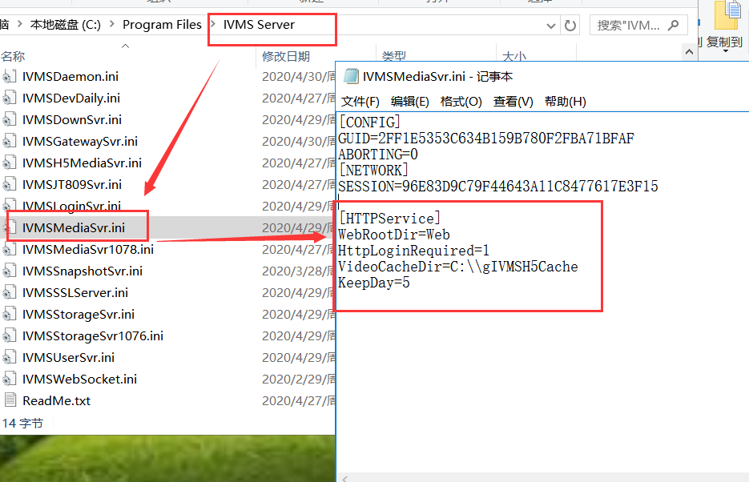

- How to get the real-tream
- http://server:port//RealplayFlv.do?DevIDNO={strDeviceIDNO}&Channel={nChannel}&StreamType={streamtype}&uSession={strUserSession}

Parameter Description

parameter | type | value | directions
DevIDNO | String | 10010 | must
Channel | int | 0 | 0: mean the channel1
StreamType | String | 0:main stream  1: sub stream | Default sub stream
uSession | string |  | User session， when HttpLoginRequired=1 of IVMSMediaSvr.ini as the third steps

http://192.168.168.65:6604/RealplayFlv.do?DevIDNO=10000&Channel=0&StreamType=1

- If requirement is successful, http +FLV will send the video real-stream as below.
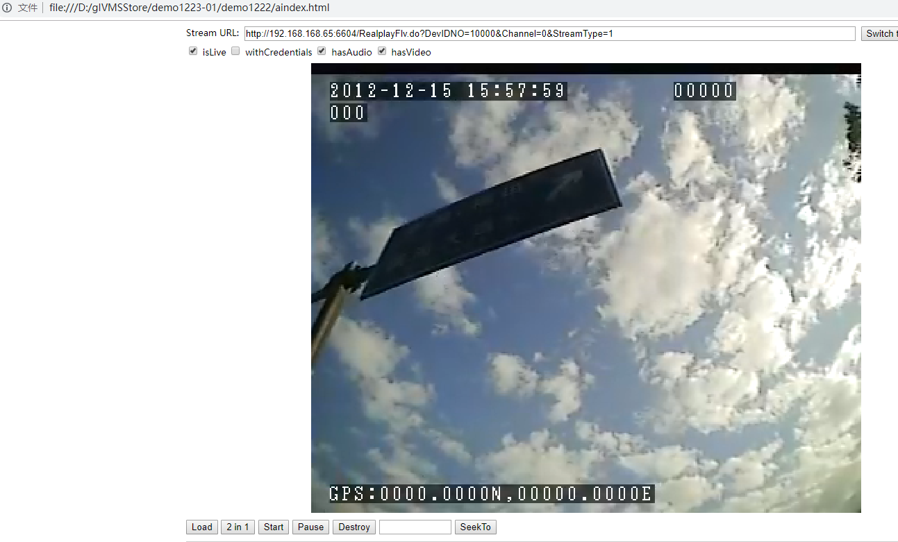
- If requirement is failed, the return format is json, and the status will be 1, message will be the reason.

For example:

{“status” : “1”,”message” : “Device is Offline” }

