How to use the forward plug-in se data to other server
1. First, stop the gateway server at your server panel, then copy the forward plug-in to your server side as below.
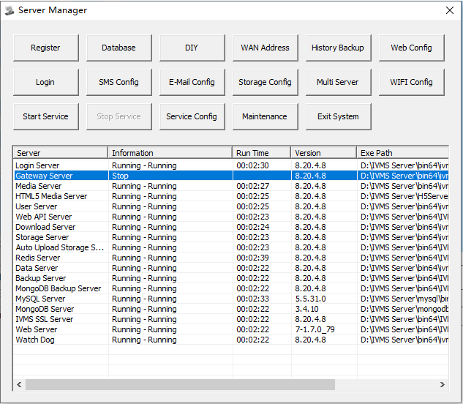
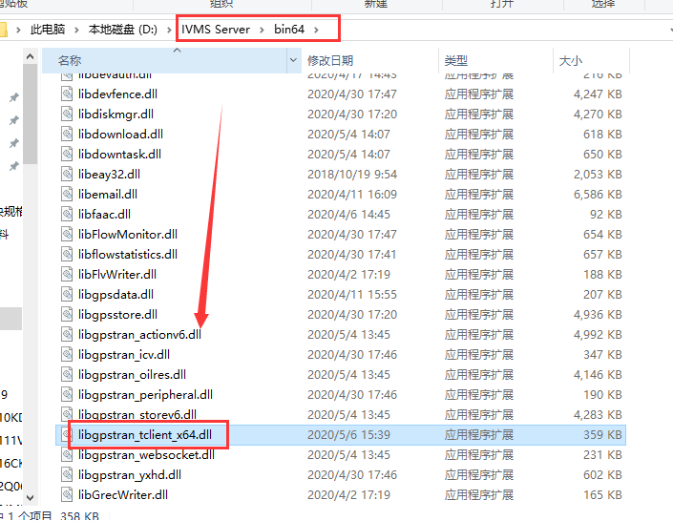
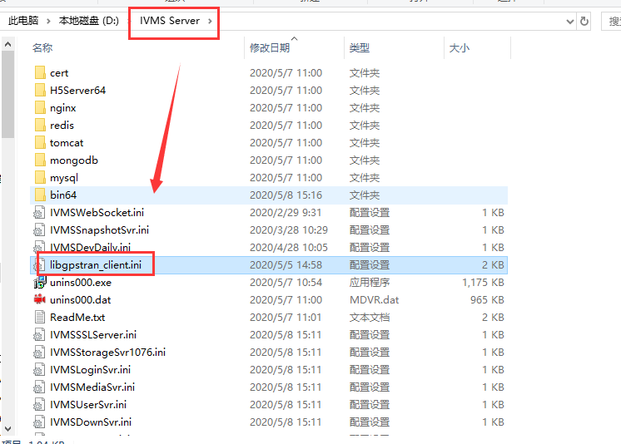
2. Config the libgpstran_client.ini file, add the server IP and port which you want to send, also make sure your server can connect to this server IP and port.
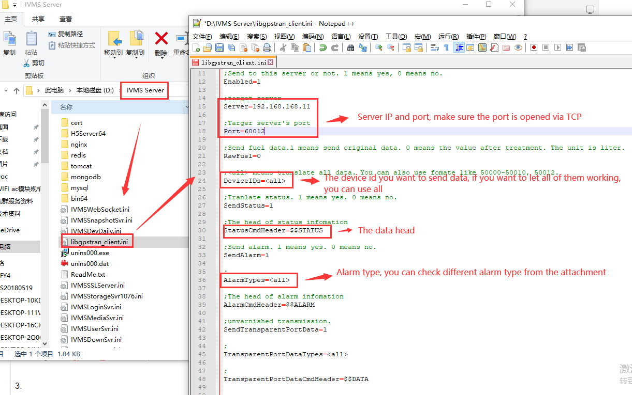
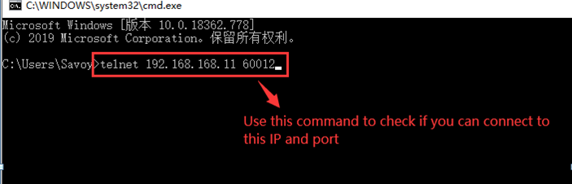
3. Restart the gateway server, then when the MDVR online, it will send data to the server you set, also you can check if it is working at this side.
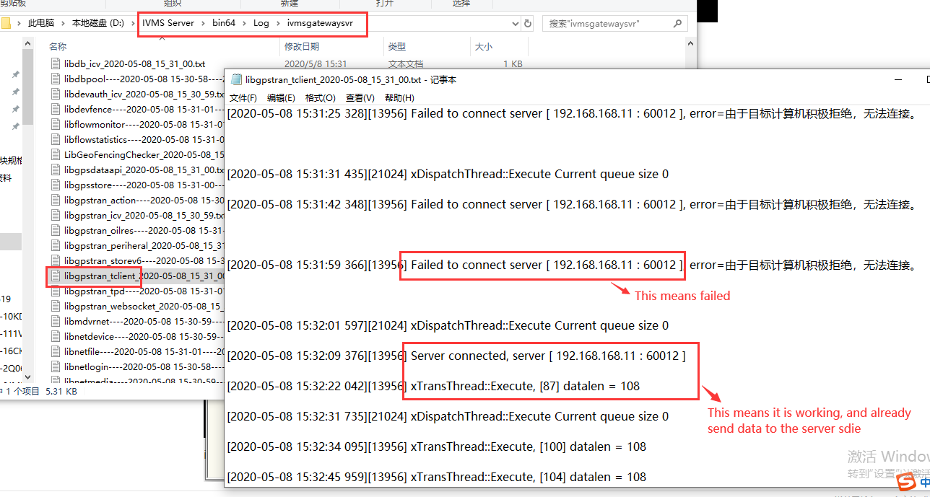
4. You will get this data at you server side, then you can follow the manual to parse it.
