How to check when the mobile device has no video output
1.Check the power status of the device. If only one blue indicator is lit up, it indicates that the
device is still in standby mode and not powered on; at the same time, check if red or yellow cable
of the main power is supplied normally; If not, the device cannot be started.
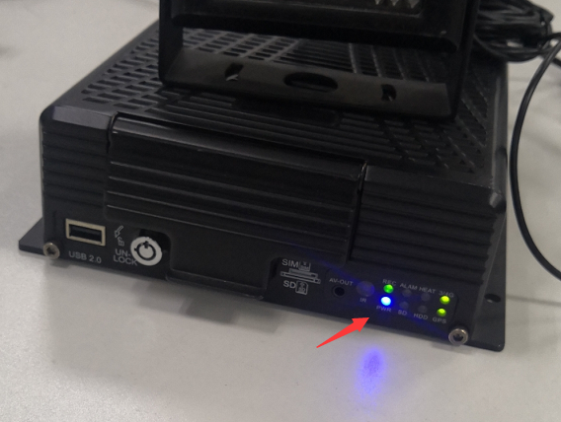
- Check if the display is powered and if the display video is switched to AV status
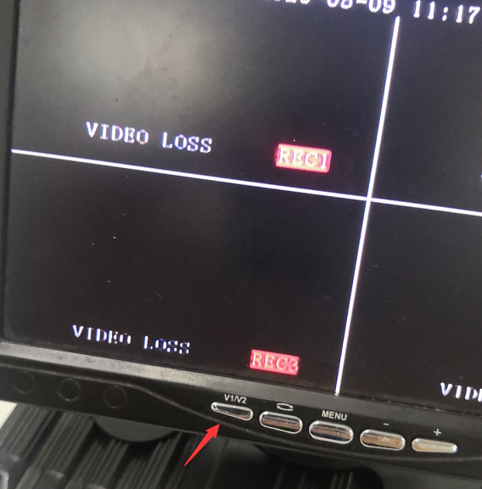
- Check the connection status of the video output cable and display
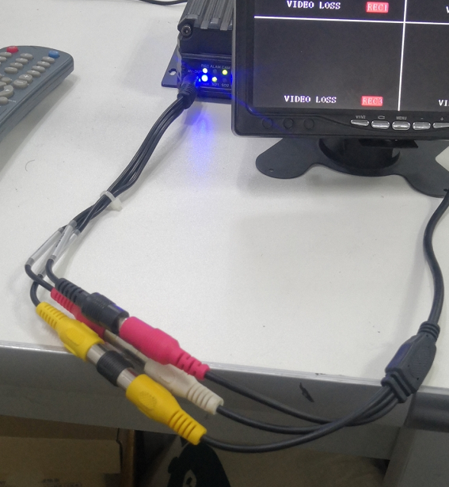
- Check the lock status the mainframe lock; the device can be started only when the lock is Operating Instruction for Vehicle Mobile DVR locked.
