How MDVRPlayer read G-sensor information
- You can refer the download link to set G-sensor parameters and get G-sensor alarm.
https://www.icarvisions.com/faq/how-to-test-g-sensor-alarm-354.html
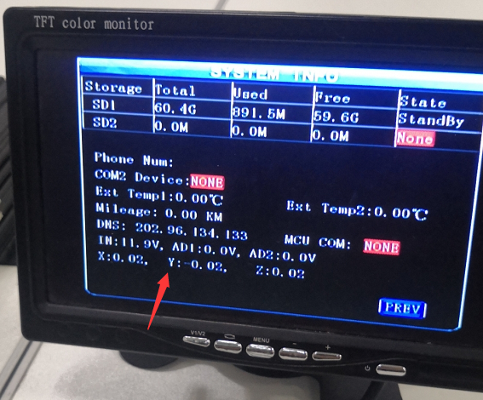
- When you get the original videos and playback using MDVRPlayer, you can see this bottom display.
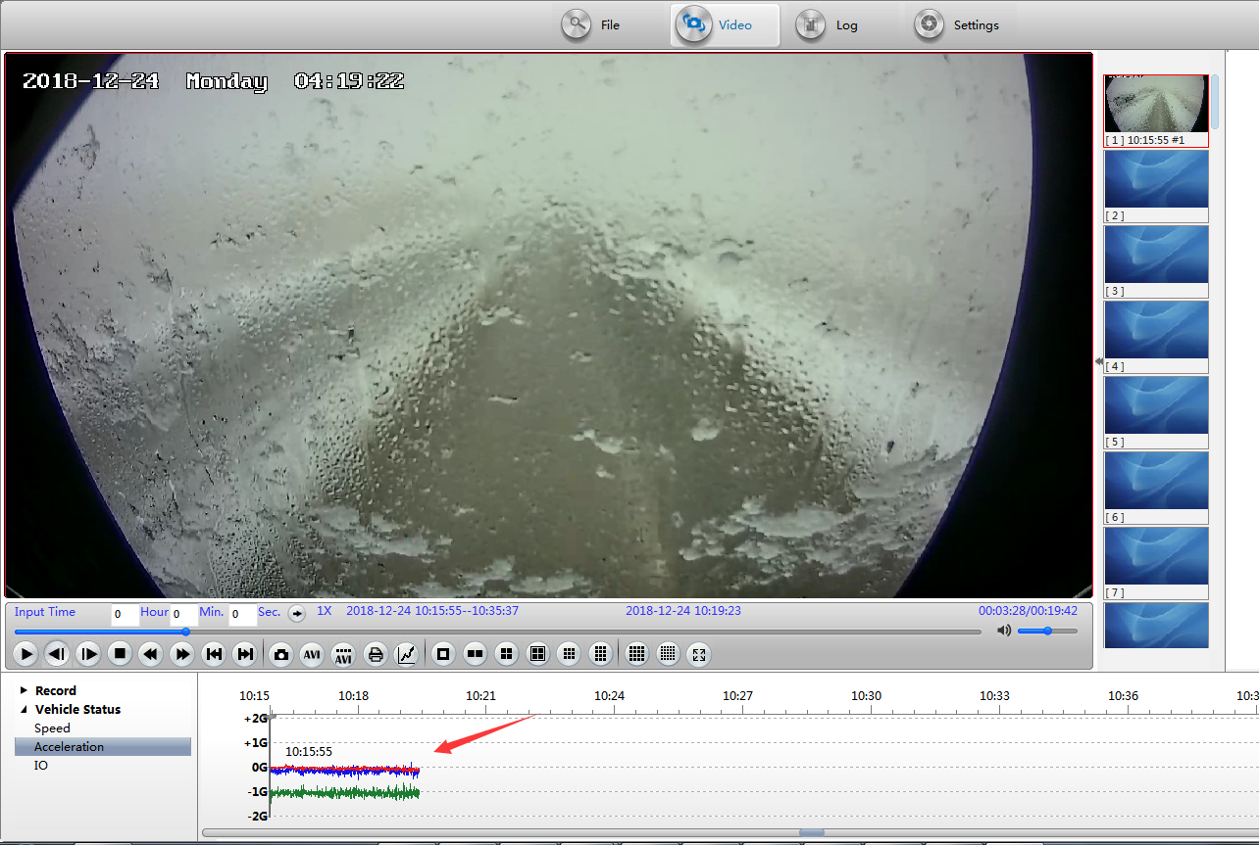
Notice: X=Blue, Y=Red, Green=Z,
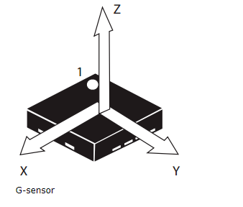
You can judge by the different G-sensor curve, you can check the vehicle status, if the vehicle has accident, you can read the curve to judge what happened.

