How to get the video recording of flv format by SDK
A. Preparations of Development

1 . Install and run the latest IVMS Server and make sure the Media Server running.
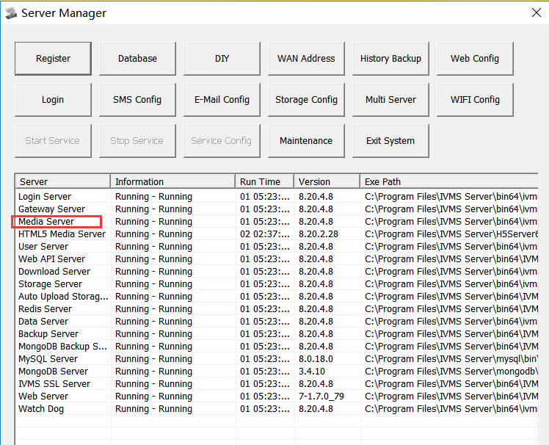

2 . How get the IP address and port of Media Server.
Kindly type the search command as below.
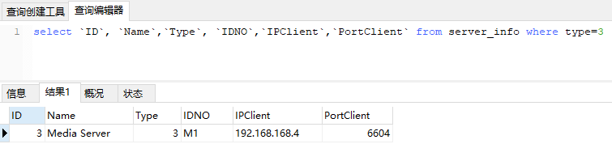
So the IP address and ports of Media Server as above is192.168.168.4 6604.

3 . Configuration of Media Server.
[HTTPService]
WebRootDir=Web
HttpLoginRequired=1
VideoCacheDir=C:\\gIVMSH5Cache
KeepDay=5
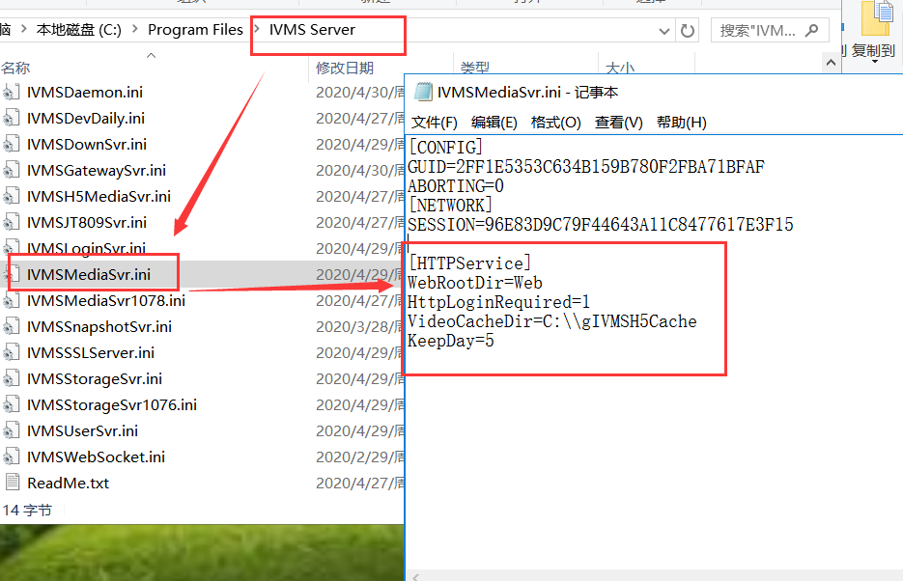

- get the video recording of flv format by SDK

http://server:port//PlaybackFlv.do?DevIDNO={strDeviceIDNO}&Channel={nChannel}&Date={yyyy-mm-dd}&FileBegin={nFileBegin}&BeginTime={nBeginSecond}&EndTime={nEndSecond}&AlarmInfo={AlarmInfo}&FileName={FileName}&Location={nLocation}&Attribute={nAttribute}&jSession={session}&callback={jsCallback}&uSession={strUserSession}&JT={isJT}

Parameter Description
parameter | type | value | directions
DevIDNO | String | 10010 | must
Channel | Int |  | 0: mean the channel1
Date | String | yyyy-mm-dd | When the date is empty, means today
FileBegin | Int | Need to be converted into the total amount of seconds of the day | Video file start time
BeginTime | Int | Playing start time, converted into the total amount of seconds, for example 09:10:00 => 9 * 3600 + 10 * 60 | default FileBegin,  BeginTime = FileBegin+ 10
EndTime | Int | Playing end time, converted into  Seconds 23:59:59 => 86399 | default 86399
AlarmInfo | Int64 | Alarm info from video | default 0
FileName | String
FileLen | DWORD | File length, returned by search results
FileOffset | DWORD | 大小偏移,字节 | default 0
Location |  | 1 device  2 storage server  3 save  4 donload server | Search location  default 1
ServerID | Int | Server ID ,When Location=2,4 available | Default 0
Attribute |  | 1 image  2 recording | type of data  Default 2
uSession | String |  | User session， when the HttpLoginRequired=1 of IVMSMediaSvr.ini

http://192.168.168.65:6604/PlaybackFlv.do?DevIDNO=1891111&Channel=0&Date=2019-01-03&FileBegin=0&Begintime=0&Endtime=900&AlarmInfo=0&FileName=/sd1/2019-01-03/H20190103-000000PAN1P0.avi&FileLen=16634240&FileOffset=0&FileType=0&Location=1&ServerID=0&Attribute=2

Success:
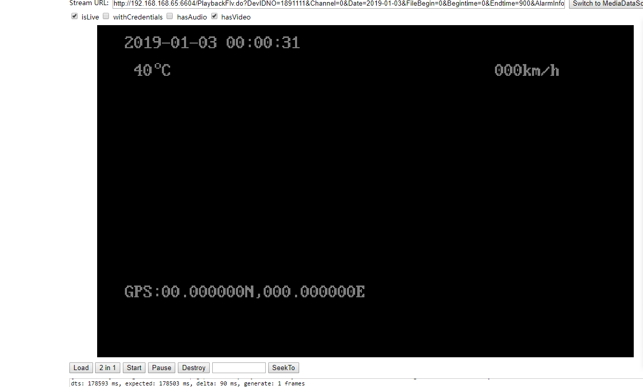

Return value
If failed , format: json, status= 1, message means reason
For example
{“status” : “1”,”message” : “Device is Offline” }

