How to solve position empty issue of reports
There is a strange phenomenon that it was no position in the reports.
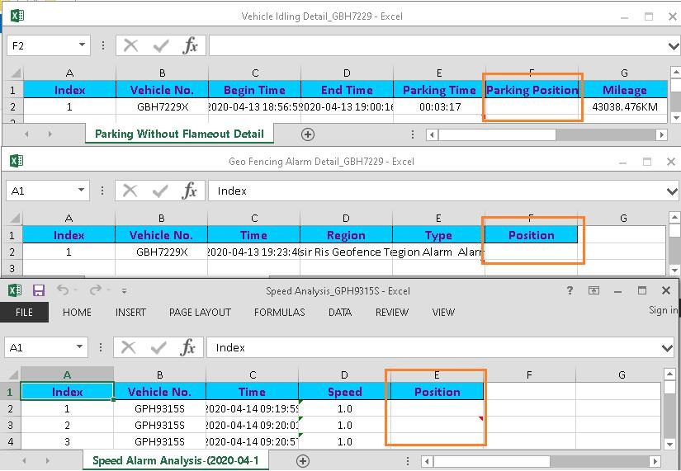
- Please try to access Google Map of your Server local side with the address “maps.google.com”.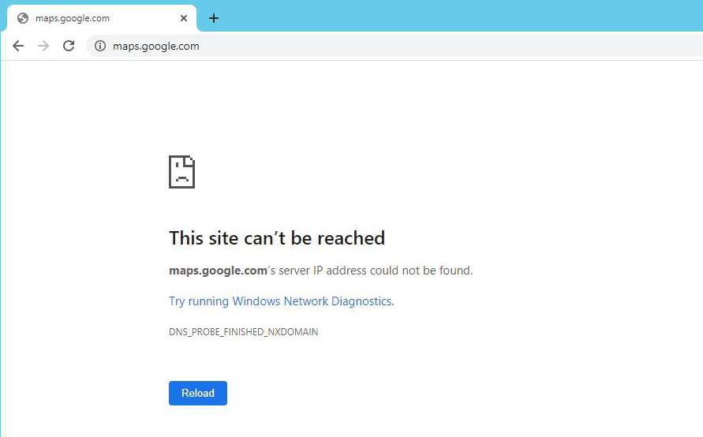
- Kindly check the network configuration, firewall, network security, etc.
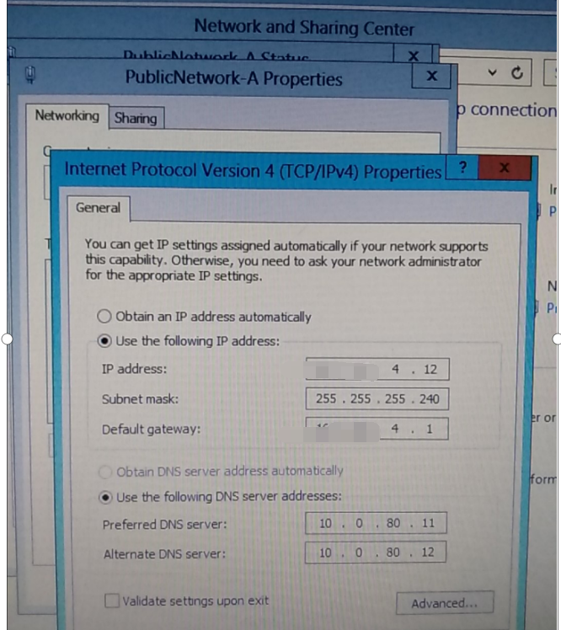
For example, Don’t forget to configure the correct DNS.

- After check the above details. Please try to access to Google Map of your Server local side again.
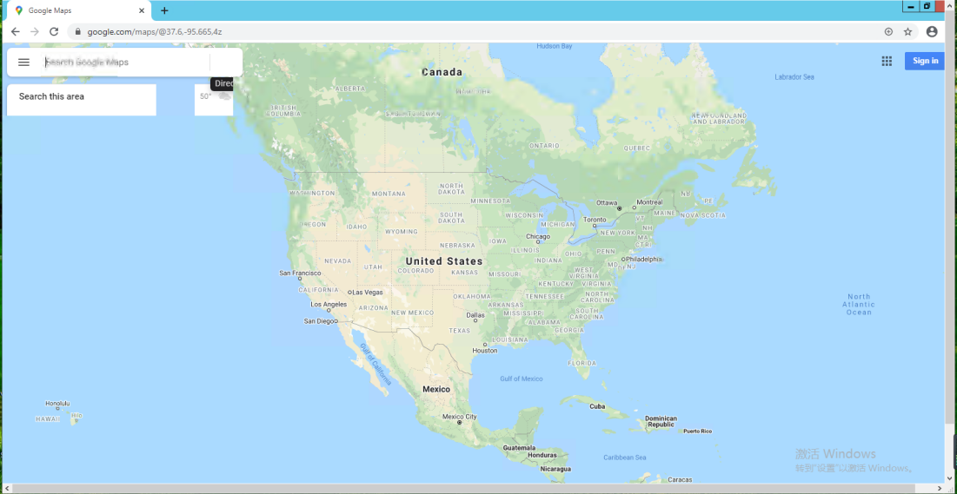

- Finally, the position empty issue of the reports has been solved.
