How to check the status of wifi
Type 1: WiFi shows signal but not shows OK,and Center-L shows NO LINK.
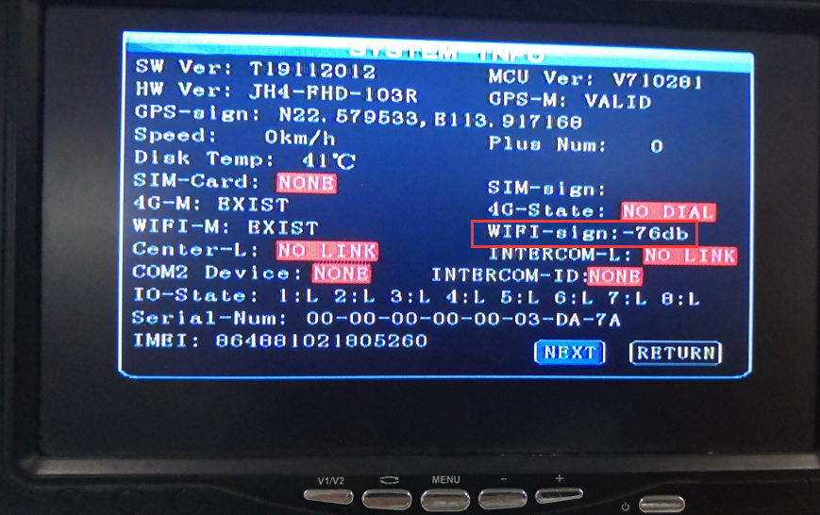
This means the wifi antenna is not connected, and also need check the wifi parameters, the SSID of the wifi is not true.

Type 2: WiFi shows 0 signal, and Center-L shows NO LINK.
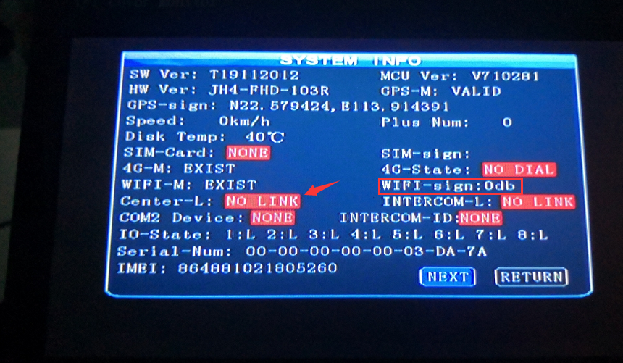
This means WiFi password is not right. Need check the password of WiFi settings.
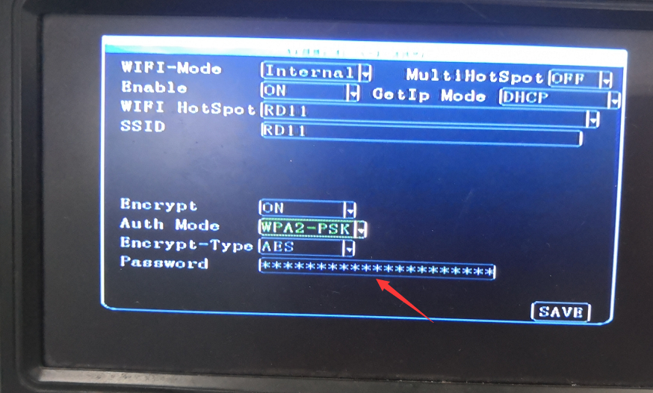

Type 3: Wifi signal shows value normally, and Center-L show SUCCESSFUL.
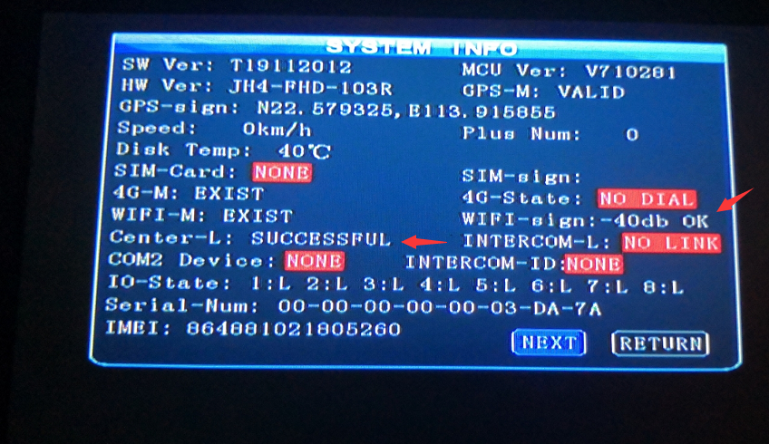
This means WiFi works well. Both WiFi settings and network works normally.

