Each error about importing / exporting parameter
Here are the steps to import or export configuration file.
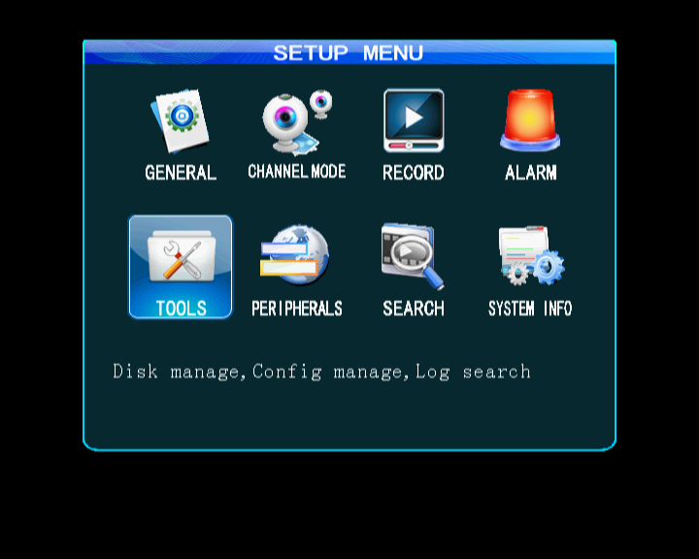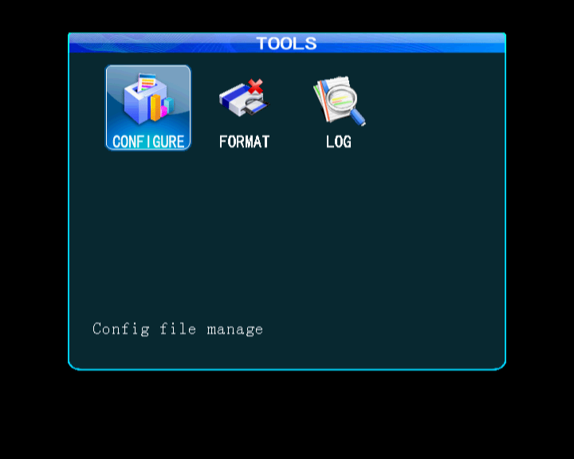
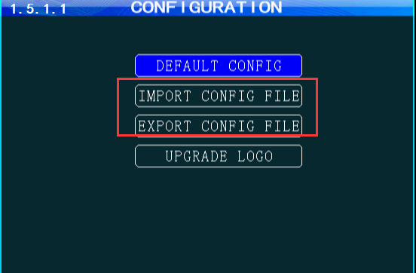
There are some Error messages when import or export configuration file. We could judge the reason by the Error messages.
- Error: “ No U-disk! ”
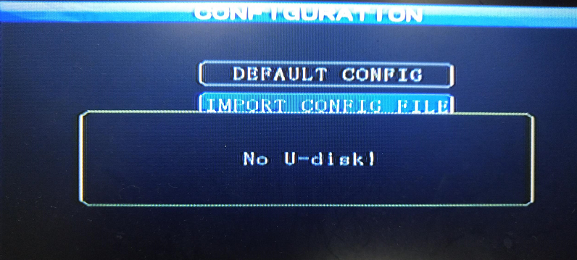
Solution: Please check your U-disk connect to MDVR well.
(SD MDVR should check the SD1 format, connection;
HDD/SSD MDVR should check the front USB format, connection)

- Error: “ Open config file fail ! ”
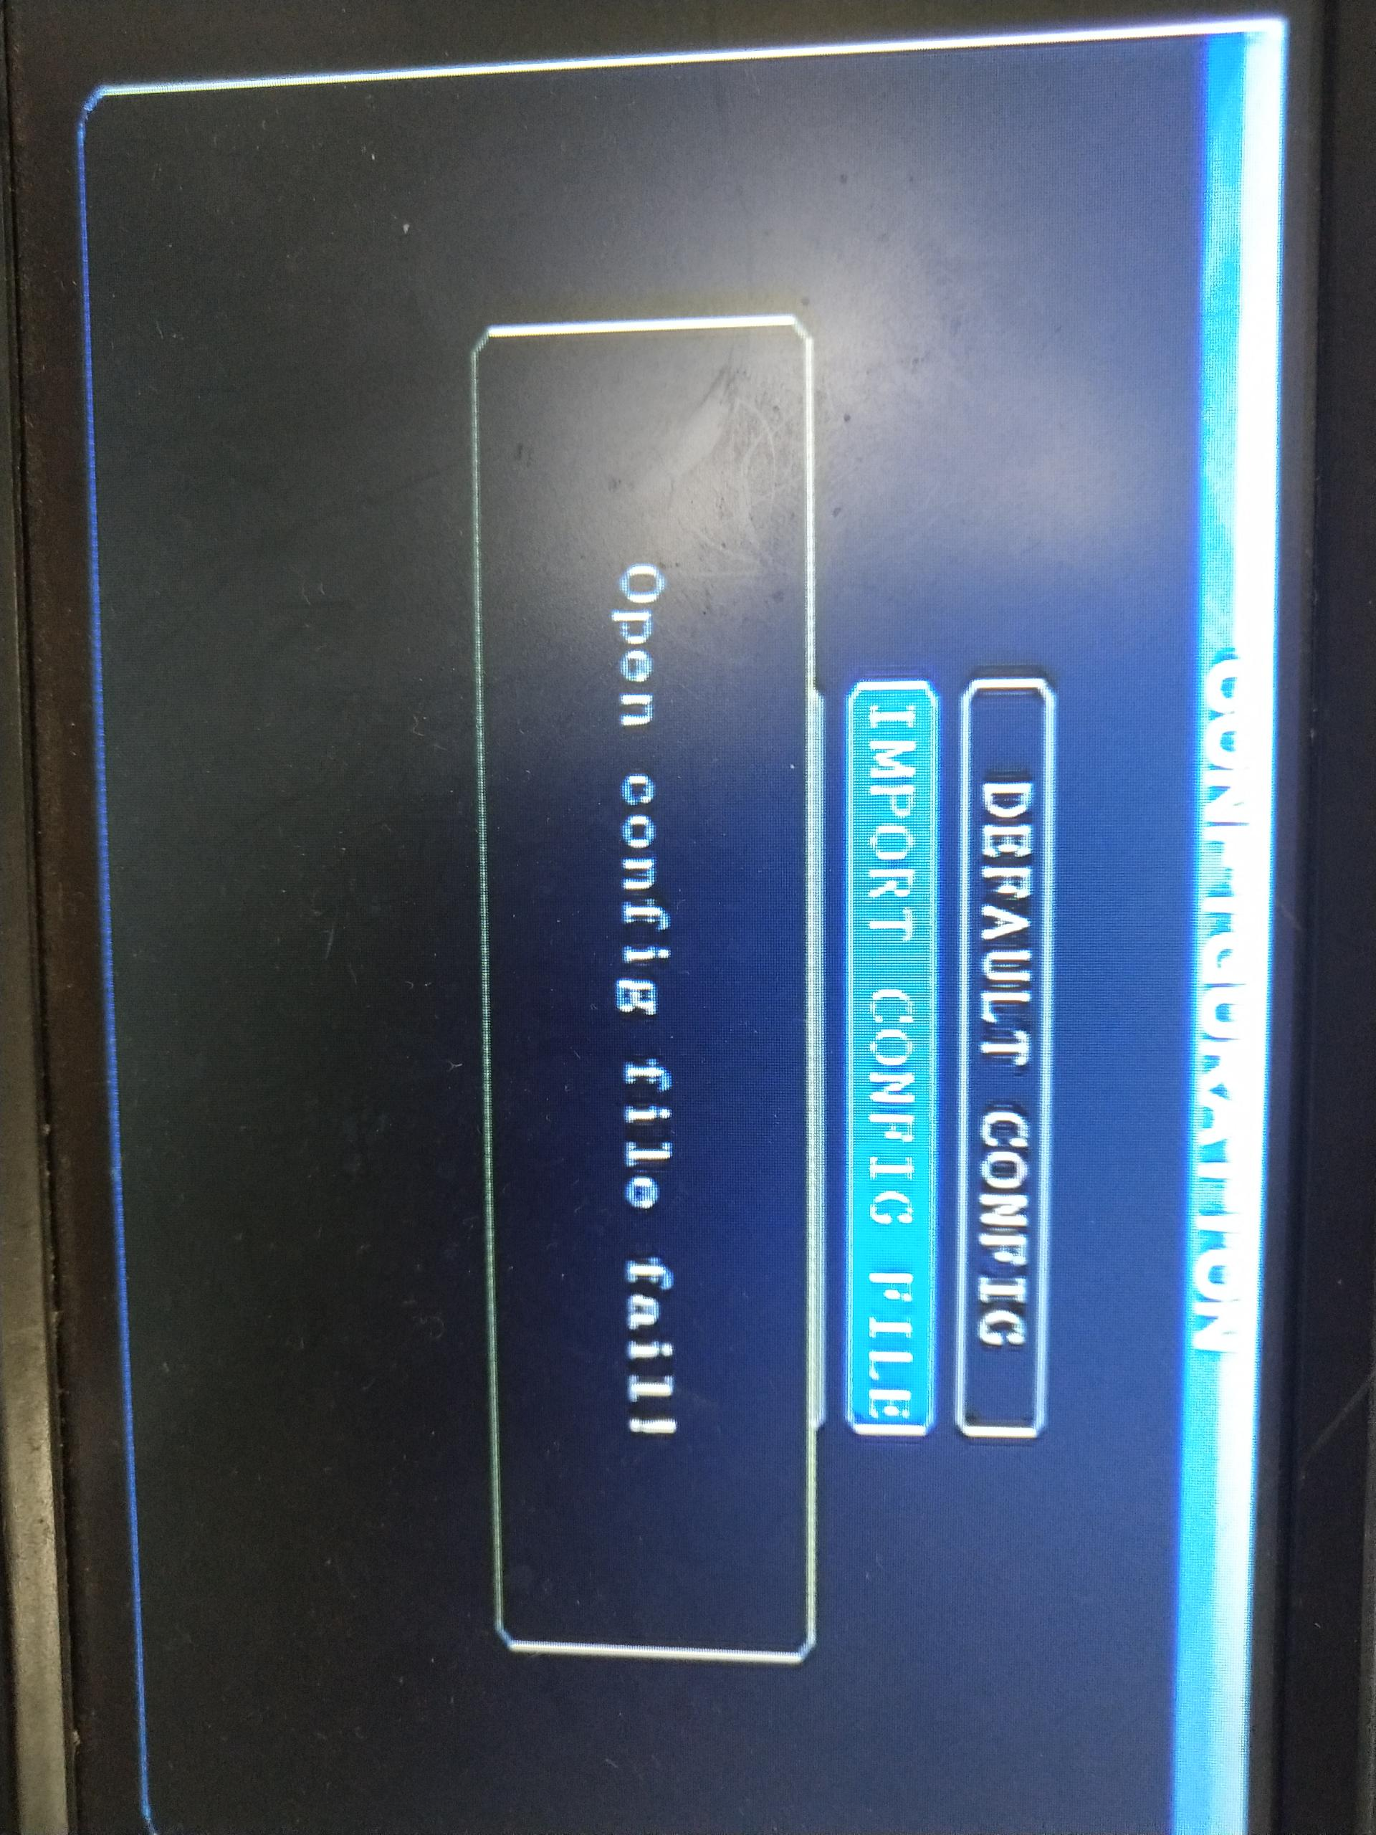
Solution: Please check if your U-disk / SD1 has this configure file.

- Error: “ Load config file failed !”
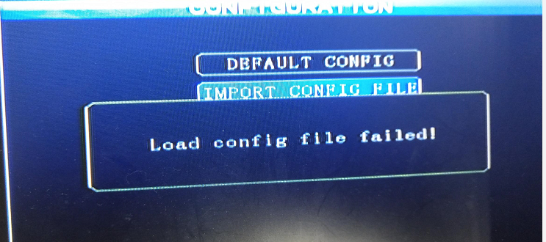
Solution: Please check if the config file was from other model MDVR.

- There will be a message that “ Load config file successful! ” if imported config file successfully.
