How to configure and Manage MDVR parameters abundantly

- There are two normal ways to upload parameters from a master configuration file. The parameters include resolution of video and any other normal settings except Device number.

1.1 Export the config file from the master MDVR to SD card, then Import the config file to the new MDVR.
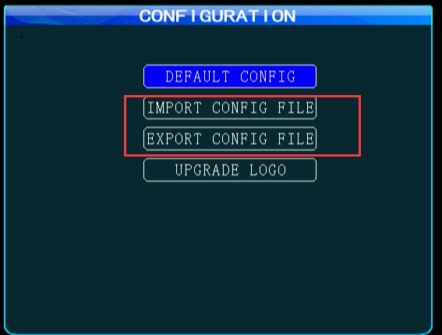
Note: Kindly read the FAQ about the details.

https://www.icarvisions.com/faq/each-error-about-importing-exporting-parameter-file-602.html

1.2 Save the parameters from master to other MDVRs via IVMS Client.
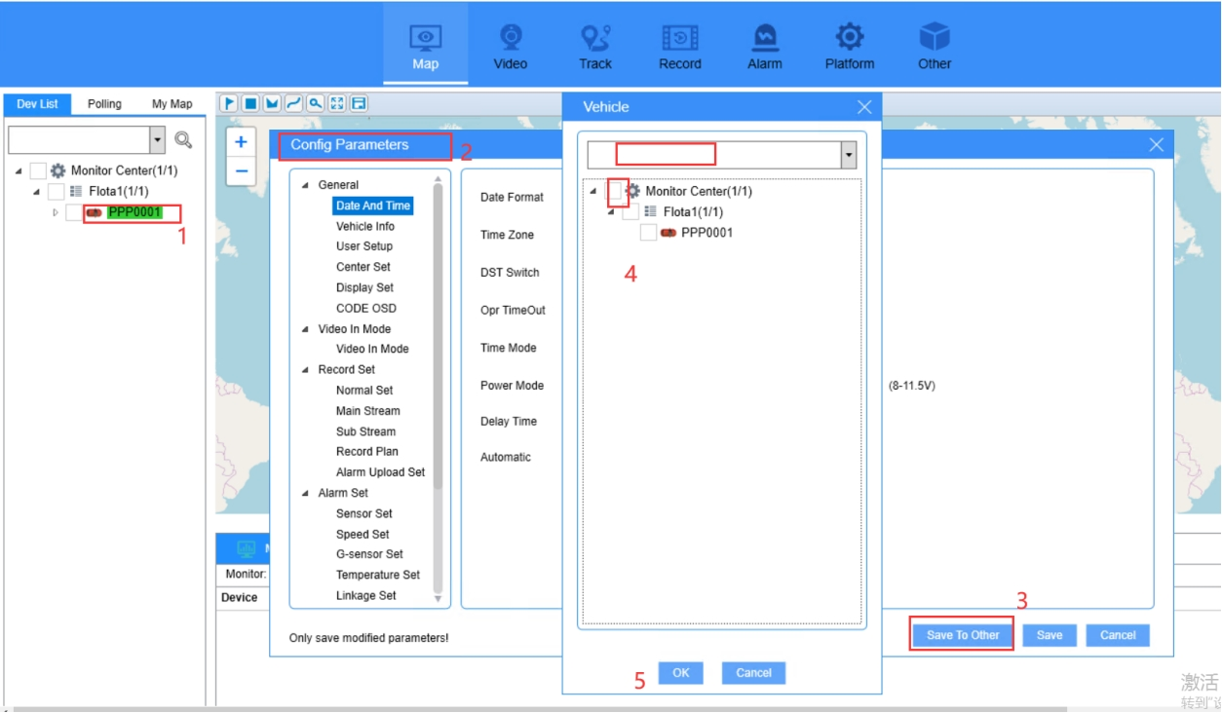

- In order to Manage the parameters of each Units systematically, there are some advice.

2.1 For each purchase order, Customers could send the Device Number list that we can consume ( for example a .txt file with 100 device numbers).
2.2 In the production, ICAR programs the Device Number and the default configuration file.
2.3 ICAR generates a .txt file with the Device Number and the associated IMEI and other important info (for example hardware type).
2.4 Each invoice should include the above .txt or .csv file so Customers could upload to the database.
2.5 The plate and phone number and other parameters could be changed from the IVMS software as 1.2.

