How to solve the issue about “ The car is not located on the map ”
There is the strange phenomenon that the car is not located on the map.

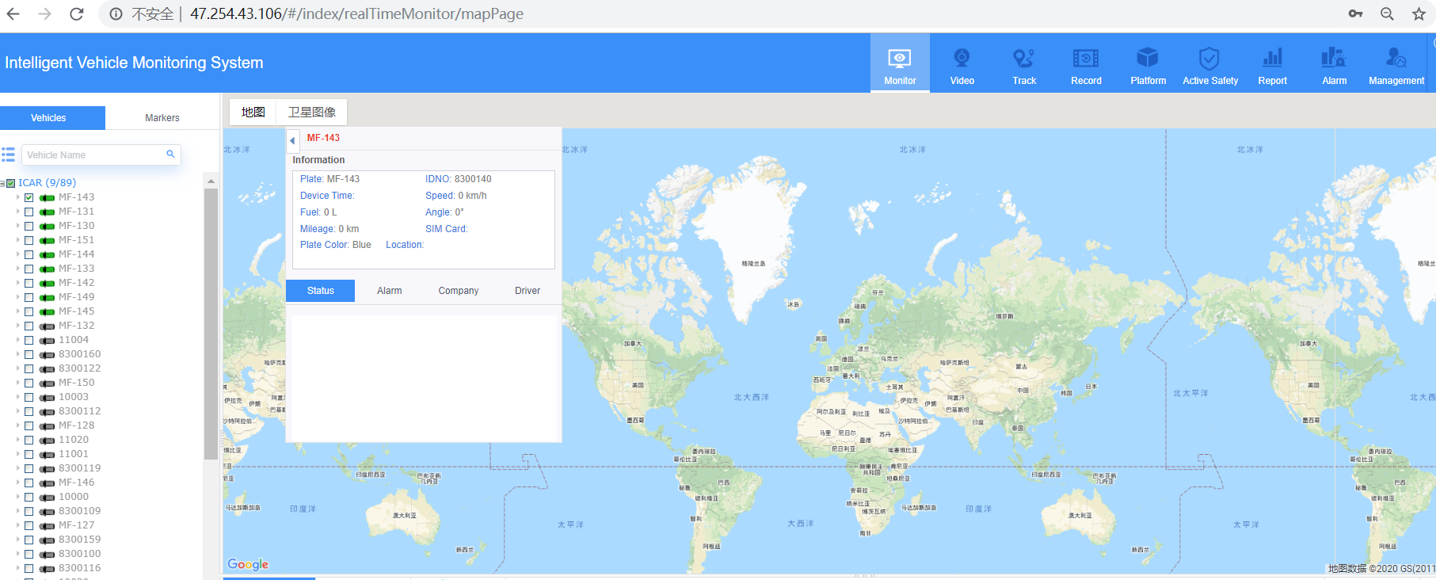

Kindly check the error with F12 or the below picture.
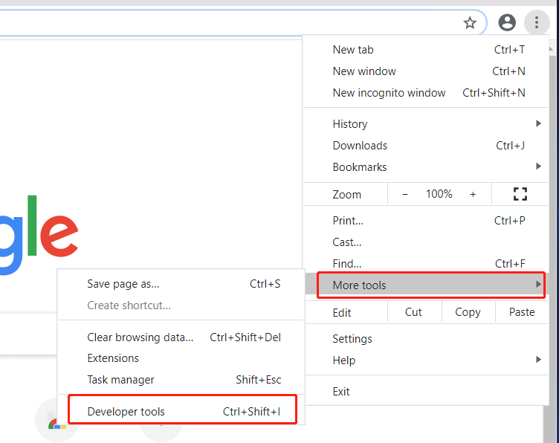

From the error message “ERR_CONNECTION_TIMED_OUT”,

you could check the network configuration, firewall, network security,VPN. etc.
After that, the car could be located in the map as below.
