MCU debug definition of the JH16
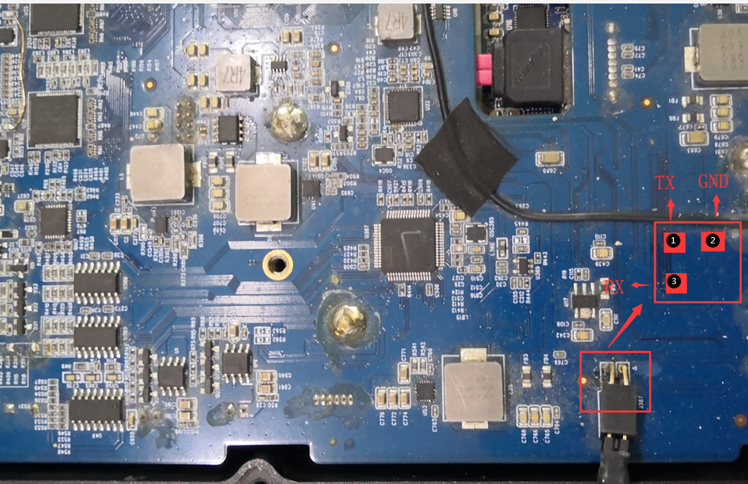
1.The MCU debug port of the JH16 is not at outside, it’s inside the device, mounted on the main board.
1 = RS232-TX
3 = RS232-RX
2 = GND
2.DB9 to USB(pic1) and DB9 to 3pin MCU(pic2), see the following pictures.
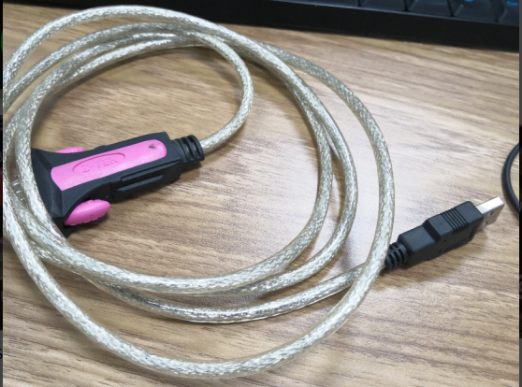pic1
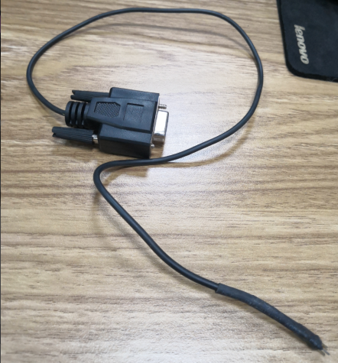pic2
3.The DB9 to MCU and it’s definition.
MCU DB9 female port(pic3 and pic4)
1 GND -->> 5 PIN
2 (null)
3 DEBUG_TX_232 -->> 2 PIN
4 DEBUG_RX_232 -->> 3 PIN
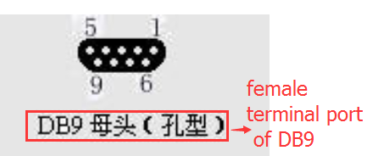pic3
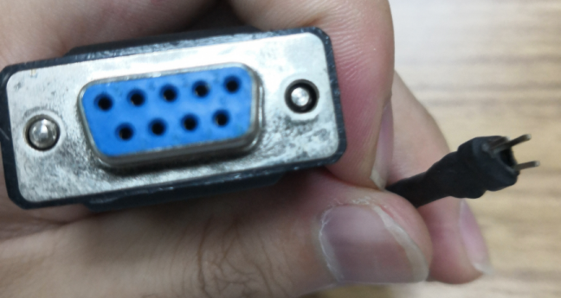pic4
DB9 female

