How to fix the IVMS Client show SD card not exist alarm all the time
1. Use your account login the IVMS Client, then check the device status first, you will find this alarm as below.
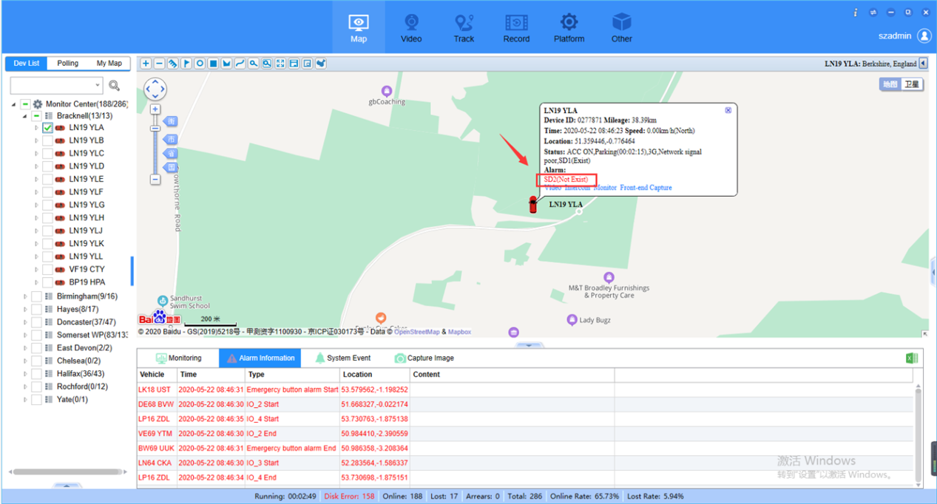
2. Click Other option, then choose Alarm Filter icon, then choose the Disk 2 no exist option, save it.
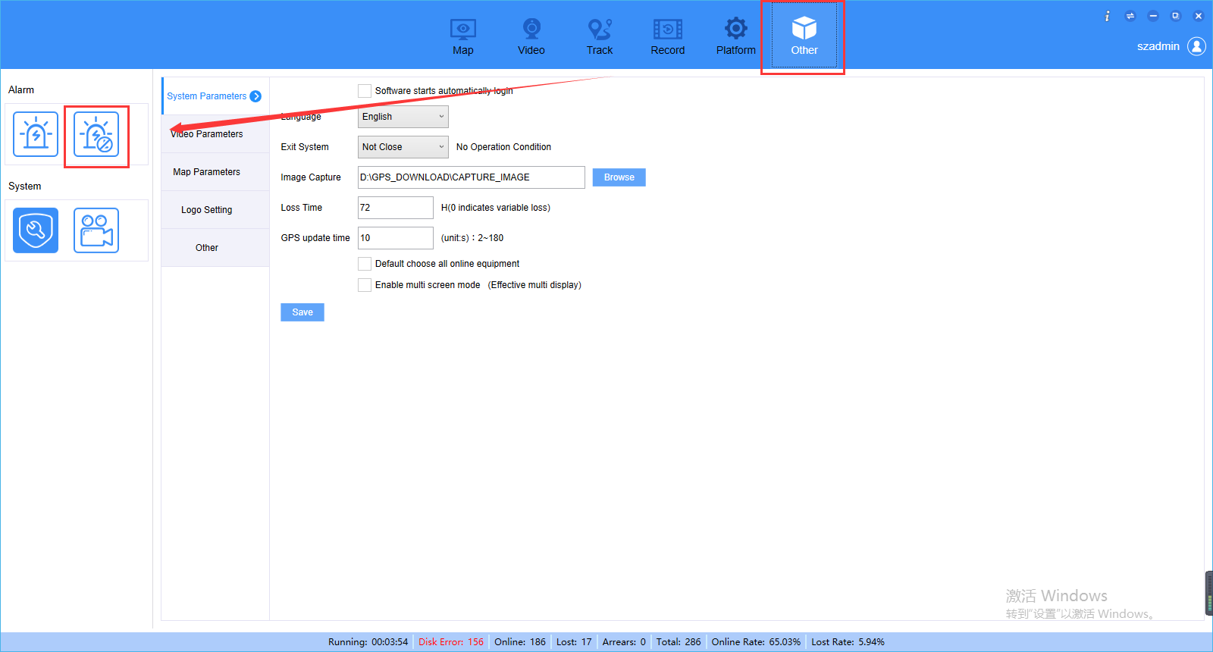
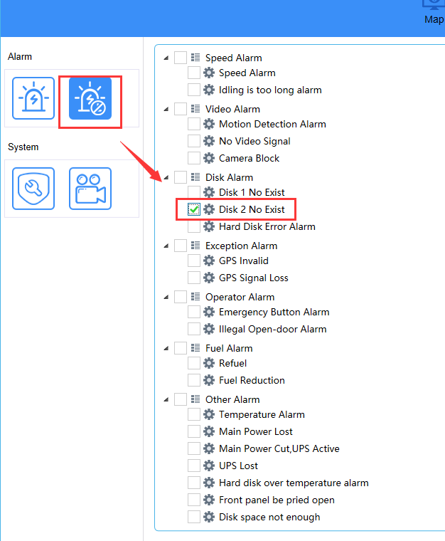
3. Restart the IVMS Client, then you will find the alarm had disappeared.
