How to check the User log from web side
1. First, use your account login the web, make sure your account have all the permissions, if it do not have the report option, please use the next higher level account login.
2. Click the Report option, then choose User log, it will show some table at this side.
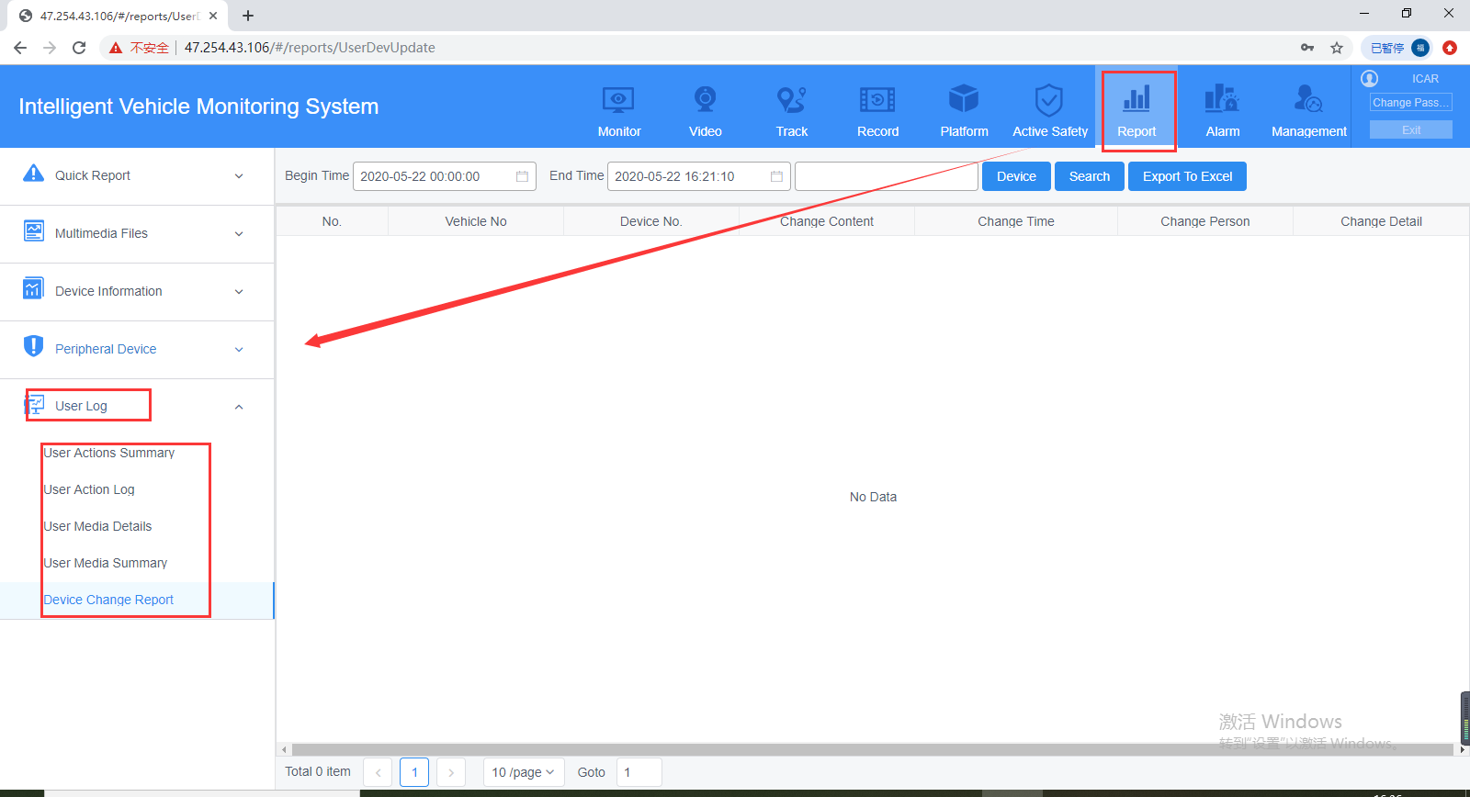
3. If you want to check who change the device information, you can choose Device Change Report to check it, it will show as below.
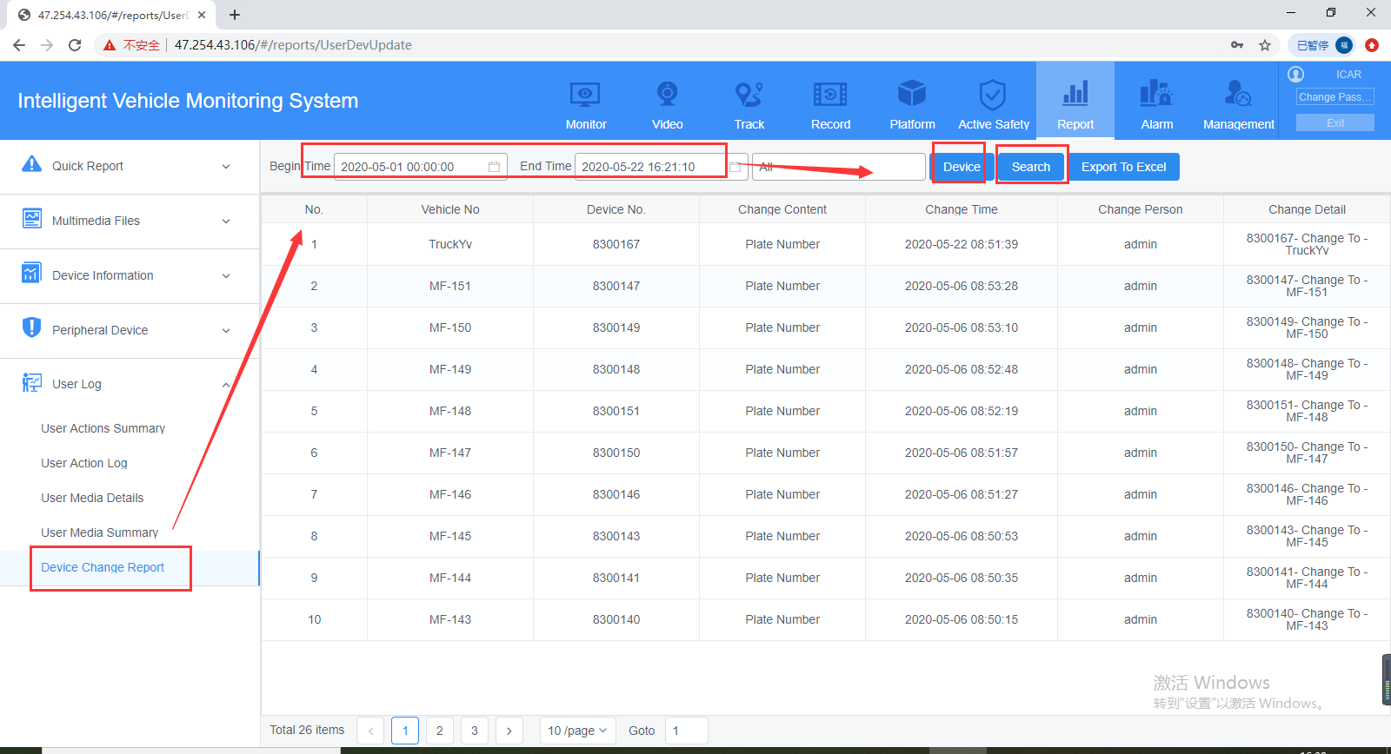
4. If you want to check the 4G data which MDVR use, you can check the User Media Details report, it will show as below.
