How to reduce the RAM of MongoDB
There is a phenomenon that the MongoDB using too much RAM. It will cause the Windows respond slowly and etc.
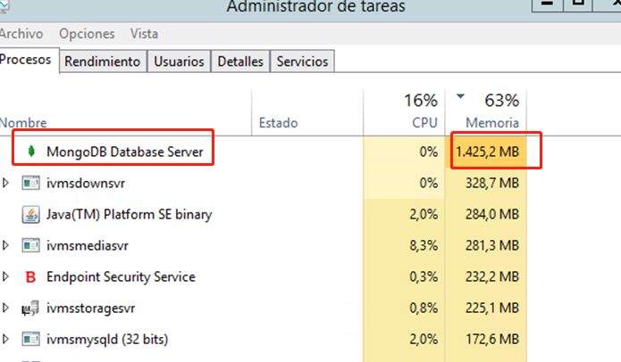

Here is the way to limit the RAM of MongoDB.
Please add the sentence “ wiredTigerCacheSizeGB=0.4 ”.
Note: 4 means 4GB.
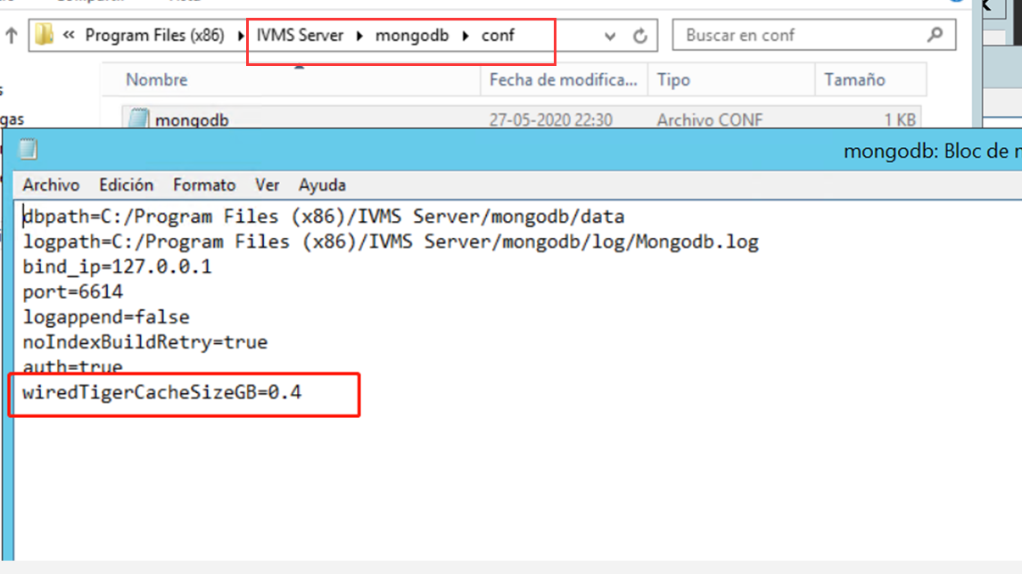

After that, the RAM of MongoDB has been reduced.
