WIFI cluster deploy solution
1.For hardware requirements
IF need install 100 devices for the WIFI download task, can refer to the following recommended suggestion.
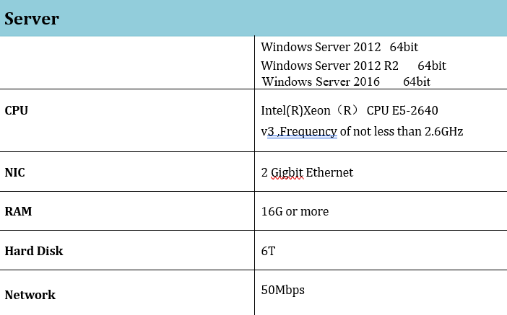
Main

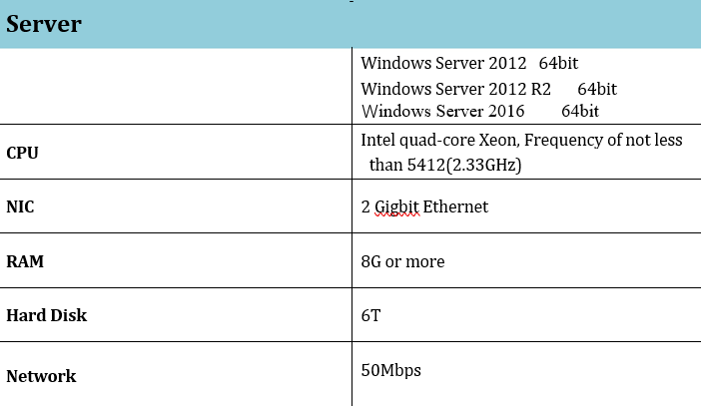
WIFI Server

For the WIFI cluster, to finish 100 devices’ download task, we suggest establish 4 Server PC, one is for running the whole IVMS Server services and other 3 also doing the download task, so totally, there are 4 IVMS Server in one WIFI download group.
And we suggest set up 4 AP stations, cause there are 100 devices, and every hour, every AP station need download around 250GB videos. So when set up 4 AP station, will make WiFi download cluster. Every download station use different SSID, same with the different group devices. And for the AP station, we suggest if use the signal amplifier, it will improve the efficient of the AP.
2.IVMS Server WIFI Cluster(Settings)
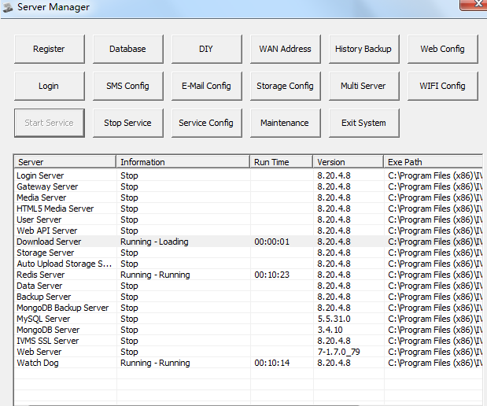
For main IVMS Server:
For main Server, for the Server Manager, need run all of the services. And for the cluster, the WIFI should be inside the local network to improve the download efficiency.
For WIFI IVMS Server:
But for WIFI cluster Server, can only run Download Server, Redis Server and Watch Dog to reduce the download pressure of the main server.
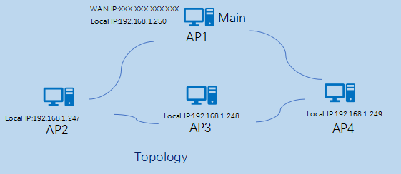
WIFI Cluster FAQ:
https://www.icarvisions.com/faq/use-cluster-to-wifi-download-570.html

