How to capture using IVMS Client
There are two method to capture.
- One is Front-Capture, you can set at two different place.
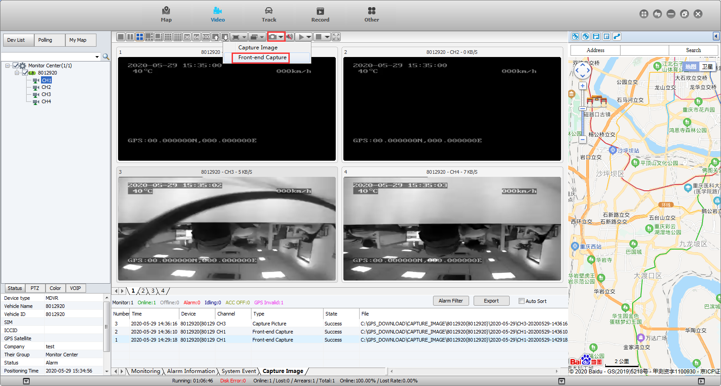
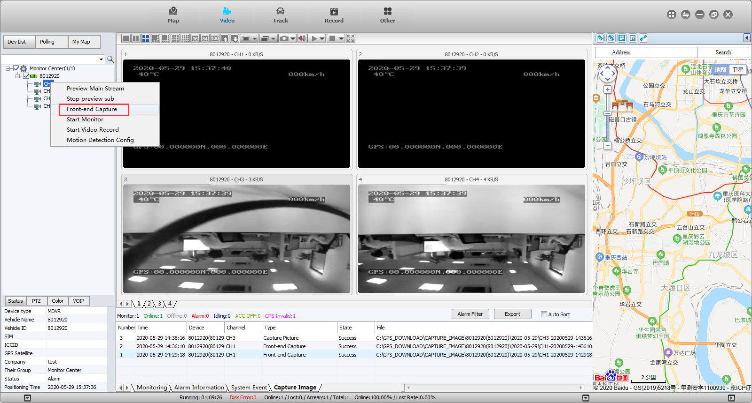
- Set direct capture.The second way is to right click the channel and will see the capture option on the list.
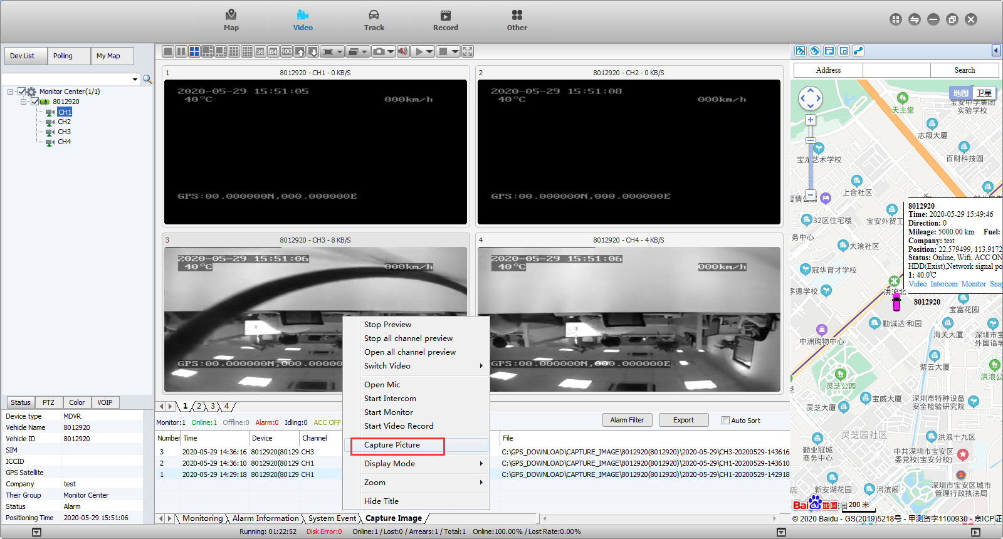
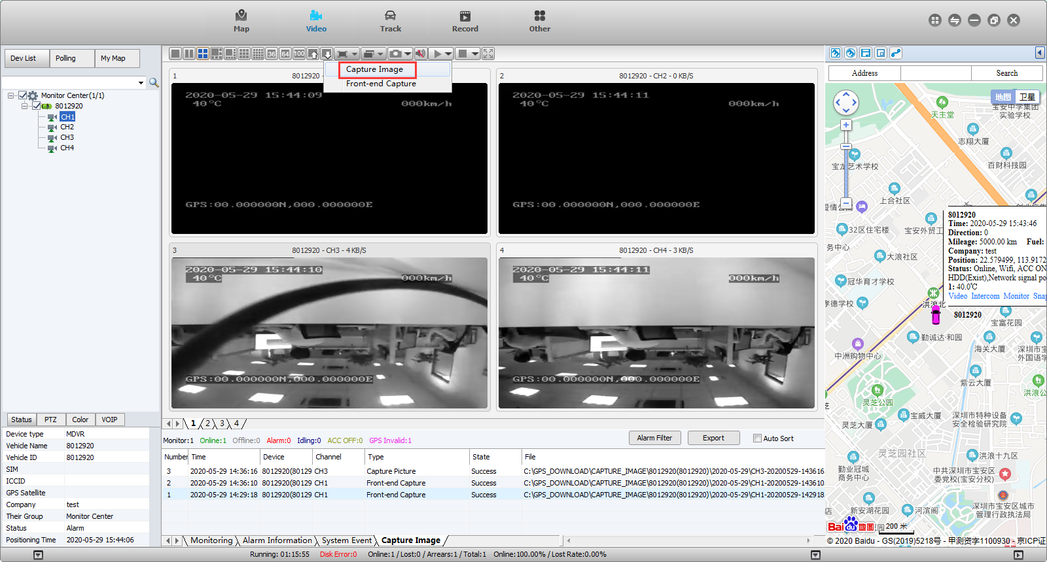
- The difference of this two method is that Front-Capture will photo at MDVR side, and then the photo will be uploaded to the PC. But if directly capture, it means capture from the channel.And both ways, can see the capture when you click the path.
