How to send TTS to MDVR
- Config the TTS option on the web.
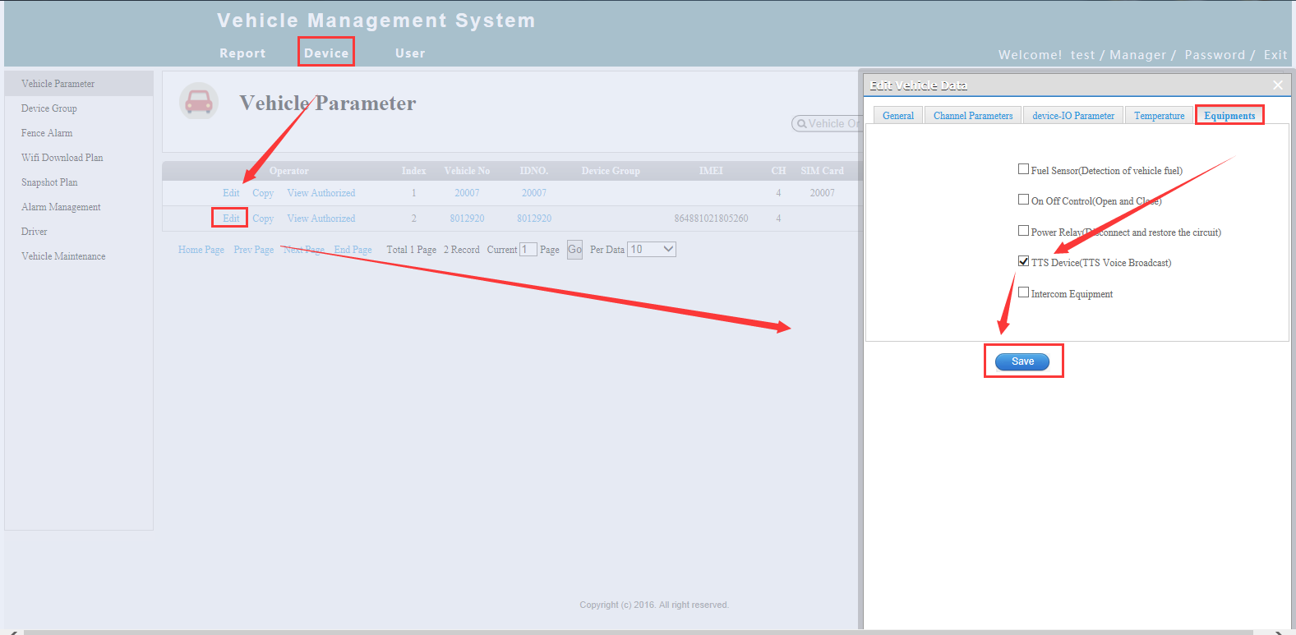
- Login the IVMS Client and right click the group.It will show TTS Voice.
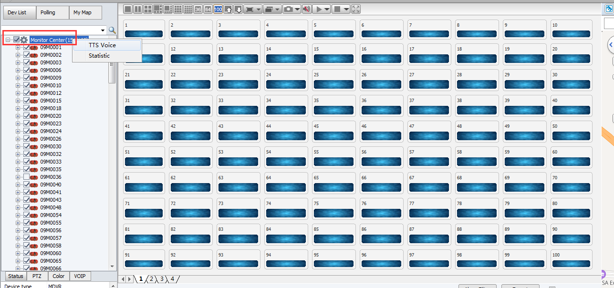
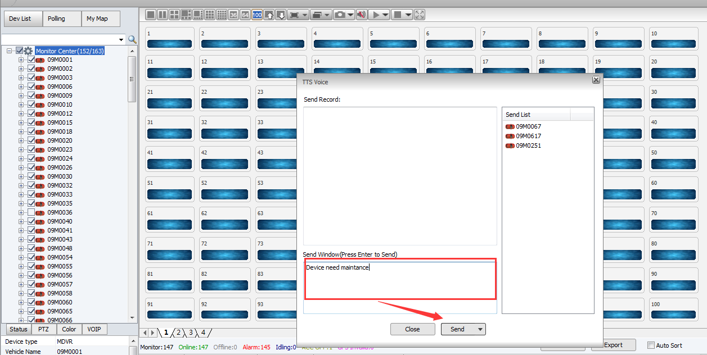
- When finished the settings, please test the function. If send the TTS successful, the device will show the notice from the IVMS Client.
