Installation Steps:

Please remember the version of MySQL.

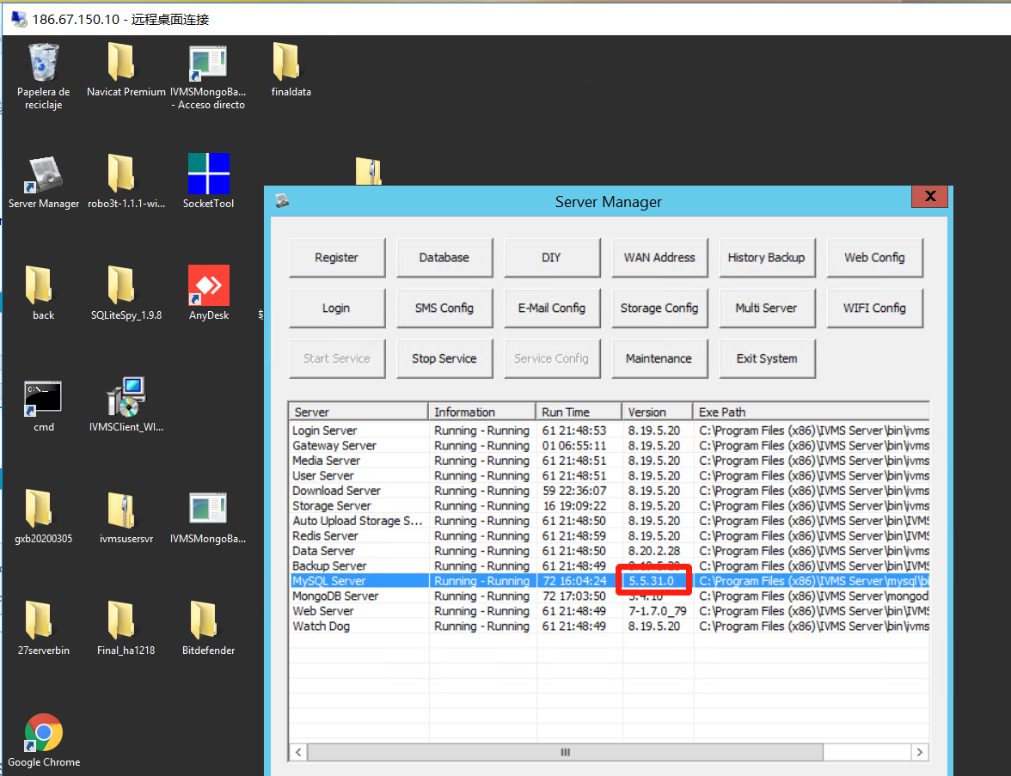

MySQL Installation.

IVMS Server Installation.

MySQL Independent installation

Select language
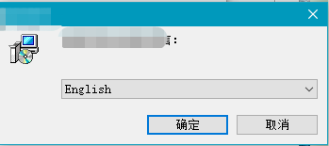

Select the installation directory
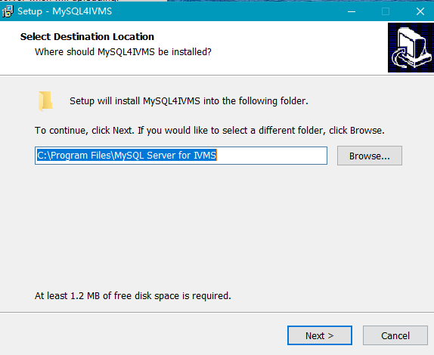
Note: the installation directory doesn’t need to be same as the server program.

Select MySQL version
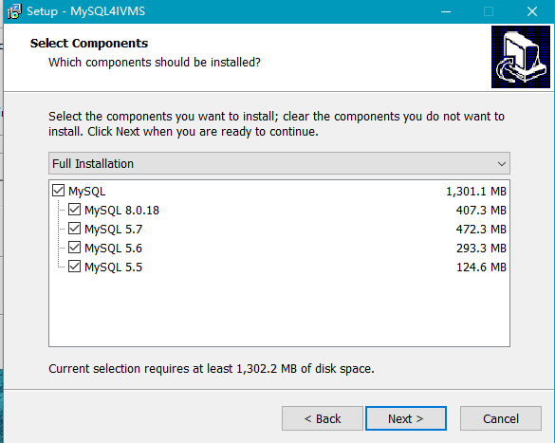

Other settting
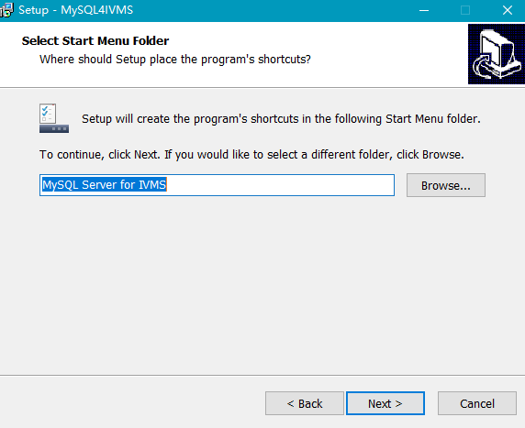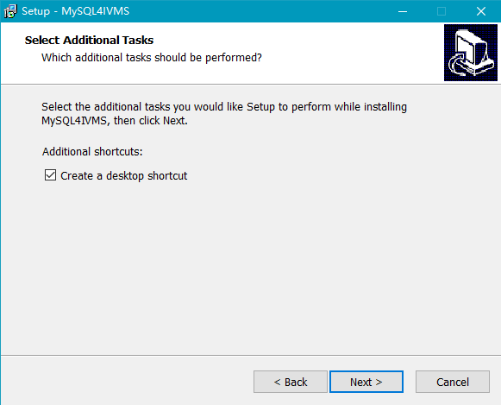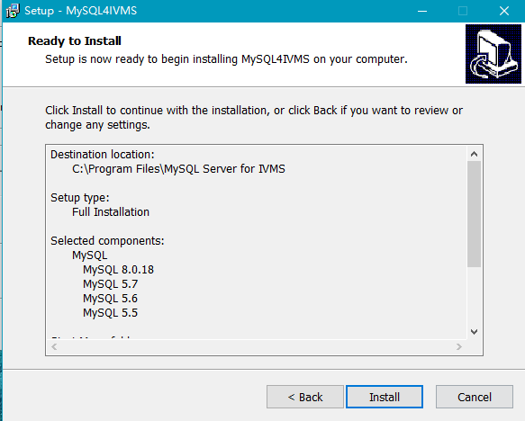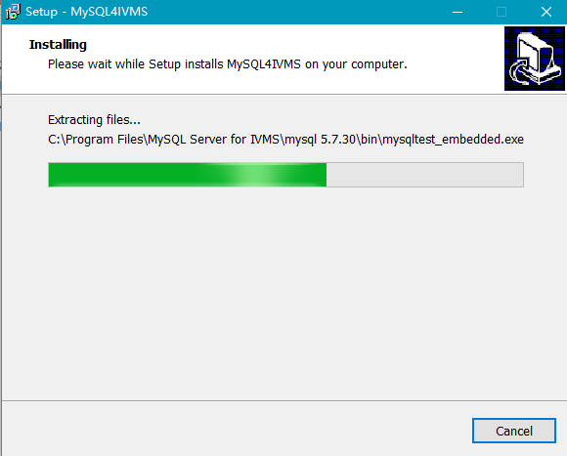

Installation finish
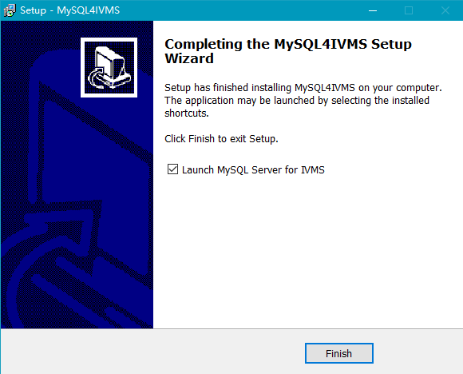

MySQL server configuration

New adding service
Click the adding button from interface of server managing software

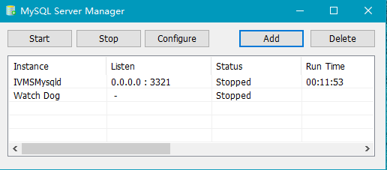

Server configuration
Service: the name for service (cannot be repetition)
MySQL version: select the version need to start according to the original version
Data path: MySQL data path
Note: if select old MySQL version, it can use original data path(need to uninstall old MySQL), the defaulted data path for old server is ……\IVMS Server\mysql\gserver_dbdata
If select new MySOL version, it is need to use upgrade tool to import data, and use new data path.(cannot uninstall old MySQL before import data)
Port: that one database using(cannot be repetition)
Binding address: database IP

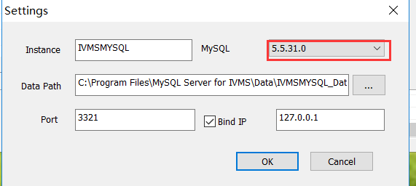

Start service
The database service and watchdog will be started automatically after configuration is ready.

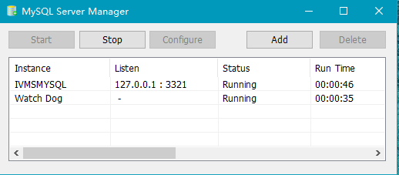

IVMS Server Installation

When install server, fill in IP port, click test, showing”OK” means ready.
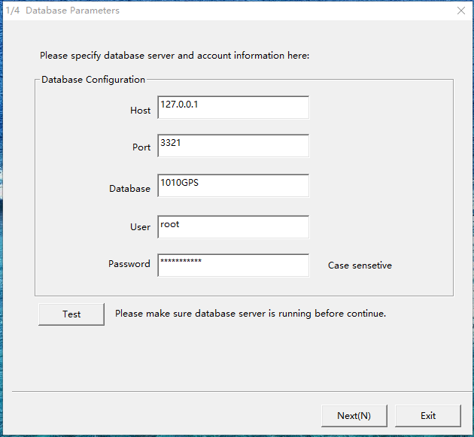
Note: It is recommended that upgrade it on weekday if you want to upgrade Product Server. So that our engineers could answer and help immediately if you have any question.

