How to fix IVMS web server frequent write error file
When we use the newest server, we will find the web server running very slow sometimes, there are so many logs inside the tomcat side, this make us can not check the device status quickly, and can not login the account from APP side.
1. First, stop the IVMS Server and open the installation directory, you will find many error files as below.
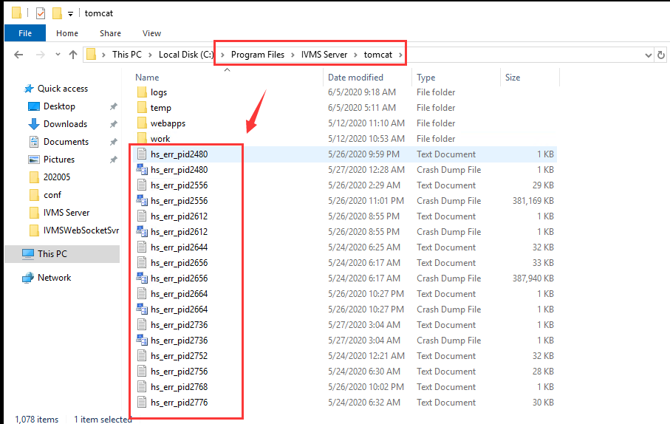
2. Find this config file, then change the setting like this.
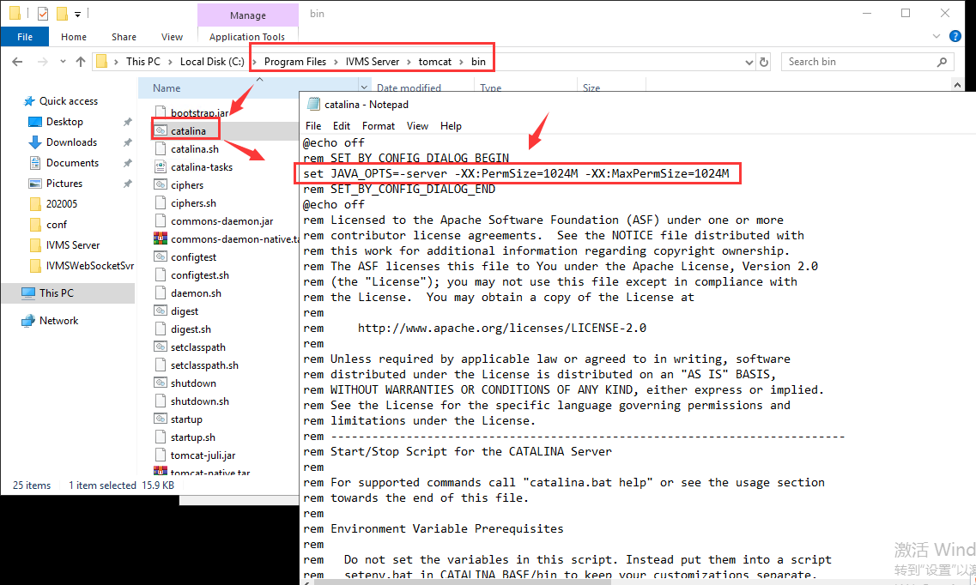
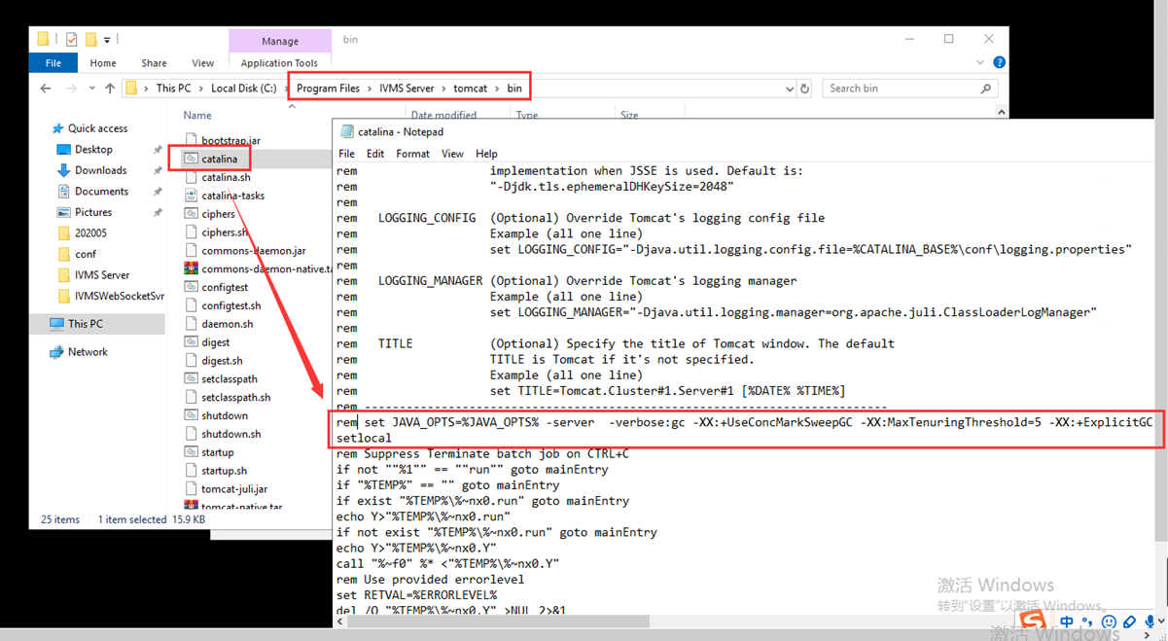
3. After change this, restart the IVMS server, you will find we can login the web quickly.

