How to check the image dark corner problem
1. When we connect the camera to MDVR side, we will find this error form AV-OUT side, Same camera connected, CH1&cCH3's video are not same as CH2&CH4.
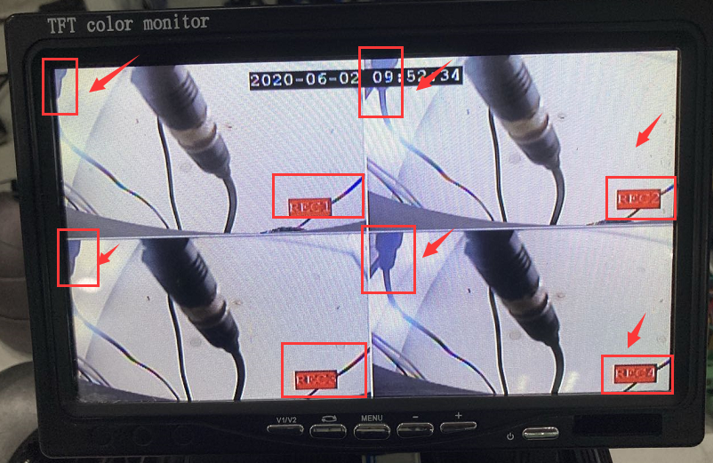

2. If your camera is show like this, you can preview the video via IVMS Client or playback the video at MDVR Player side. If it shows same for each channel, then it means the video do not have probelem, only the av-out to monitor have some problem.
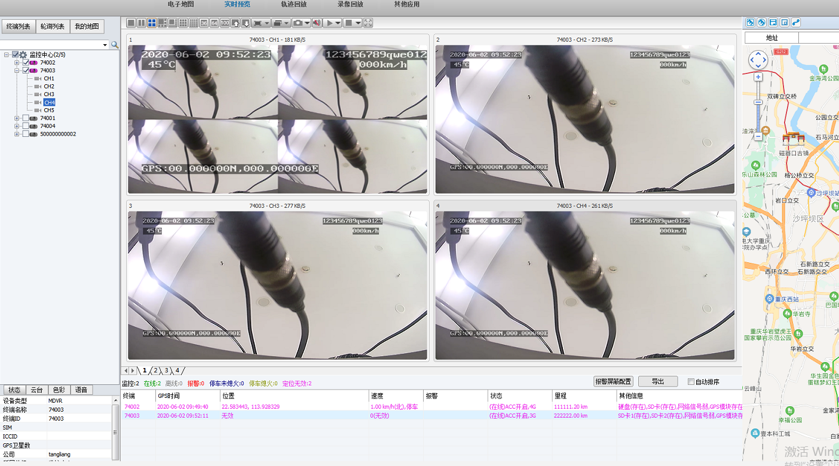
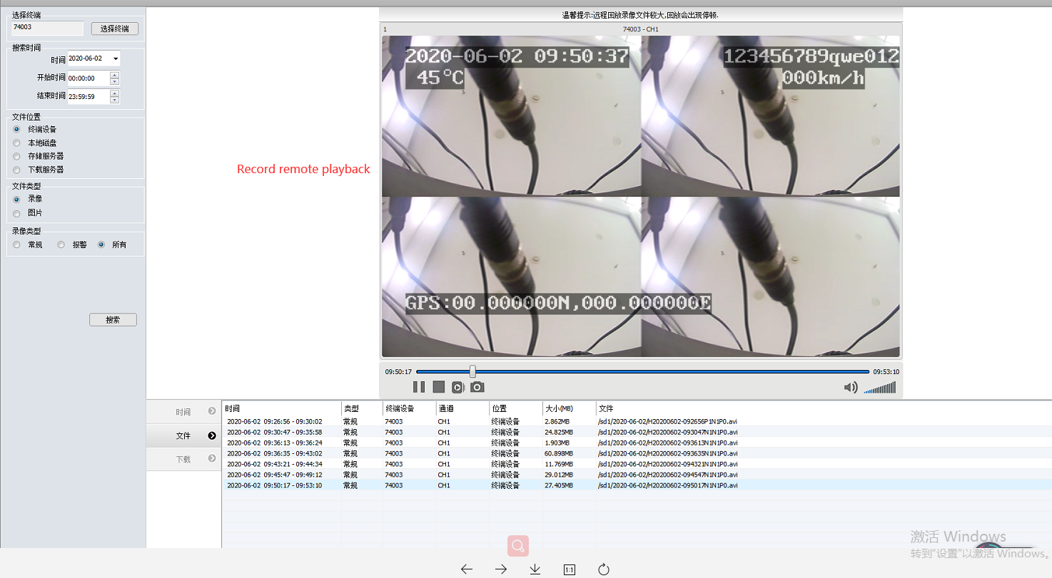
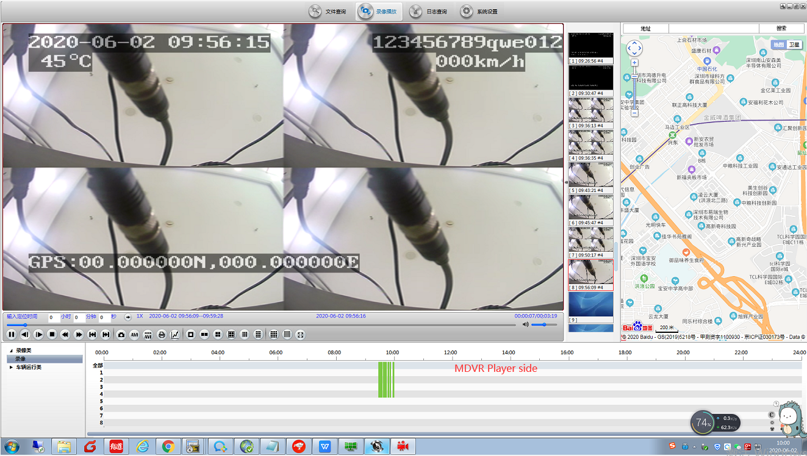
3. If the IVMS client and MDVR Player show same as the MDVR side, maybe it is the camera problem.
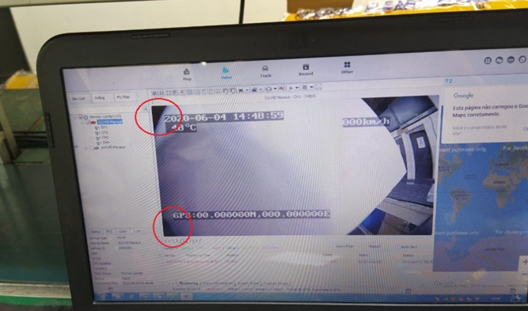
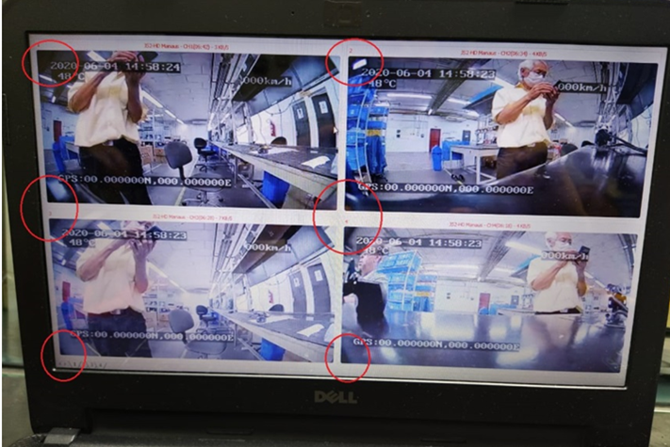
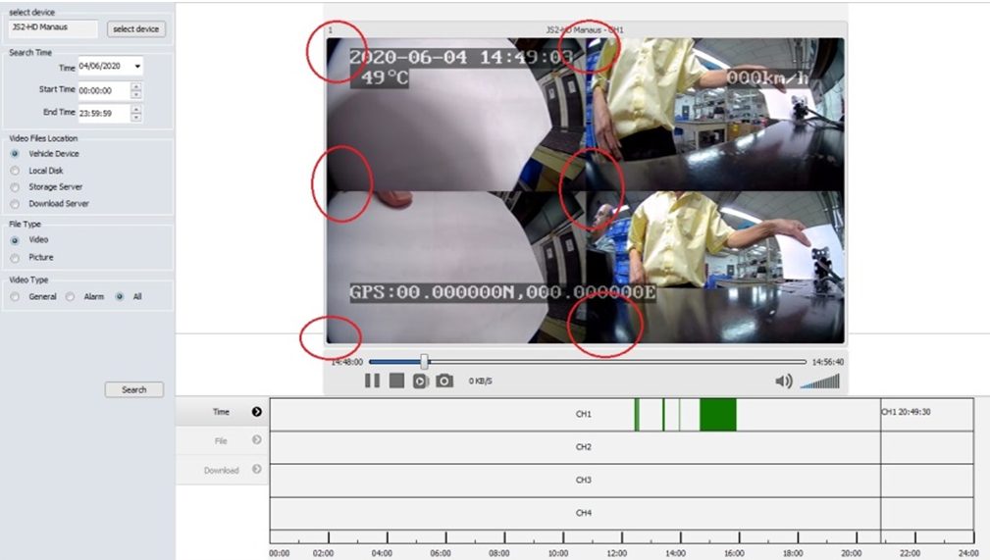
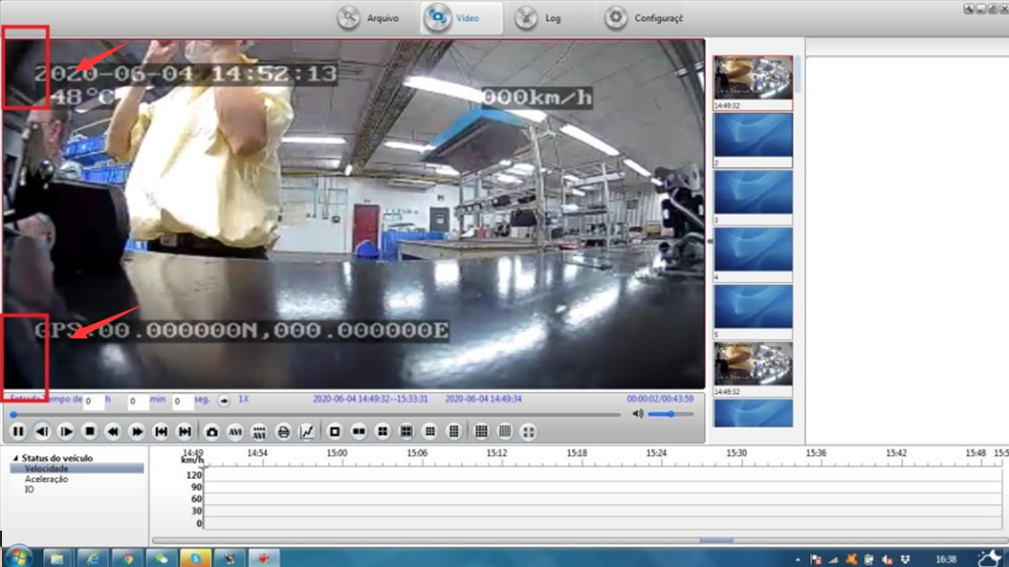
4. You need to checke the camera lens and sensor are match or not, you can try to connect the camera to the monitor without our MDVR, to see if it still like this, if it still show like this, it will be the camera problem.

