How to search the Statistics and details of ADAS and DSM

There is the steps to search the Statistics of ADAS and DSM.

- After you login your Server in web side, please click the “ Active Safety”.

- Then you could see the Statistics data about ADAS and DSM. You could also select the month you want to read.
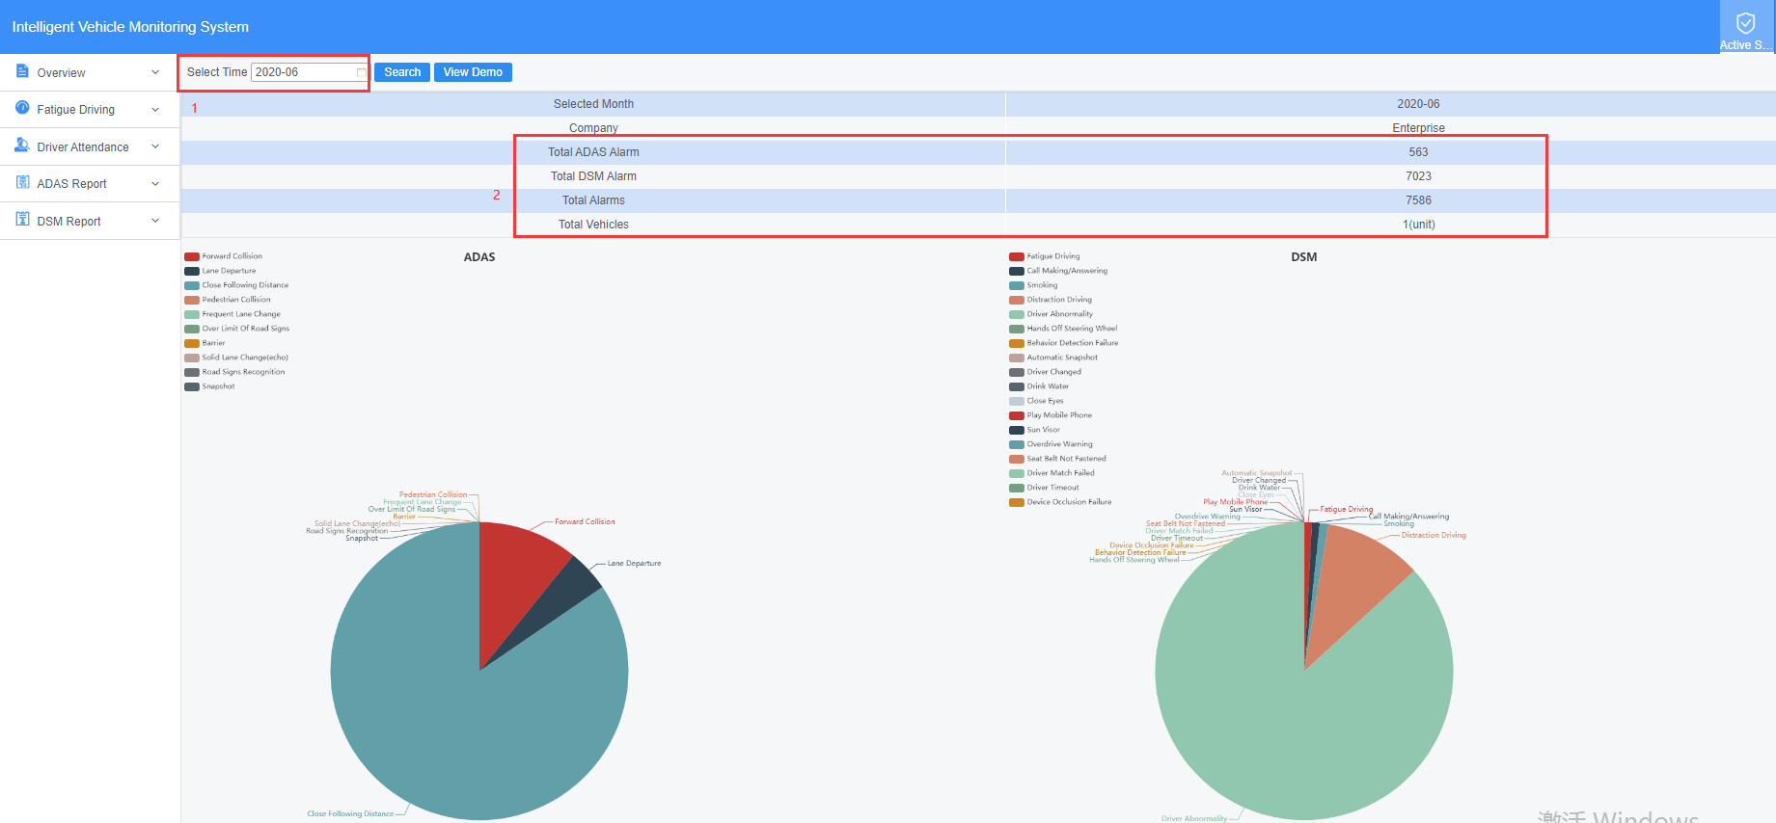

- You could search each ADAS / DSM alarm statistics by day or minutes.
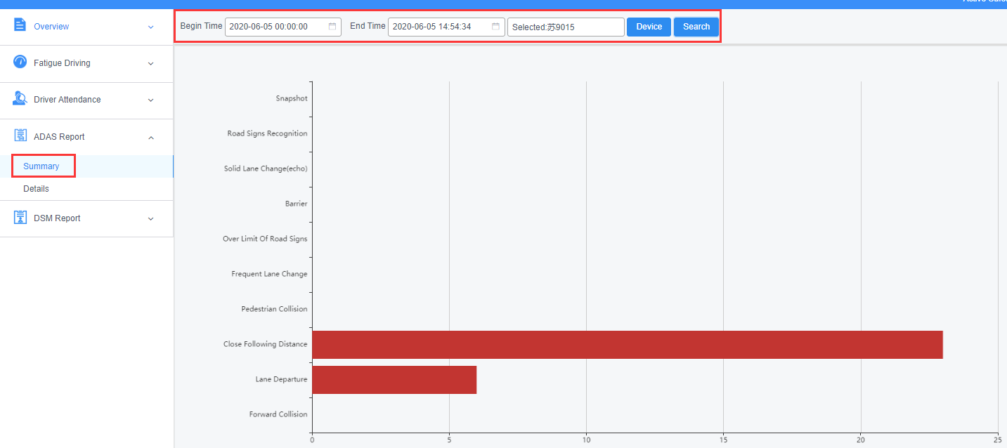
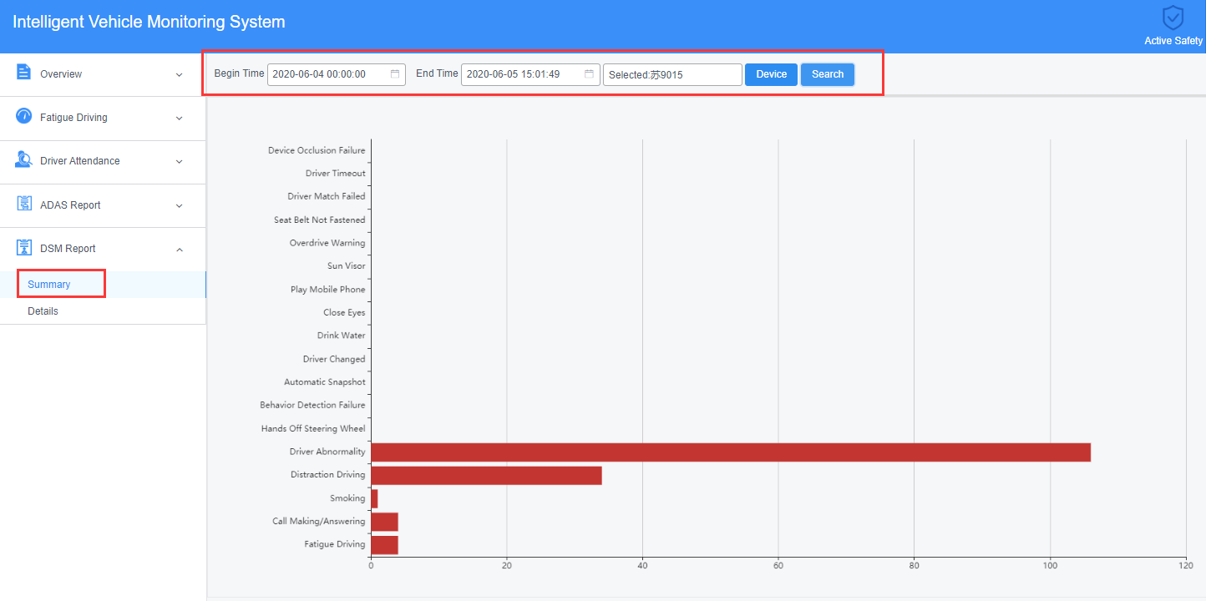

- If you want to learn more details about each ADAS / DSM alarm such as Plate No, Alarm type, time and position, speed etc, you could search and download the recording files as below.
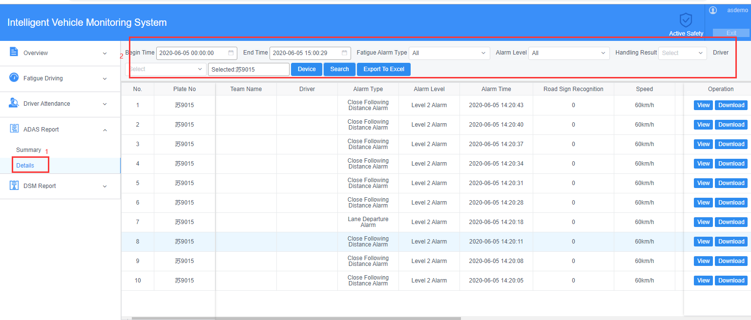
ADAS details.

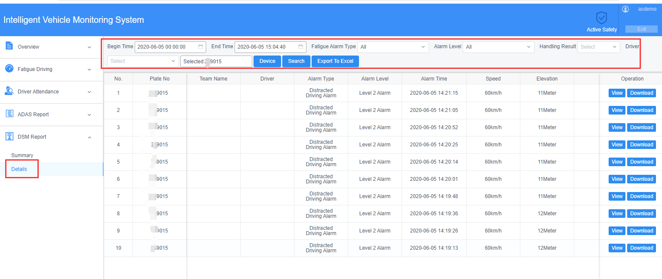
DSM details
- After you downloaded and unzip the alarm files, you could watch the alarm snapshot and alarm video recording.
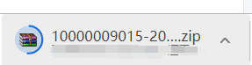
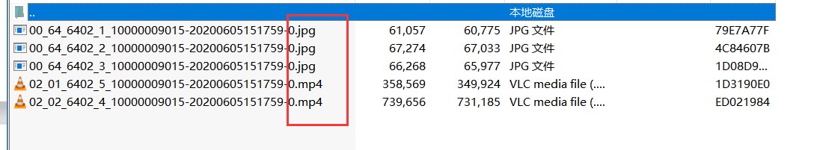
Download and Unzip files

