How to solve Web Server failed issue
There is a strange phenomenon that login Server failed and web Server can not run normally.
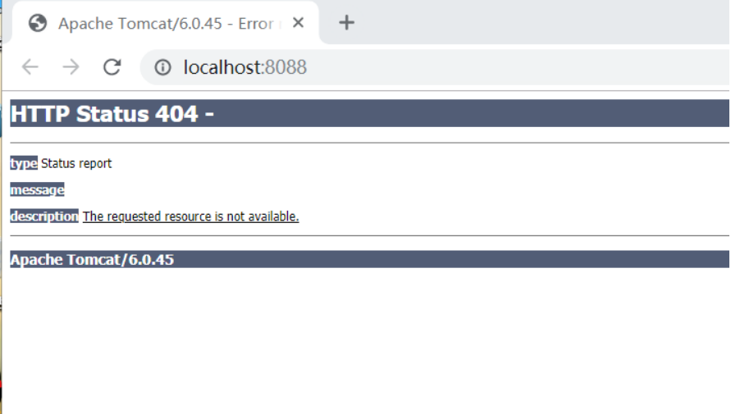
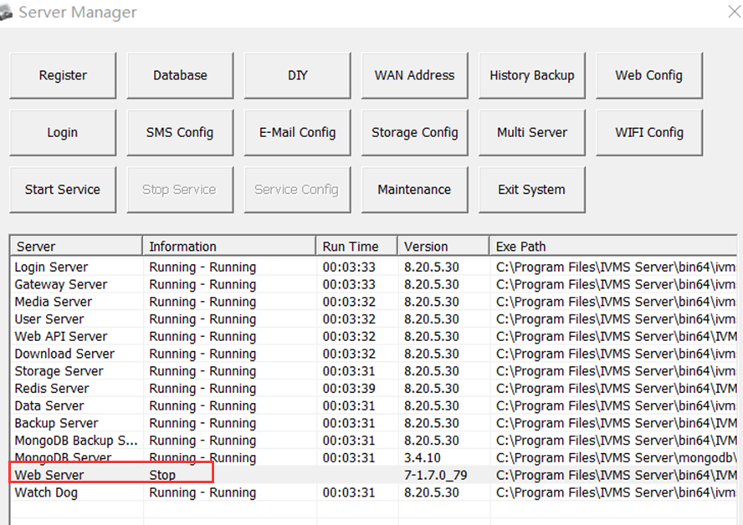

Please select the correct version of IVMSMYSQL as below.
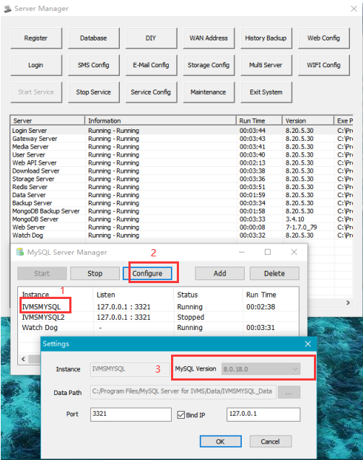

After running the correct version of IVMSMYSQL.
You could login the Server successfully as below.
