How to solve the Web Verification Code cannot be displayed
There is a strange phenomenon that the Web Verification Code cannot be displayed.

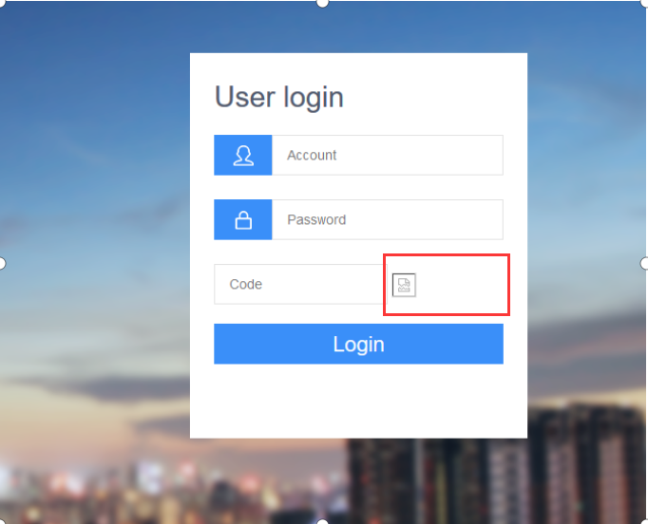

- Please make sure your disk has enough space. Web Verification Code can not be generated if the disk was full.

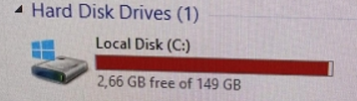

- Please check the Error from the log as the below path.

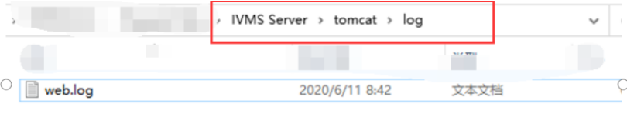

- Different errors have different ways to solve the issue.
Here is one of the Error from the log.
“ Found class com.sun.image.codec.jpeg.JPEGImageEncoder ” .

- We found it is tomcat configuration problem, which is caused not loading JDK information when start up.

- 进入tomcat/bin/ catalina.sh
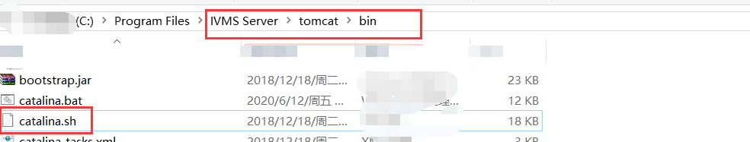
Add JDK configuration in the startup script:

JAVA_HOME=/XXX/jdk1.6.0_26
PATH=JAVAHOME/bin:JAVA_HOME/bin:JAVA
HOME/bin:PATH
CLASSPATH=.:JAVAHOME/lib/dt.jar:JAVA_HOME/lib/dt.jar:JAVA
HOME/lib/dt.jar:JAVA_HOME/lib/tools.jar
export PATH JAVA_HOME CLASSPATH

- Restart Tomcat.
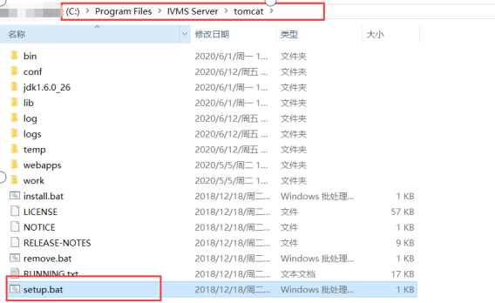

- After that , the Web Verification Code could be displayed successfully.
