How to check the database stopped by memory run out off
- If found that the database is stopped, like the following shows.
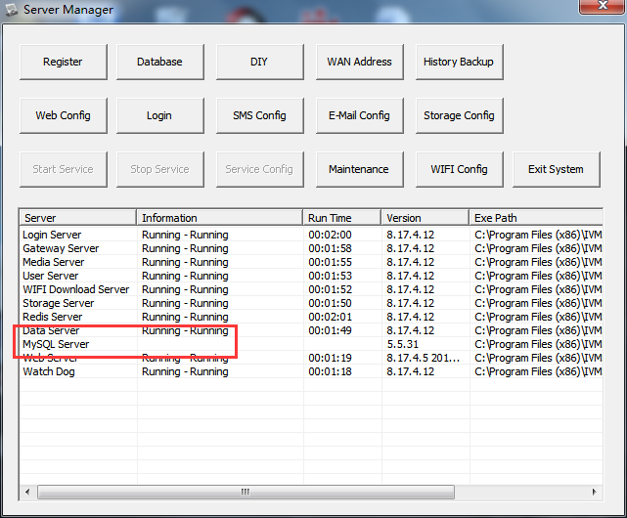
- Normally, you can restart the IVMS Server, and check if the MySQL Server will work or not. If the IVMS Server still not work, you can check the Event Viewer.
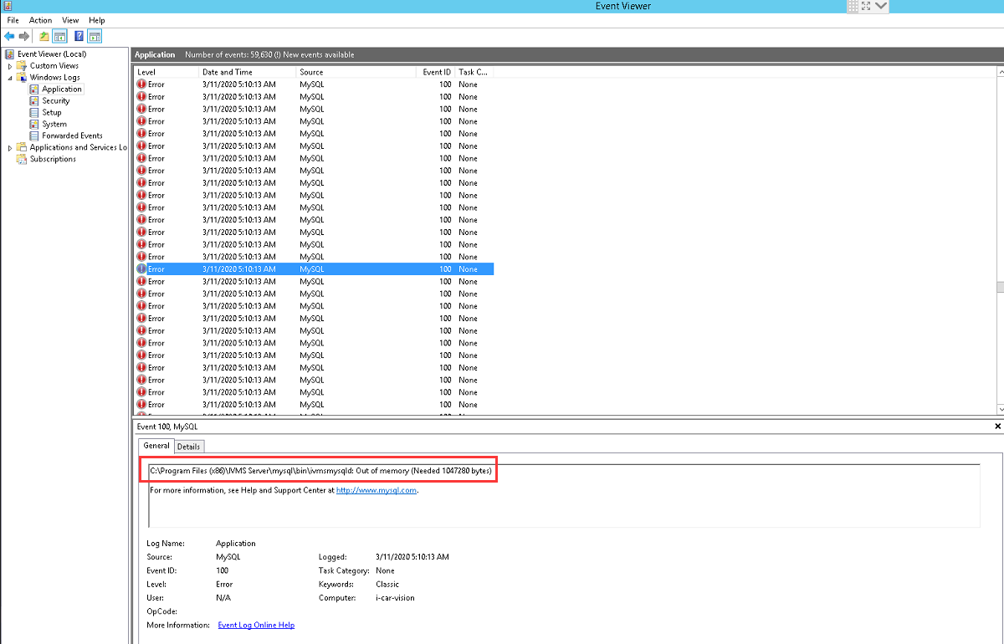
- If the Event Viewer shows like the above, you can enable the IVMS Server to mainntance. And you can also monitor the memory occupy situation.
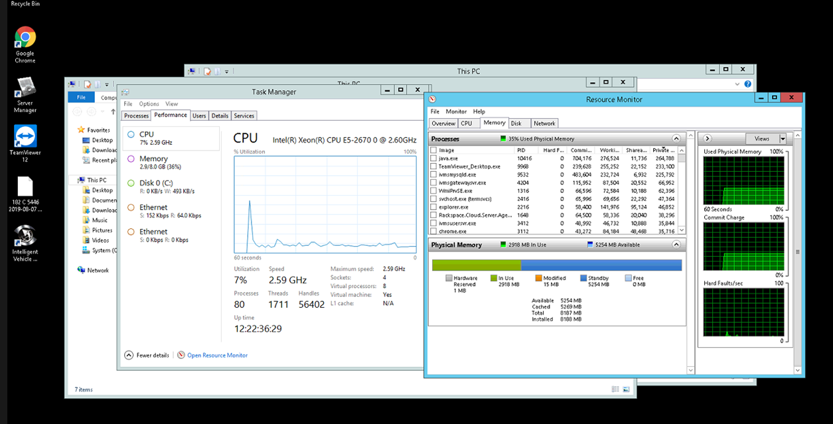
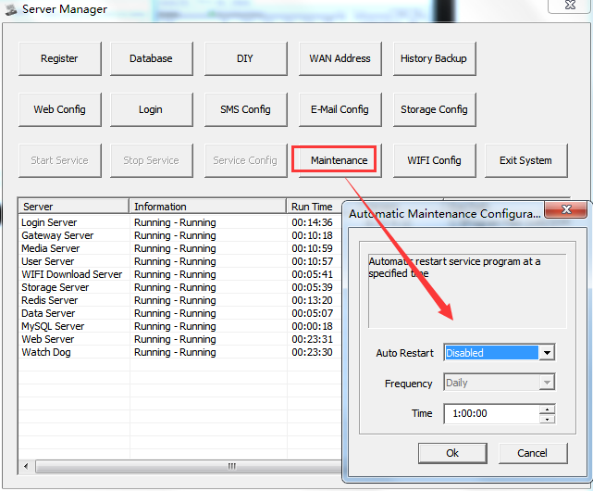
After set the IVMS Server to Maintenance, it will auto restart at the schedule time. This will relieve pressure of the memory of the PC Server.

