How to add KPI website to your IVMS Server side
1. First, download the KPI file from this link, then unzip the zip file.
https://www.dropbox.com/s/b4cd8zuv5lmlm3c/kpi-.zip?dl=0
2. Open the IVMS Server installation directory, then copy the KPI file to this side.
Such as: D:\IVMS Server\tomcat\webapps
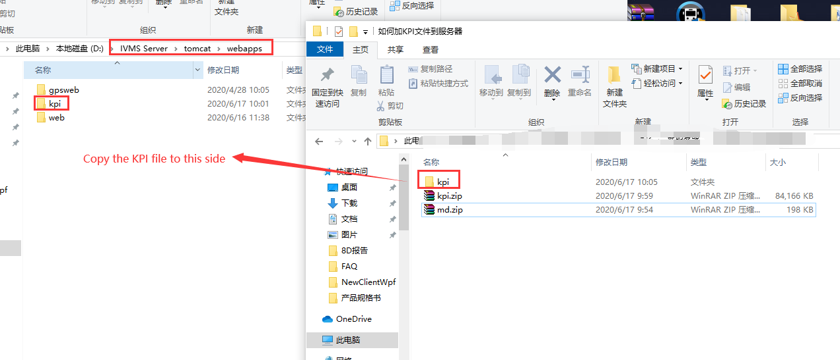
3. Open your server web, then add /kpi/ to the link side, then you can access to the API by using your server IP or domain name: xxx.xxx.xxx.xx /kpi/.
Such as: 192.168.168.11:8080/kpi/
