How to zoom one area in the video using MDVRPlayer
- Open the video using MDVRPlayer.You can open by file or by folder.
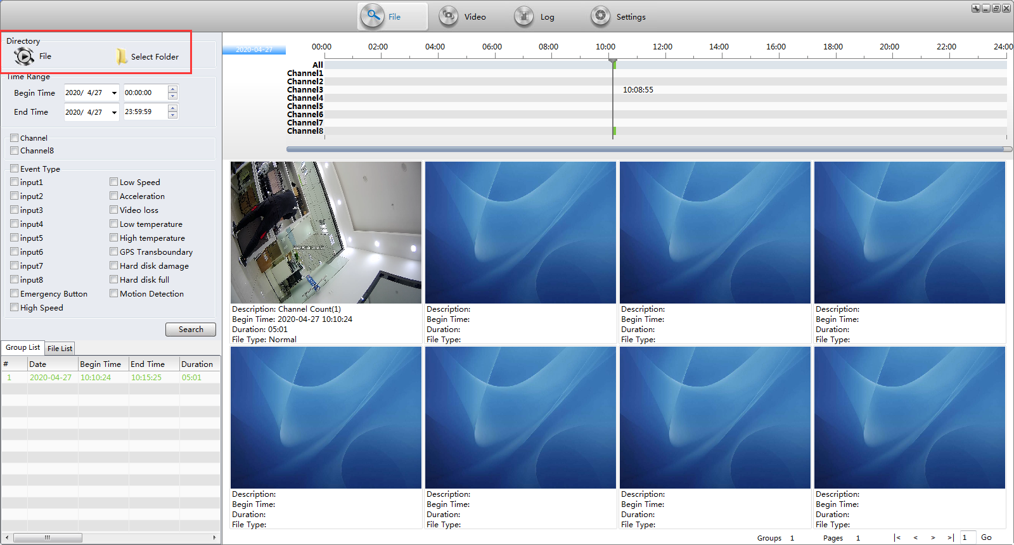
- Click the channel and watch the video.
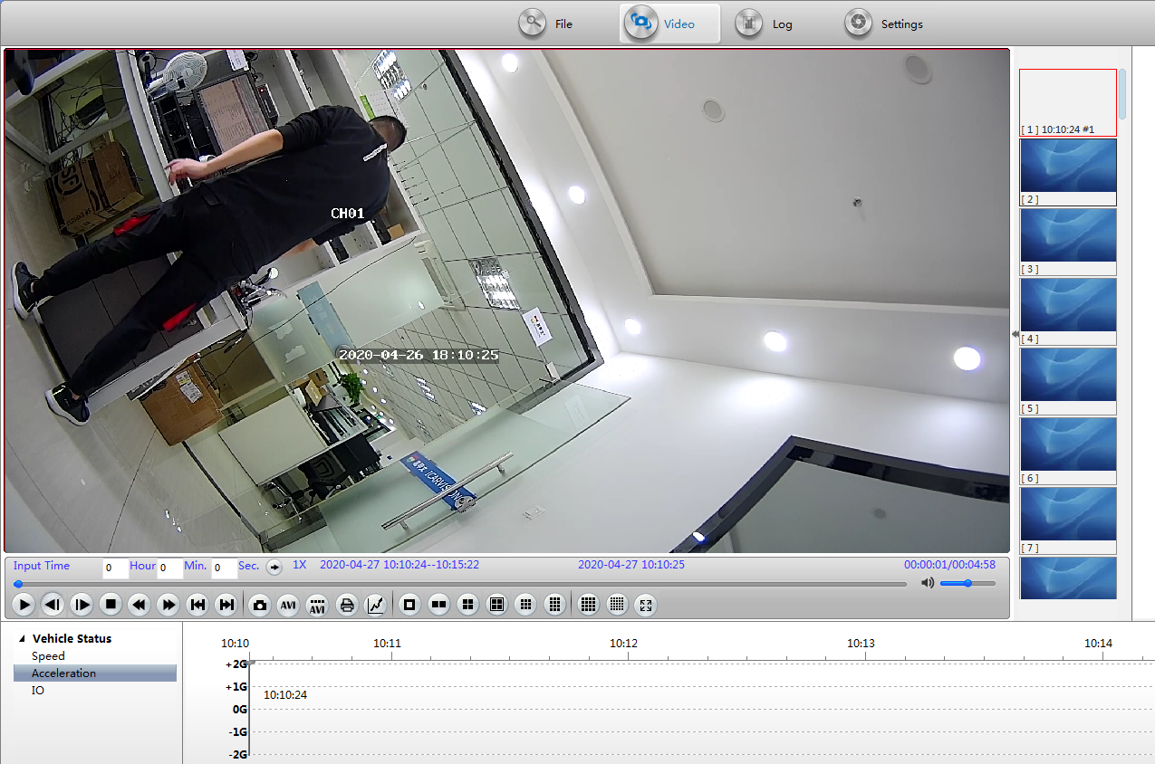
- Select one place of the video and circle it using mouse(left click). And it will zoom the place you marked.
