How to solve the problem that Server keep creating lots of files in Mdump
There is a strange phenomenon that the Mdump folder is too huge.

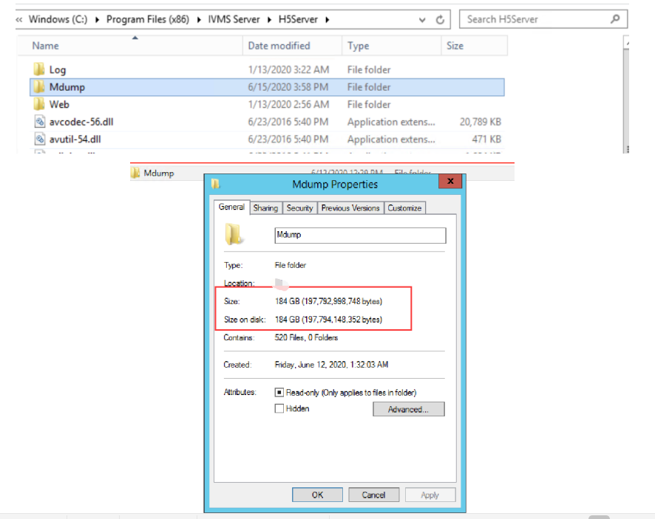

After clicking the Mdump folder, you would found that the files keep creating each minute.

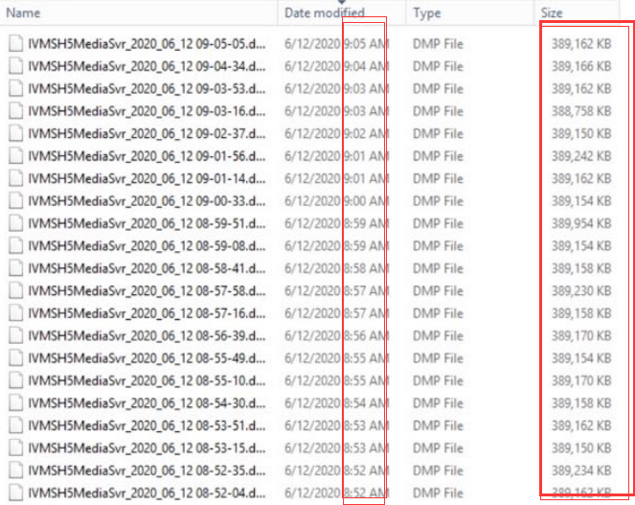
We could see the Error message “ Connect to Redis failed “ from the Log.

So please make sure the port 6619 was not conflicted by other services.

Kindly use these commands to check the port.
netstat -ano | findstr port
tasklist | findstr
telnet IP 6619
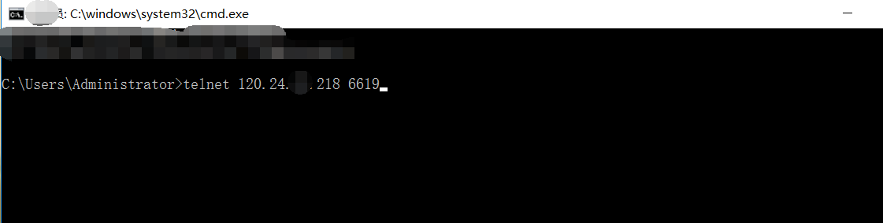

After checking everything about port 6619.
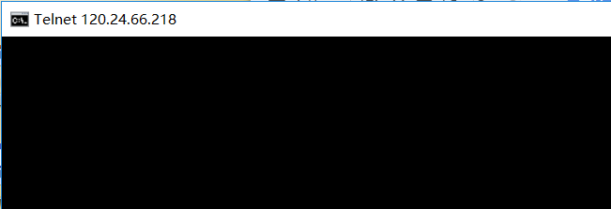

Kindly restart the HTML5 Media Server as below.
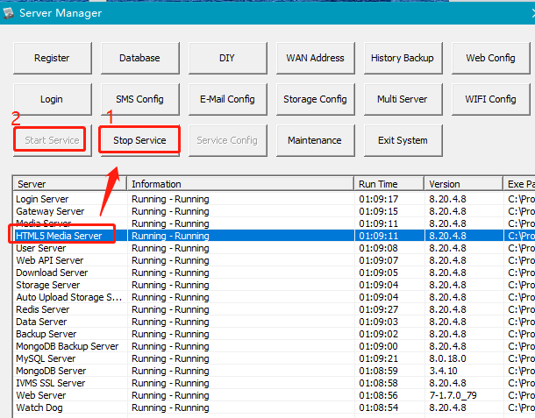
After that. The Server wont keep creating lots of files.
Finally, you could delete the useless files in Mdump.

