How to solve the problem that MDVR failed to upload snapshot to email
There is a strange phenomenon that MDVR failed to upload snapshot to email.
Here is the Error message “ Errcode = -11, ( Net_Error ) ”.

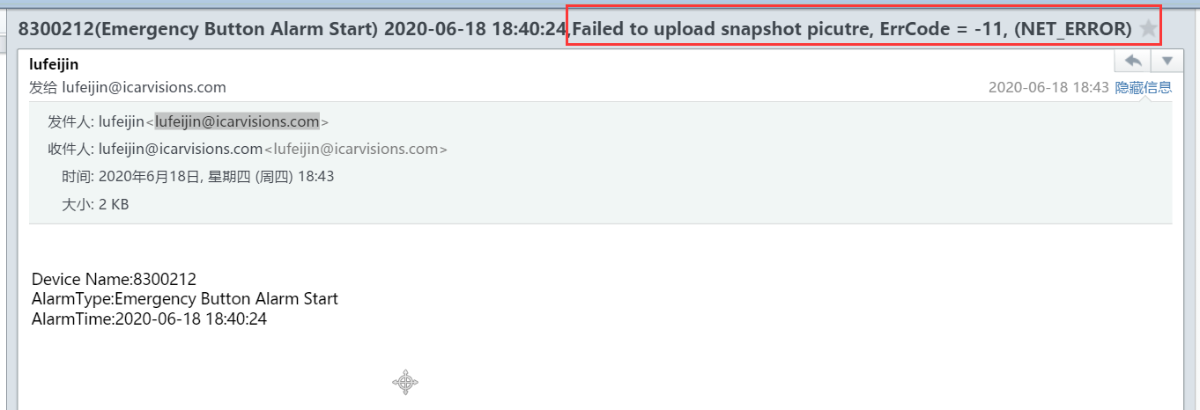

There are some ways to check the problem.

First. Please make sure that turn on the both buttons of “ SNAP PIC “ and “ TOServer “.
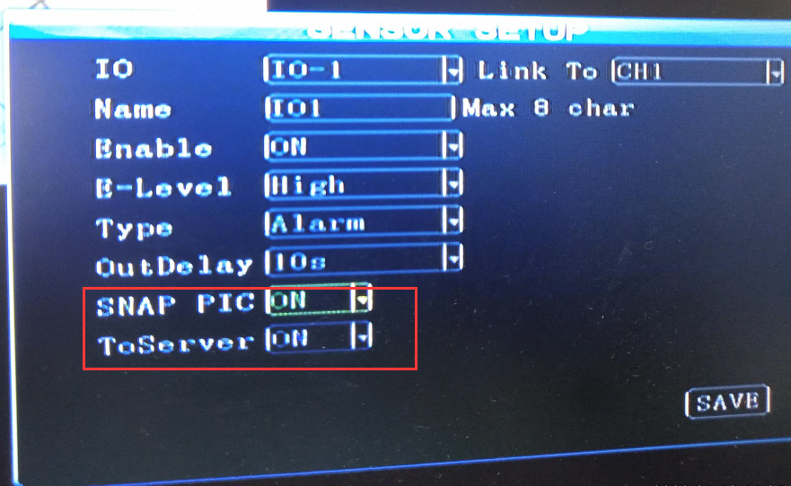

Second, Please make sure that the MDVR is on recording status when the alarm was triggered.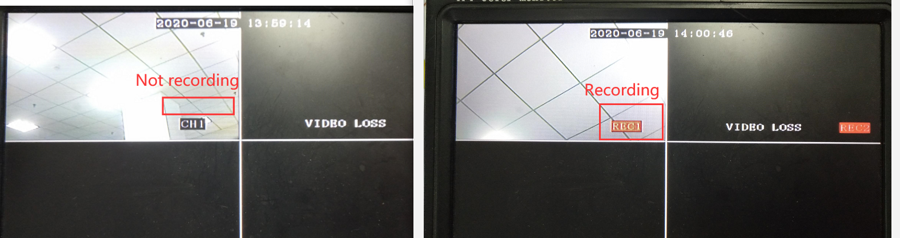
Here is the FAQ link about how to check the MDVR not recording.

https://www.icarvisions.com/faq/how-to-check-the-mdvr-not-recording-313.html

Note:
Please select the Auto Record Mode.
Please contact with our Technical Support Engineer if You found the MDVR is not recording once the alarm was triggered.
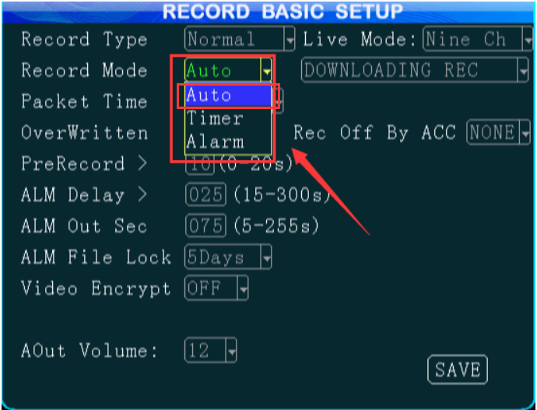

Finally, after all the configuration, you could receive the snapshots successfully as below.
