How to test the Operation Humidity of MDVR
Experiment Purpose:

It proves that MDVR can work normally under the condition of high temperature and high humidity.

Experimental procedure:

First. Please record the Voltage and Electric Current and status of MDVR.
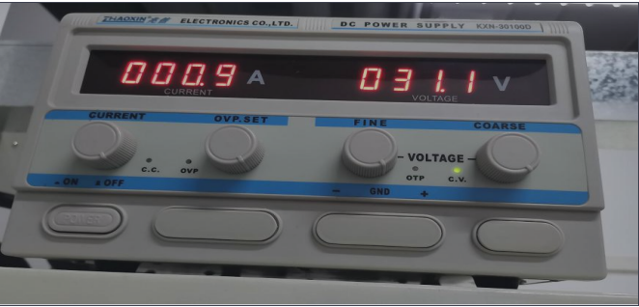


Second, Please put the MDVR in the “ Constant Temperature Humidity Chamber “ for two hours.

Set the Temperature from -5 °C to +80°C
(-5°C is the lowest working temperature of ordinary SSD, -40°C is the lowest working temperature of the MDVR)
Humidity from 0% to 90%

For example. Set the temperature and humidity as below.
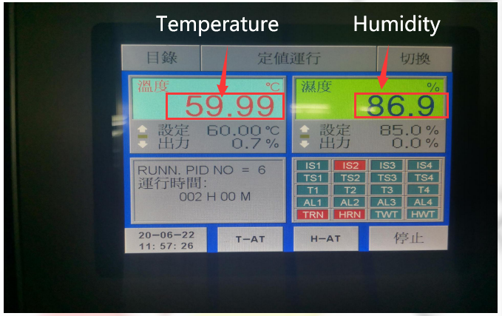
MDVR has been working for two hours in this environment.
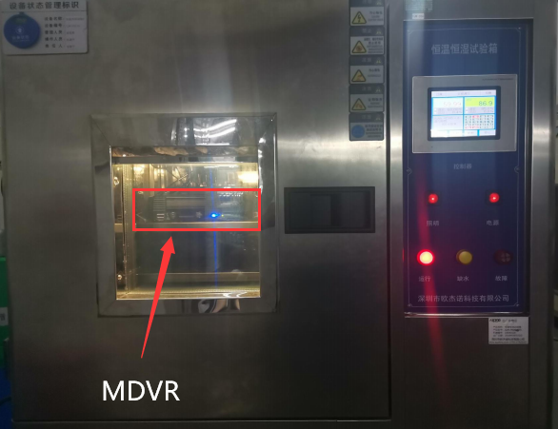
Experimental results:

- Operating Voltage and Electric Current is normal.
- Recording status is normal.

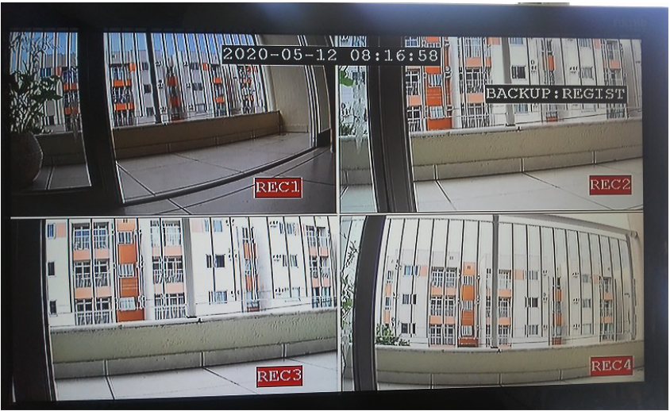

Experimental Conclusion:

MDVR can work normally under the condition of high temperature and high humidity.

