How to open format disk and search log function at IVMS Client side
1. First, close the IVMS client, open the IVMS Client installation directory, then find the config.ini
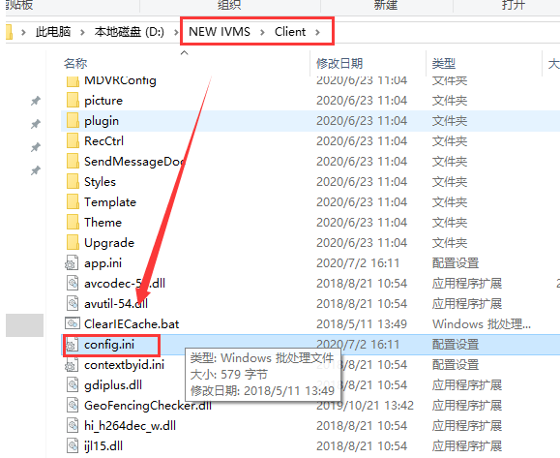
2. Change the setting as below, then save it.
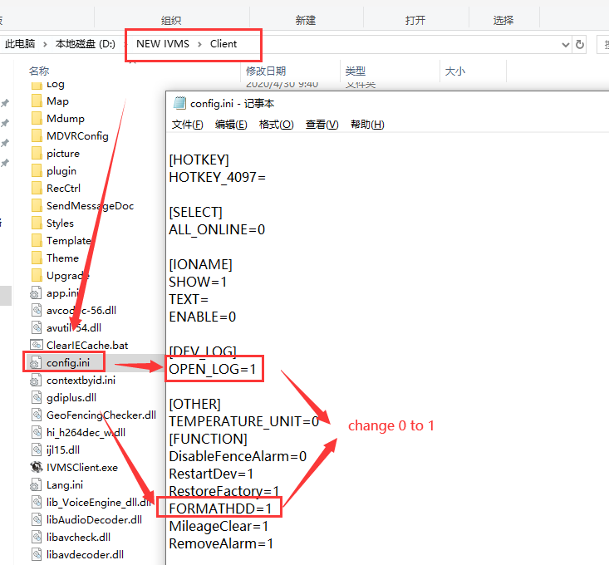
3. Restart the IVMS Client, then login to check it, you will find this two function is working now.
