How to check if the device always upload 0 speed
- The problem is shown as below.
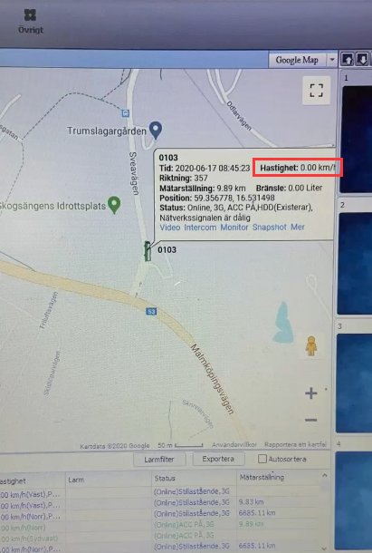
- First check the Speed settings, check the speed source is from GPS or vehicle, if it from vehicle, it will have this issue.
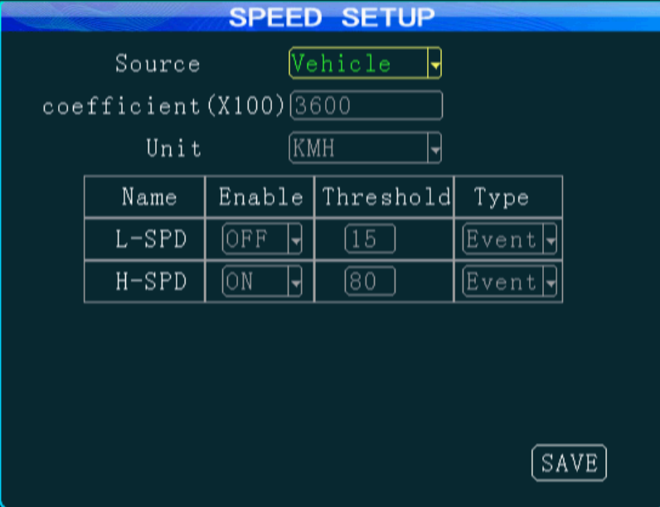
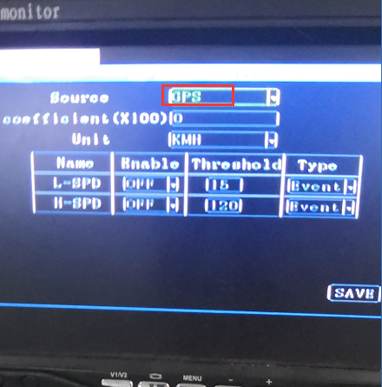
- You also can set it remotely on IVMS Client.
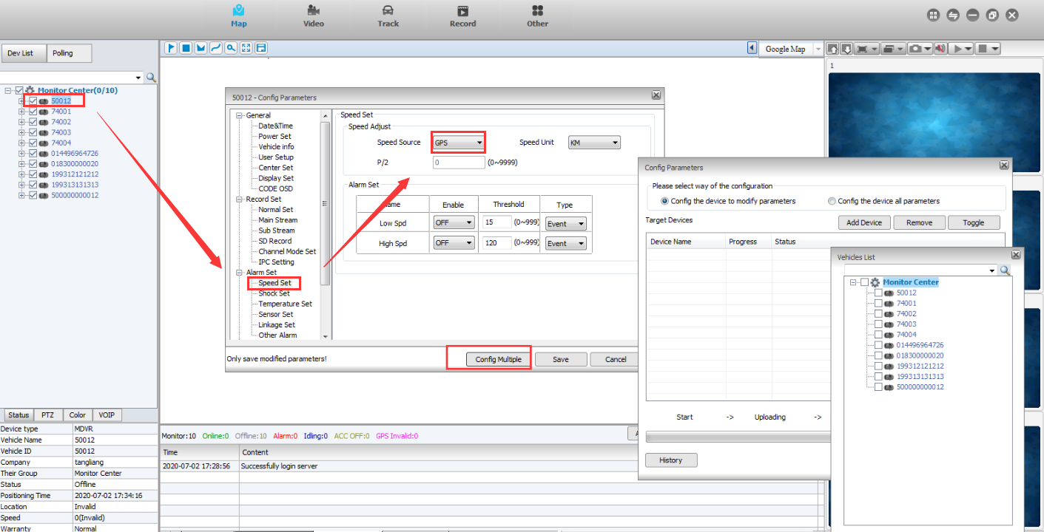
- After that you can check the speed information again.
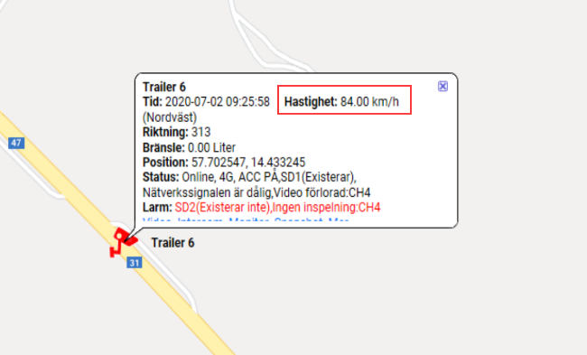
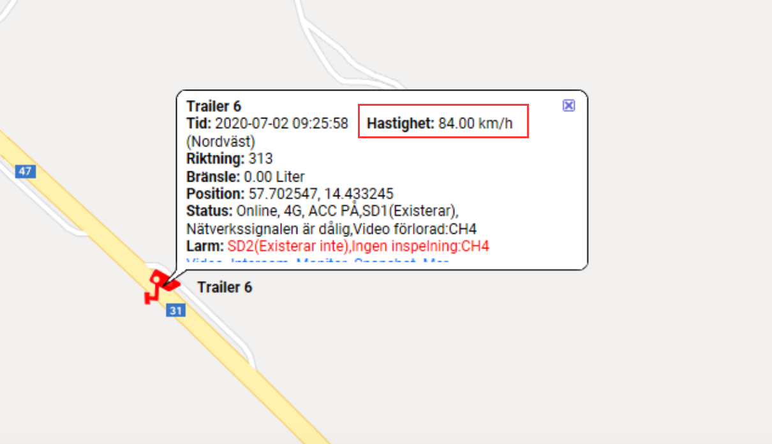
5.If use this method still useless, you can contact our engineer, we can help find the solution.

