How to use OSD settings
1.Set Encode to “OFF” and set Front to “ON”, then you will get this following views.
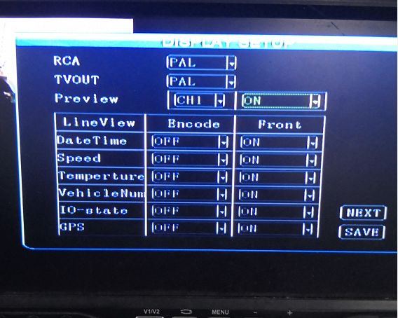
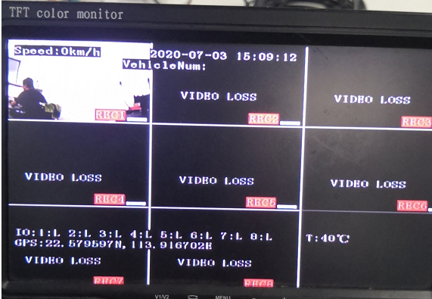
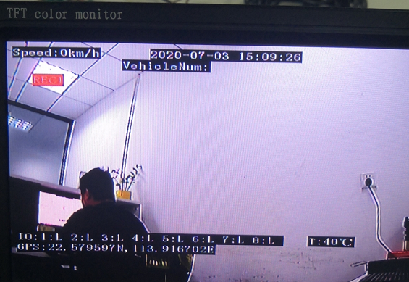
And if you query the videos using MDVRPlayer, you will get this view with the above OSD setting.
2.If set it to opposite like the following settings.
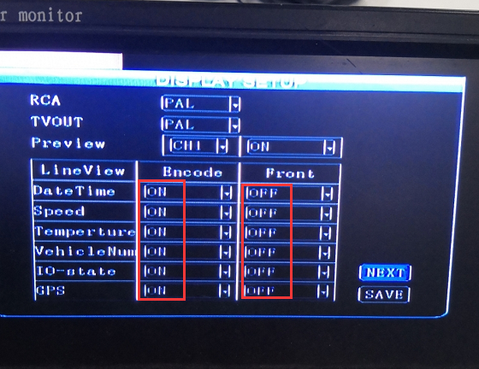
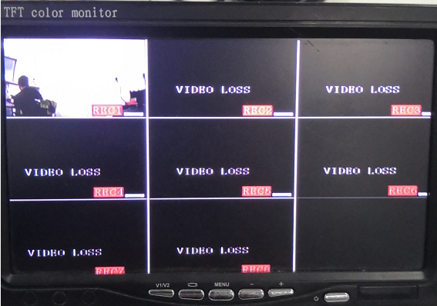
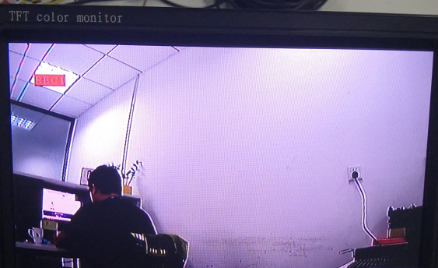
And if you query the videos using MDVRPlayer, you will get this view with the above OSD setting.

