How to move the old server date to new server side via IVMSDBBackup file
1. First, copy the backup file to new server side, then install the same old server at new server PC side.
2. After install the old server, copy the backup file to the IVMS server backup path, change the server PC time to the backup file's data, then click this to restore the old server data. You can choose restore the basic data or big data (it take long time to restore the big data), also can choose the restored days. Firstly, restored process will first check previous backup data in REPAIR folder, if can't find REPAIR folder, there will find parent directory IVMSDBBackup folder to restore.
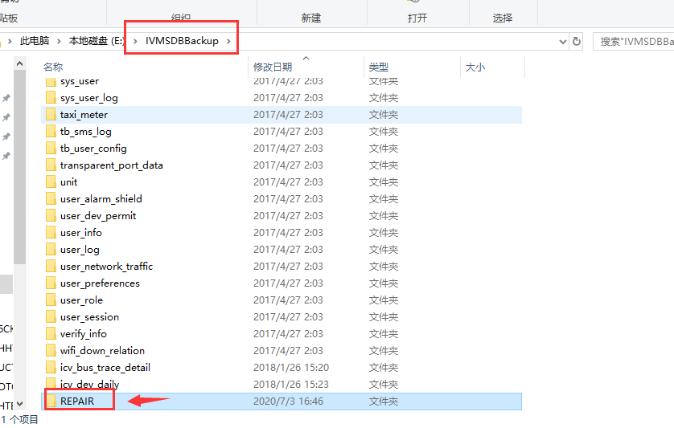
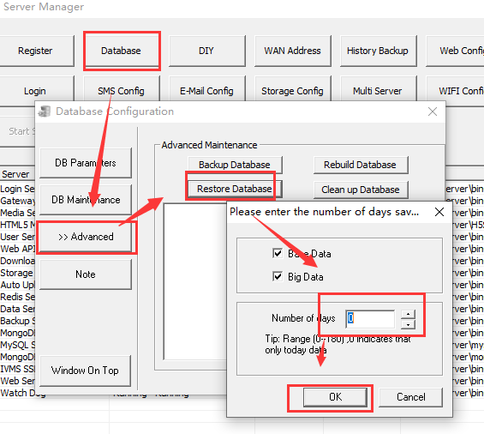

3. After this finished, close other service and running DBCheck.exe to load the server, then you can use the Navicat for mysql software or login the web to check if your mysql have date or not, if the old data had restored, it will show like this.
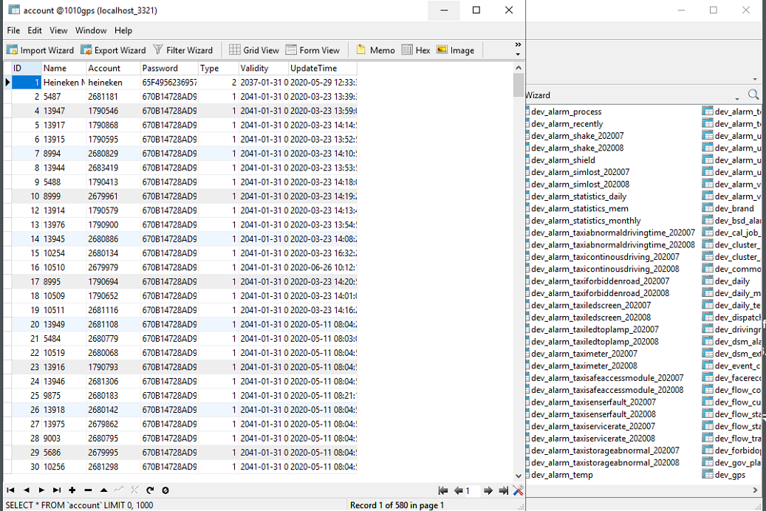

4. Uninstall the old server version, and install the new server to the same path, load the old server's mysql file, then you will find the old server date had move to the new server side.
