- axis sensor introduction
1.Introduction
MPU-60X0 is the world's first integrated 6-axis MotionTracking device. It integrates a 3-axis MEMS gyroscope, a 3-axis MEMS accelerometer, and an extensible digital motion processor DMP (Digital Motion Processor), which can be connected to a third-party digital sensor, such as a magnetometer, with an I2C interface. After expansion, it can output a 9-axis signal through its I2C or SPI interface (SPI interface is only available on MPU-6000). MPU-60X0 can also connect non-inertial digital sensors, such as pressure sensors, through its I2C interface.
The MPU-60X0 uses three 16-bit ADCs for the gyroscope and accelerometer, respectively, and converts the analog quantity it measures into a digital output. In order to accurately track fast and slow movements, the measurement range of the sensor is user-controllable, the gyro measurement range is ±250, ±500, ±1000, ±2000°/sec (dps), and the accelerometer measurement range It is ±2, ±4, ±8, ±16g.
An on-chip 1024-byte FIFO helps reduce system power consumption. Communication with all device registers uses 400kHz I2C interface or 1MHz SPI interface (SPI is only available for MPU-6000). For applications that require high-speed transmission, a 20MHz SPI can be used to read and interrupt registers. In addition, a temperature sensor and an oscillator with only ±1% variation in the working environment are embedded on the chip. The chip size is 4×4×0.9mm, using QFN package (leadless square package), which can withstand a maximum impact of 10000g, and has a programmable low-pass filter.
Regarding power supply, MPU-60X0 can support VDD range 2.5V±5%, 3.0V±5%, or 3.3V±5%. In addition, the MPU-6050 also has a VLOGIC pin, which is used to provide logic levels for the I2C output. The VLOGIC voltage can be 1.8±5% or VDD.
- Features
Digital output of 6-axis or 9-axis rotation matrix, quaternion (quaternion), Euler angle format (EulerAngleforma) fusion calculation data.
3-axis angular velocity sensor (gyroscope) with 131 LSBs/°/sec sensitivity and full-scale sensing ranges of ±250, ±500, ±1000, and ±2000°/sec.
Programmable control, and the program control range is ±2g, ±4g, ±8g and ±16g 3-axis accelerator.
Remove the sensitivity between the accelerator and the gyroscope axis to reduce the effect of the setting and the drift of the sensor.
The Digital Motion Processing (DMP: Digital Motion Processing) engine can reduce the load of complex fusion calculation data, sensor synchronization, and posture sensing. The motion processing database supports the built-in operating time deviation and magnetic sensor calibration calculation technology of Android, Linux and Windows, eliminating the need for customers to perform additional calibration.
Digital output temperature sensor
Digital input sync pin (Syncpin) supports video electronic video stabilization technology and GPS
Programmable interruption supports gesture recognition, panning, zooming in and out of the screen, scrolling, rapid descent interruption, high-G interruption, zero motion sensing, touch sensing, and shaking sensing functions.
VDD power supply voltage is 2.5V±5%, 3.0V±5%, 3.3V±5%; VDDIO is 1.8V±5%
Gyroscope operating current: 5mA, gyroscope standby current: 5uA; accelerator operating current: 500uA, accelerator power saving mode current: 40uA@10Hz
I2C in fast mode up to 400kHz, or SPI serial host interface up to 20MHz
The built-in oscillator has a frequency variation of only ±1% within the operating temperature range. Optional external clock input 32.768kHz or 19.2MHz
- Function introduction
Pin output and signal description
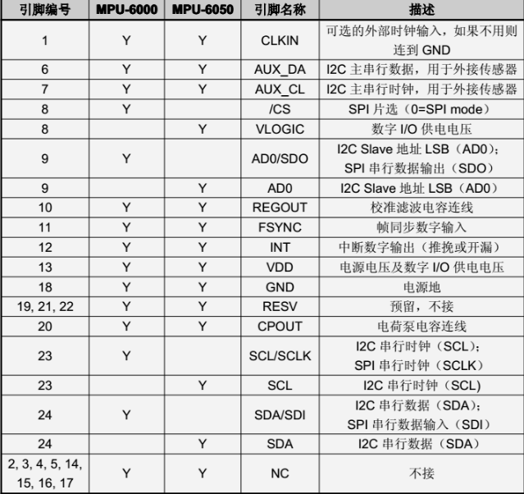
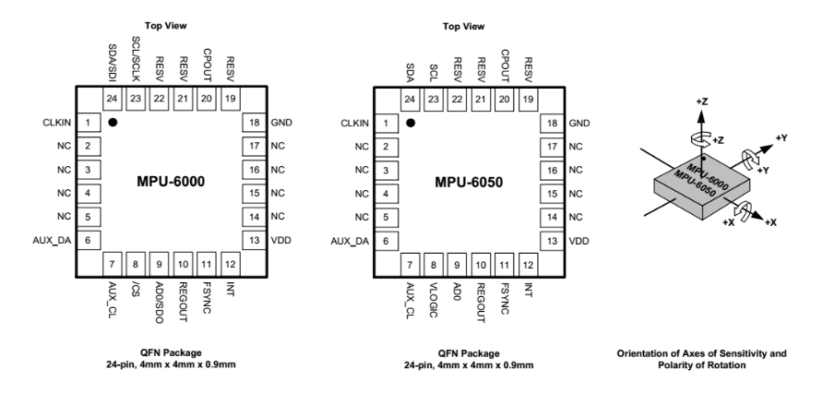
Typical usage
