How to set ADAS and DSM alarm linkage at IVMS Client side
1. First, you need to install the newest server and IVMS Client which support this function, then put the MDVR and ADAS/DSM online.
2. Use your account login the IVMS Client, then setting the ADAS/DSM alarm linkage as below.
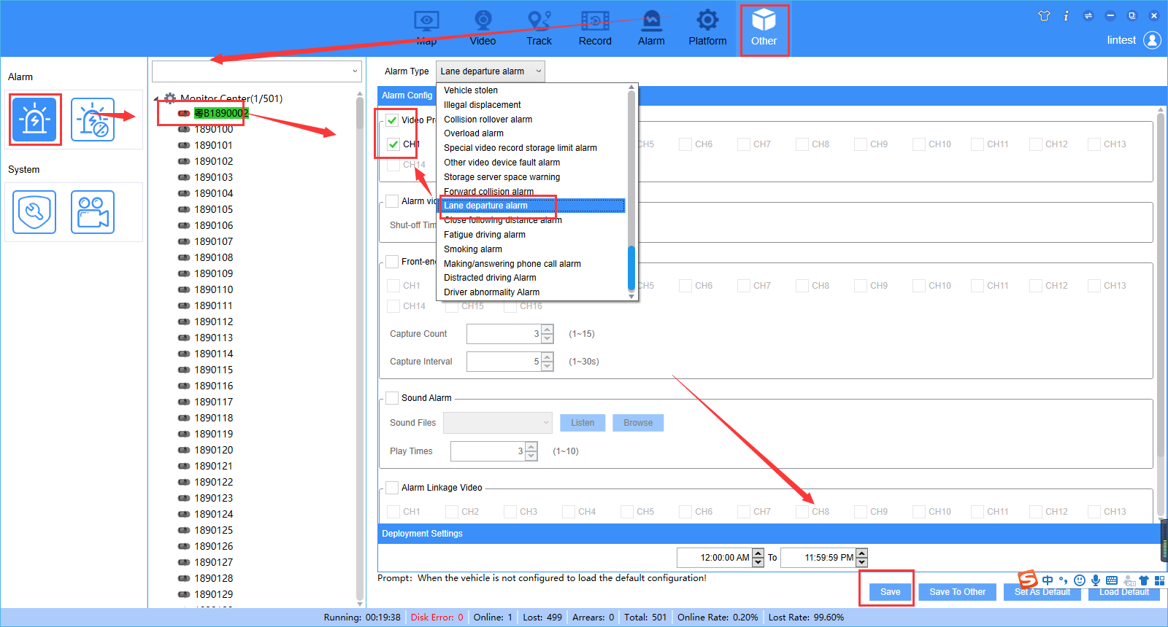
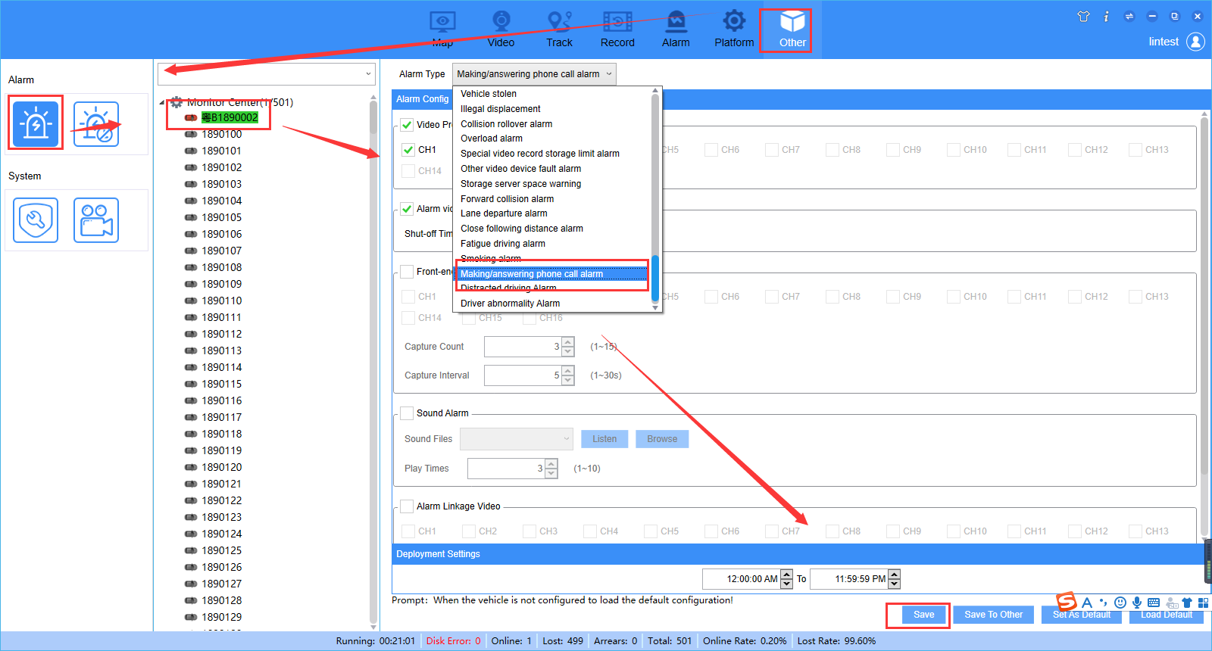
3. Trigger the ADAS and DSM alarm, then it send alarm to platform side, and auto link the channel you set.
