How to use USB Serial port to upgrade AI-BOX-A
1. First, power on the MDVR, and let it online, then connect the LAN cable to AI-BOX-A, then AI-BOX-A will use the MDVR network to registration activation algorithm.
2. Connect the USB Serial port to AI-BOX-A 's rear panel, another side connect to the PC USB port, restart the AI-BOX, it will enter the download mode, we can find the port at PC's Device manager, it will show as 'Qualcomm HS-USB QDLoader 9008'.
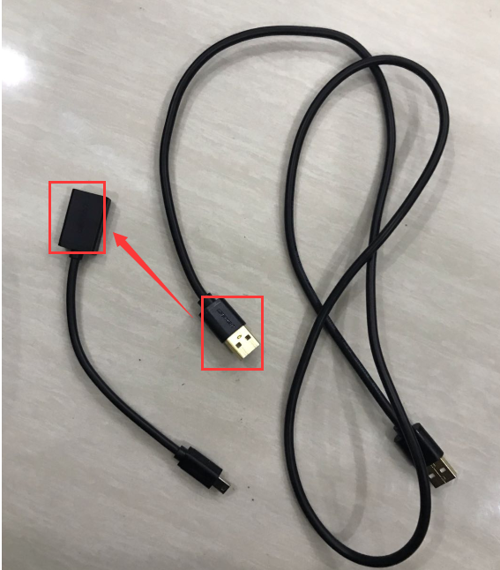
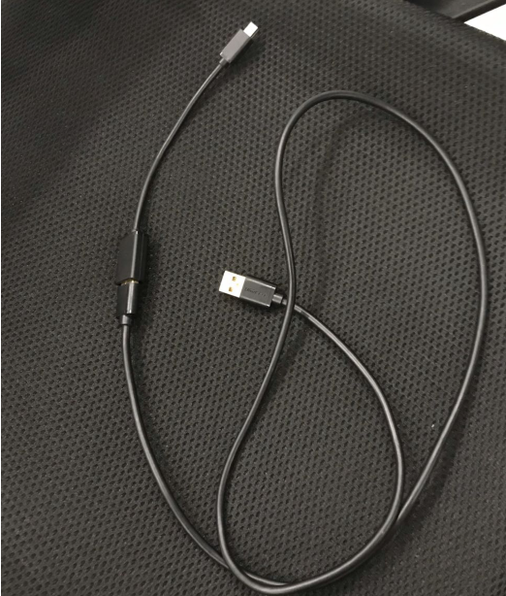
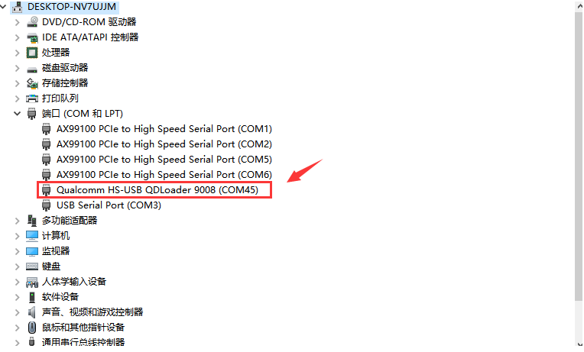
3. Unzip the MultiDownload_V2.1.zip file, open MultiDownload_V2.1.exe, Choose
LoadXML，then use password 123456 enter it.
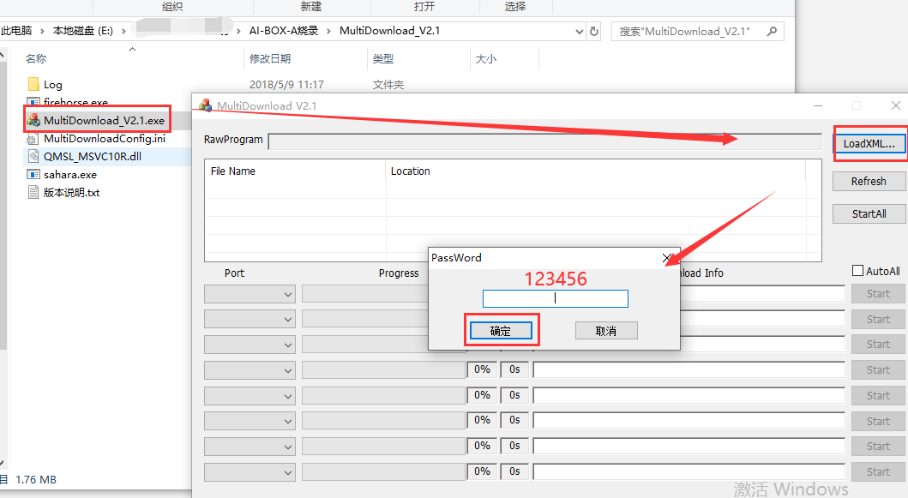

4. Unzip the spf-2-0_common_5.6_038bb55_JS1A_V9_2019122401_user.zip, choose "rawprogram0_16G_split.xml", then check the port and choose start to upgrade the AI-BOX-A.
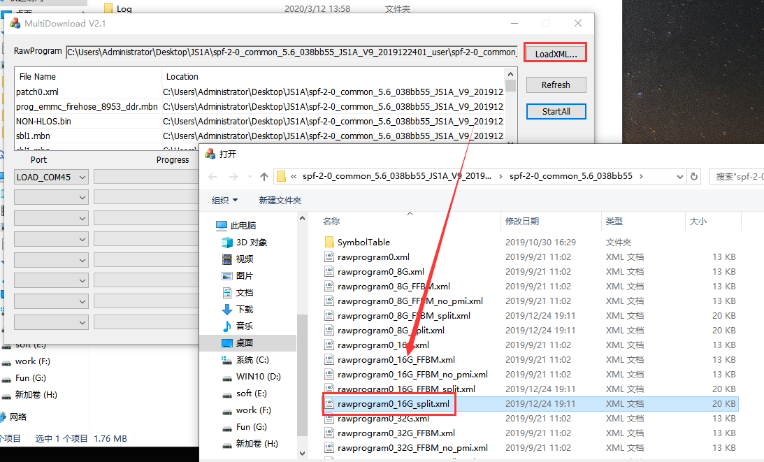
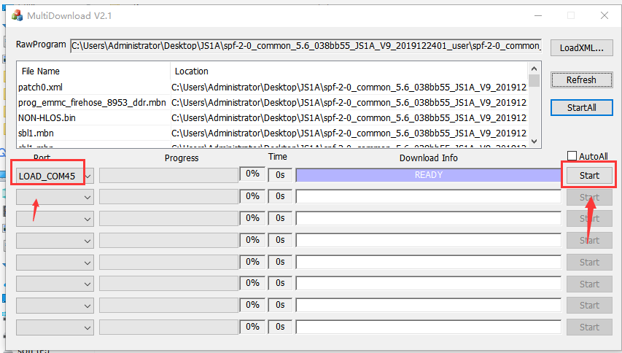
5. After finished this, remove the USB cable, and restart the AI-BOX-A(wait more than 10s to restart again), then wait the Android system loading, it will need about 3 mins, then you can check the version at MDVR side.

