Why MDVR still power on when the MDVR electronic lock is not locked
When customer use the new MDVR with GD303RC MCU, they will find the MDVR also can power on when the MDVR electronic lock is not locked, the new MCU will show like this.
​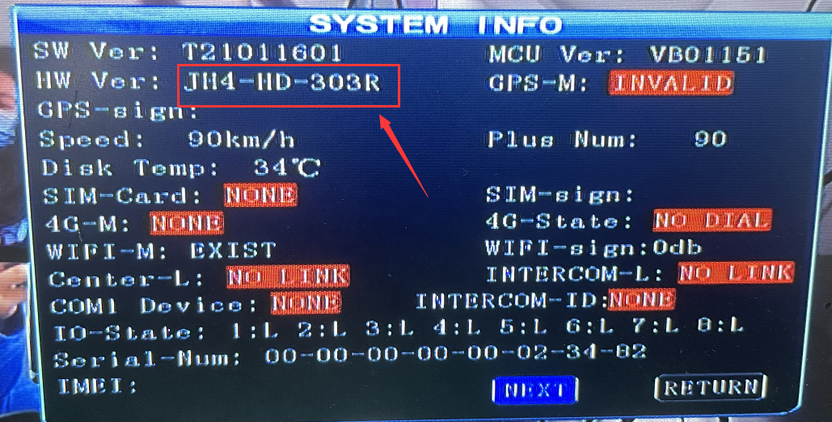
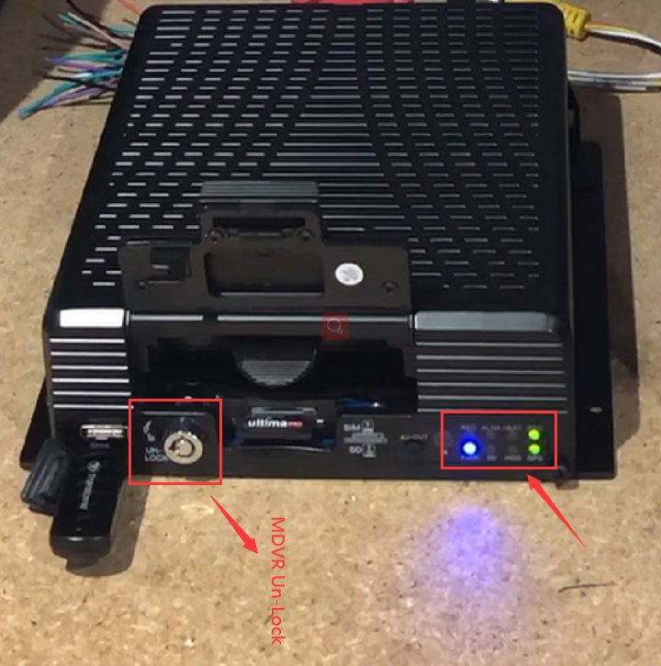

We had add a new feature at this new MCU, when the MDVR ACC ON or connect the power, even the MDVR electronic lock is not locked, it also will power after few minutes (maybe about 5-10 mins). This feature can help enhance two scenarios for customers, DVR may have a faulty lock occasionally and unable to power on or the faulty lock could affect the recording when the vehicle is driving. But please don’t worry as this won’t drain the vehicle battery as MDVR is connected to the ignition of vehicle ACC, and when the driver turns off the ignition, the MDVR will power off whne the power-off delay setting time run out.
