How to create users at IVMS web client
1.After installed your IVMS server, The first step is to login your admin account
Account:admin
Default password:admin

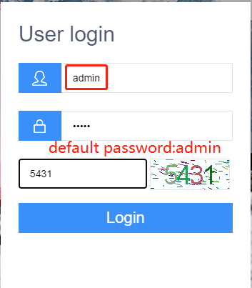
2.Following the steps shows in the picture below to add a level 1 user.
>>Management >> user management >> Add
>> input user name, account , number of terminal licenses
>> click detail information >> set max download traffic from 200 to 0 to remove traffic restrictions

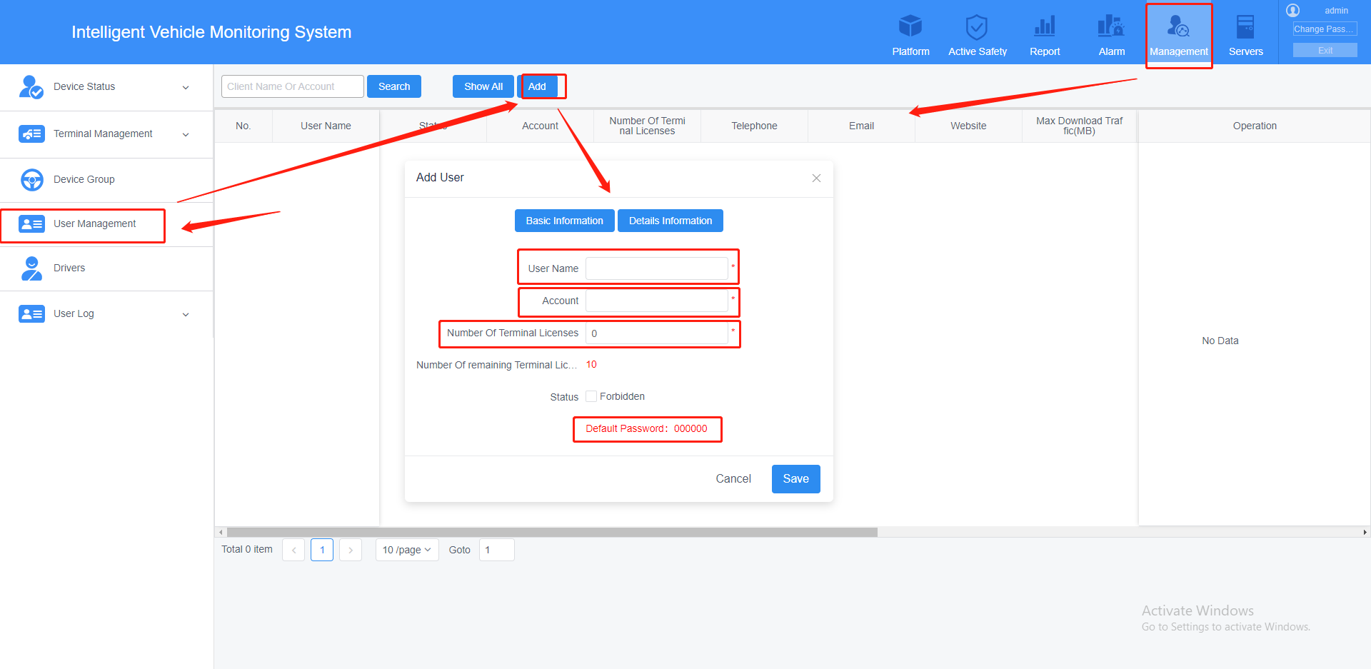

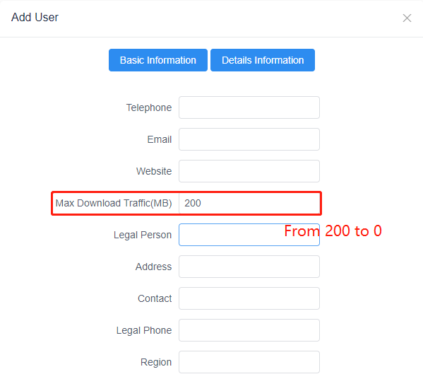
3.Vehicle terminal management
Following the steps shows in the picture below to add terminals
>> Management >> Terminal management
>>Choose Add or Batch add to determine to add one or multiple consecutive terminals

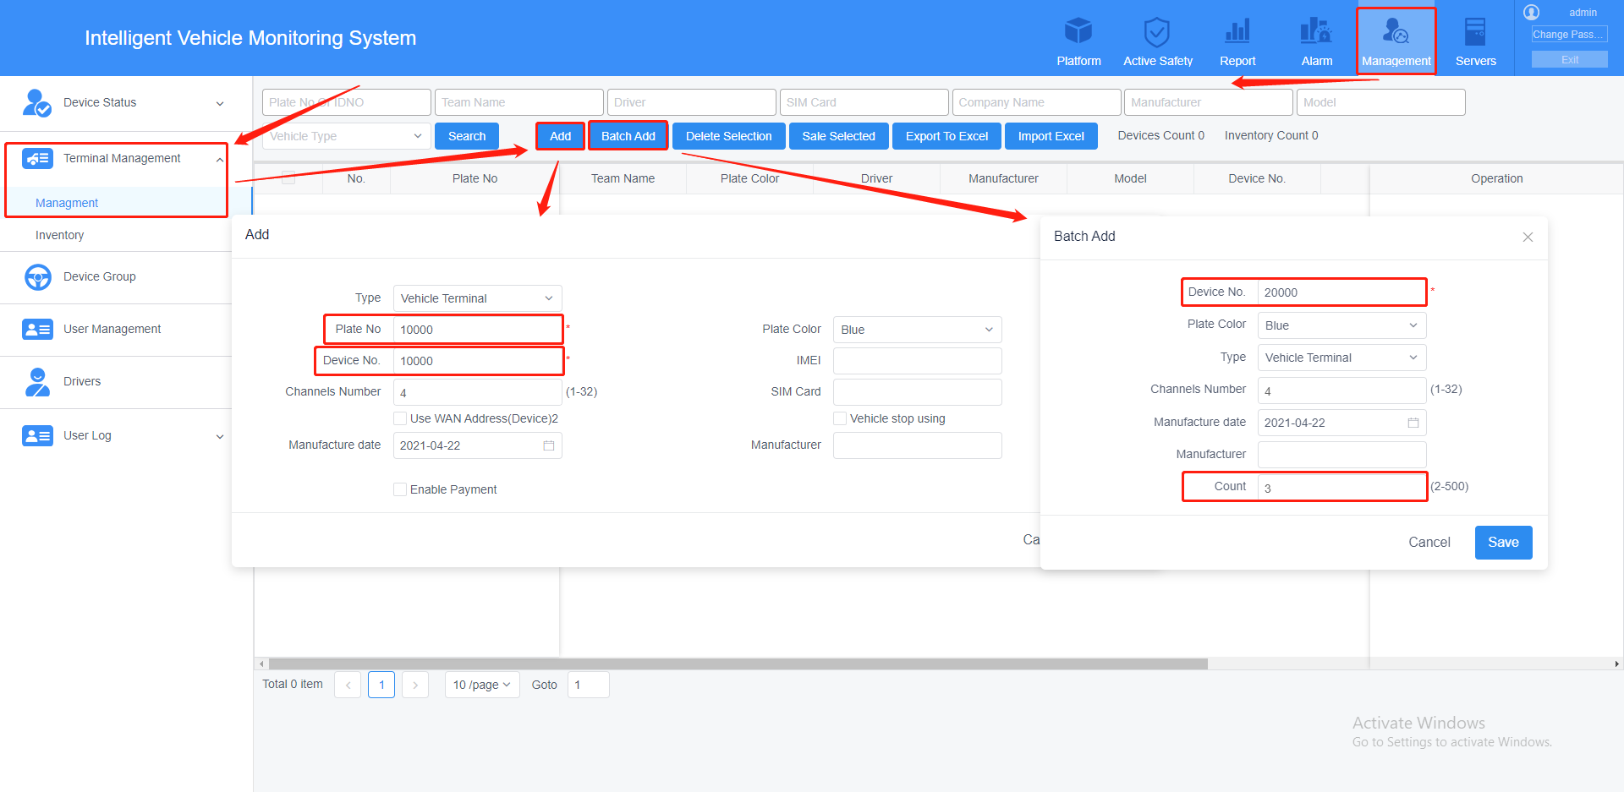
4.>> click Sale to sale teminals to the level 1 account you added >> save

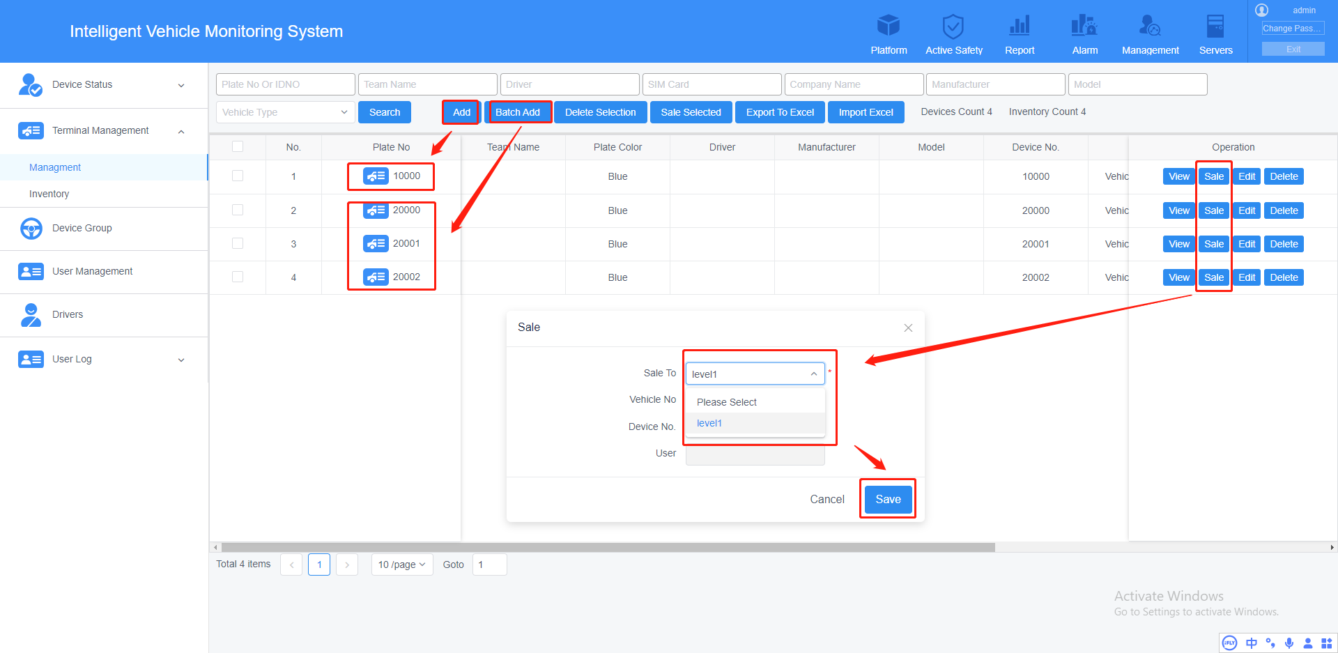

5.Add terminals to Storage server and Download server for setting wifi download plan and record plan
>> Servers >> Storage server and Download server >> select all >> add select
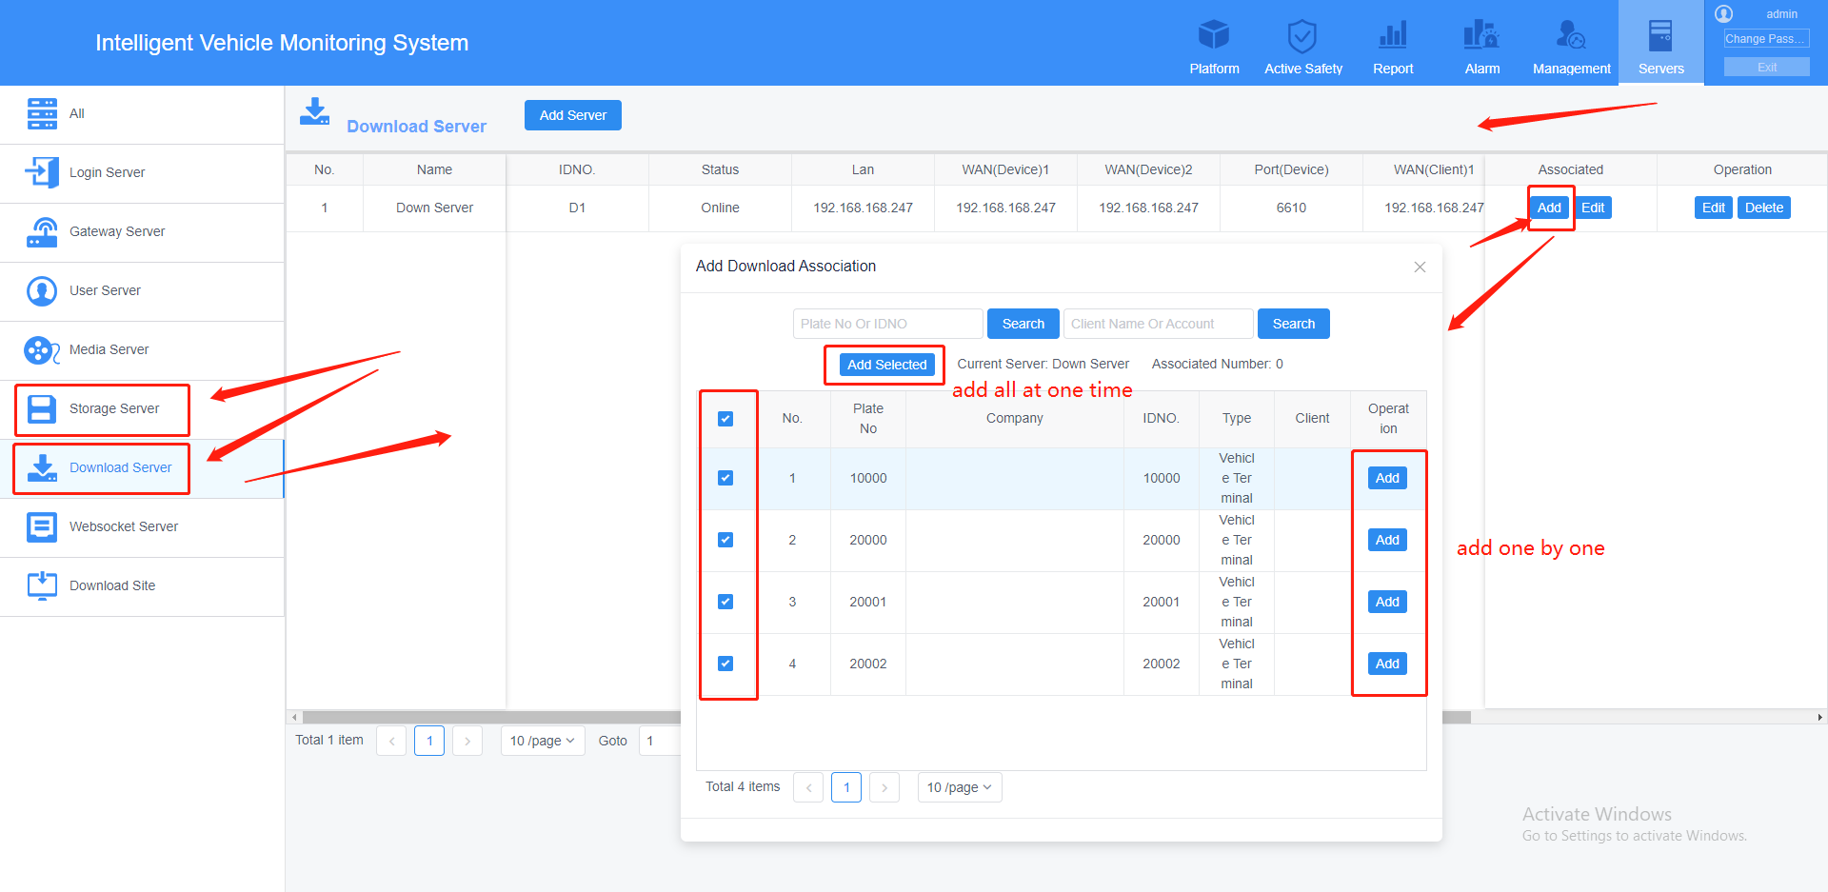

6.Login your level 1 account that you added, the default password is 000000
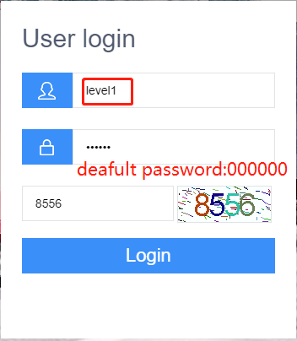

7.Add Role
>>Management >> Role management >> add
>>input Name >> choose the authority that you want to give >> save
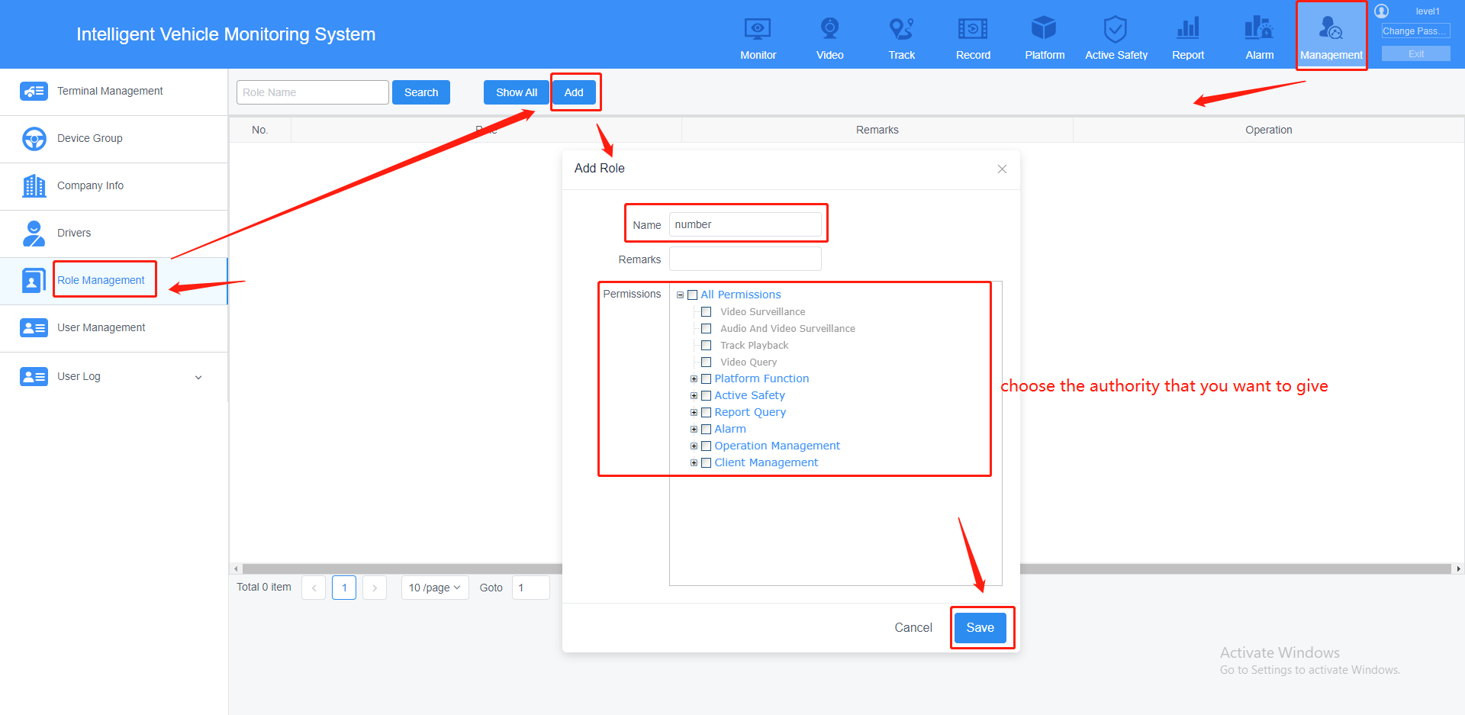
8.Add level 2 account for your client
>>Management >> User management >> add
>>input Account, Name >> choose the role you added >> detail information
>>choose your user grade >> set max download traffic from 200 to 0 >> save
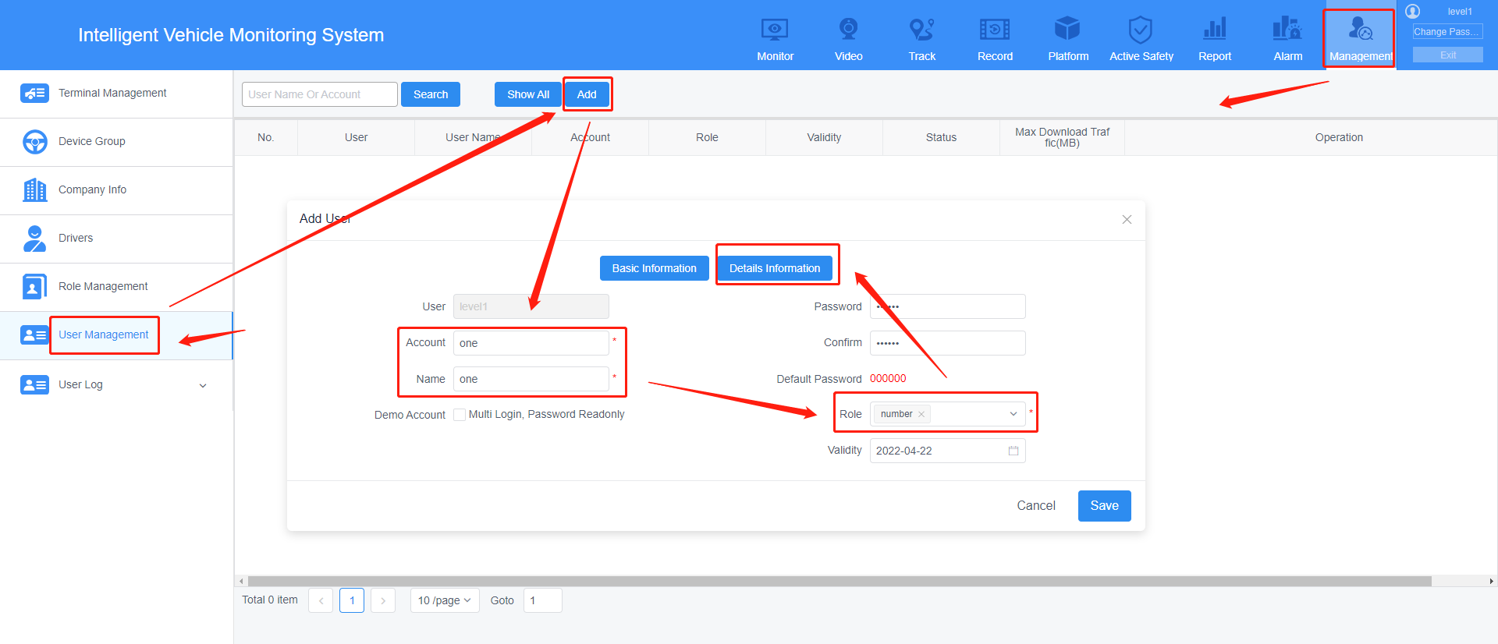
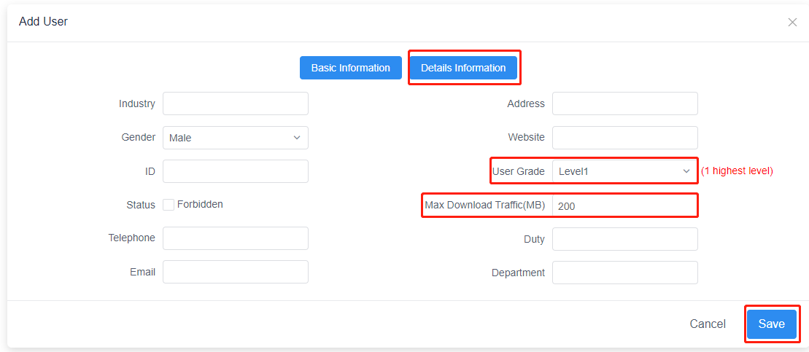
9.Device Authorized
>> choose the account that you want to add terminals >> click unauthorized
>>choose the terminals that you want to give (one terminal could add to multiple different account at the same time)>> save
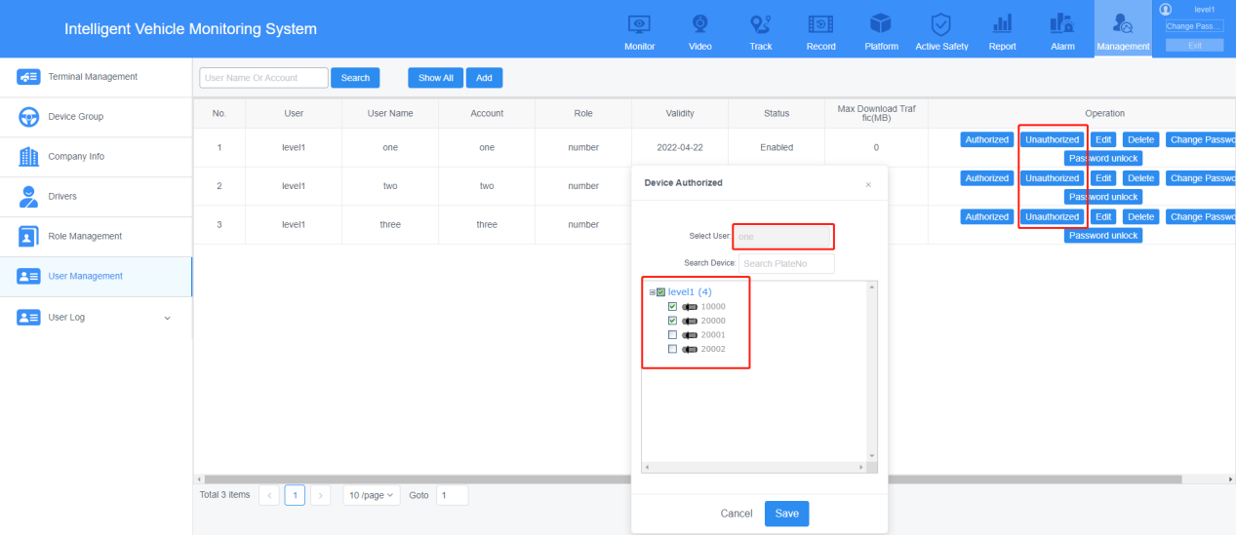
10.You could use your level 2 account to create level 3 sub-account, if you give your level 2 role Operation management authorities, and also You could use your level 3 account to create level 4 sub-account as long as your role has the Operation management authorities, and so on.

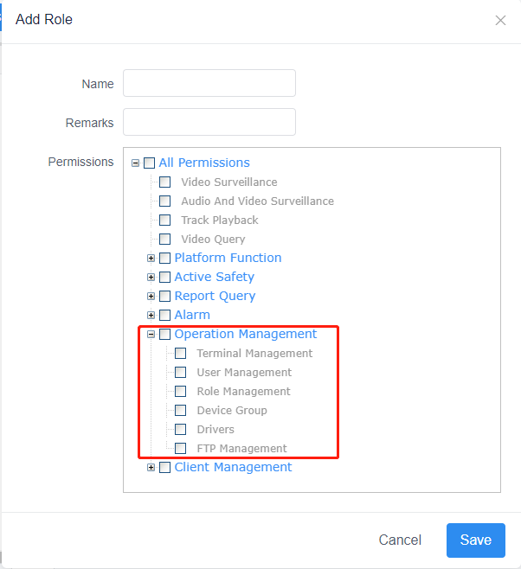
Without Operation management authorities, you can’t create sub-account anymore
