How to configure software download at web side
- First, open the IVMS Server installation directory, and find this folder. Put the software installation package（ICARview andriod apk, IVMS client, MDVRplayer） in this folder
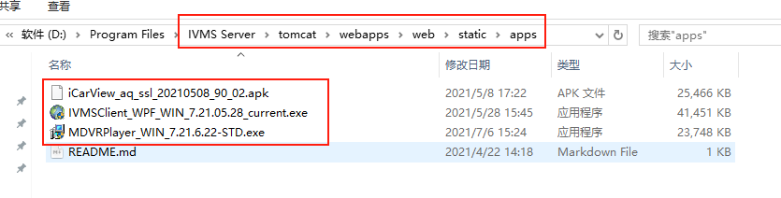
- Second, open the IVMS Server installation directory, and find this folder. Open the other.properties file.
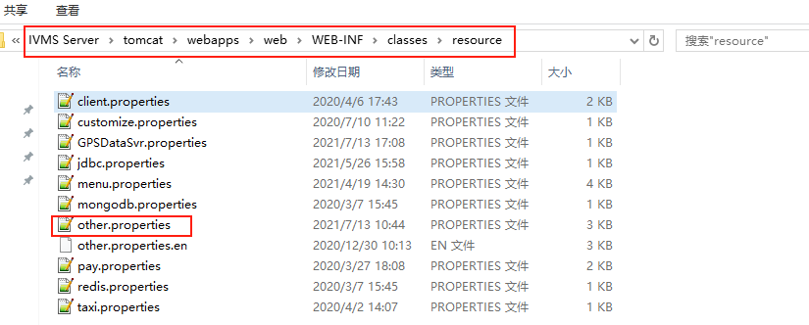
- Following the pictures below, replace # with corresponding software file name, and don’t forget the suffix of the file, IOS directly fill in this link : https://apps.apple.com/cn/app/id1064405427.
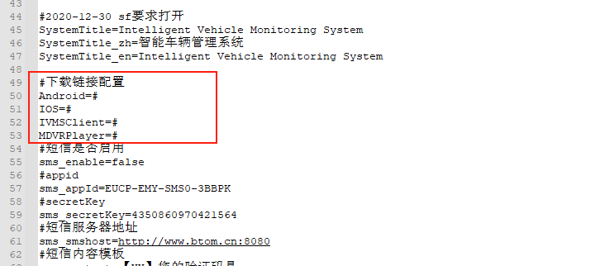
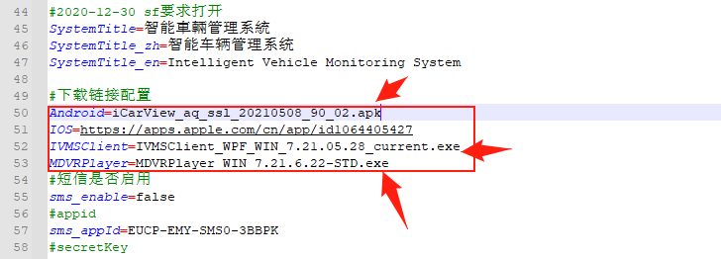.
- After changing these, save, restart the web server, reopen the web page, clean up the cookies.
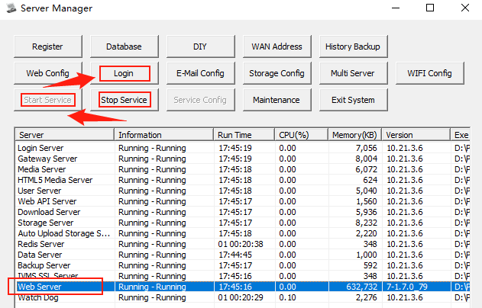
- Then you can download the software on the web side by clicking the icon.
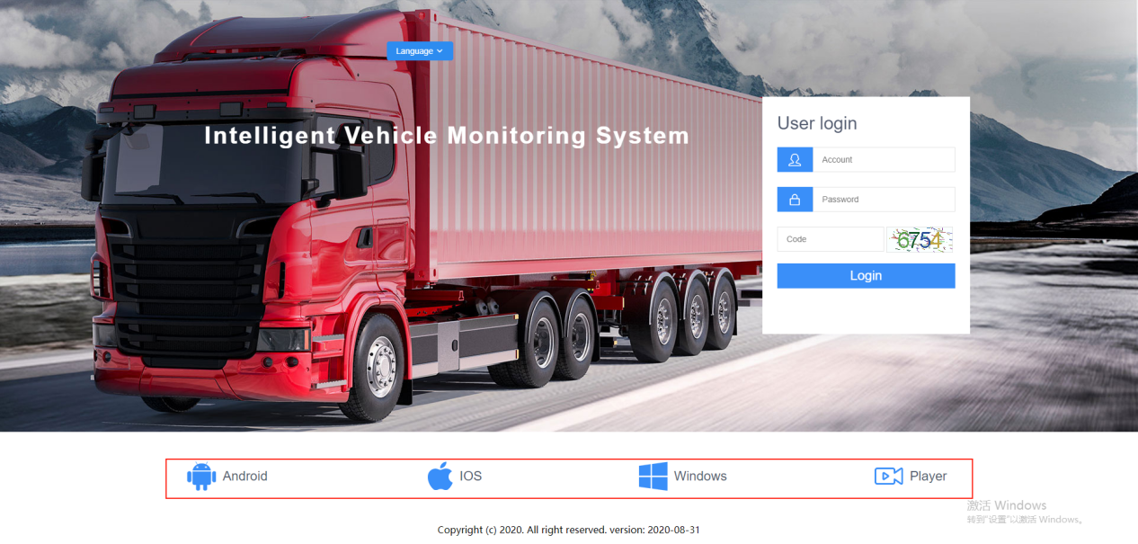
6.If you want to update the software to the latest version, please follow the previous steps again.

